Executive Summary

ES-05 Executive Summary - 24 CFR 91.200(c), 91.220(b)
1. Introduction
This Five-Year Consolidated Strategic Plan covers fiscal years 2019 through 2023 and includes a one-year Action Plan for fiscal year 2019. It is prepared in compliance with requirements of the U.S. Department of Housing and Urban Development (HUD) as a plan and an application for funding under one formula grant program: The Community Development Block Grant (CDBG).
The City of Cuyahoga Falls is an entitlement city, which HUD defines as a qualified city with a population of at least 50,000. Entitlement cities are entitled to receive annual grants from HUD. The amount of the CDBG entitlement grant is determined by HUD through the use of a statutory dual formula which uses several objective measures of community needs, including the extent of poverty, population, housing overcrowding, age of housing and population growth lag in relationship to other metropolitan areas.
This document presents a strategic plan to address the three goals established by federal statute for this program:
• Provision of expanded economic opportunities,
• Provision of a suitable living environment, and
• Provision of decent, safe and sanitary housing.
Further, this Strategic plan has been developed to address Assessment of Fair Housing goals:
- NIMBYism (Community Opposition),
- Enforcement of Fair Housing Laws,
- Lending Discrimination
- Availability of Affordable Housing Units, and
- Lack of Accessible Housing.
This program is primarily intended to benefit persons and families of low-to moderate-income, which HUD defines as 80% or lower of the area median income, as determined annually by HUD. The income limits used by the City of Cuyahoga Falls are the Akron Metropolitan Area Income Limits. In addition to these efforts, during the 2019-2023 Plan period, the City of Cuyahoga Falls will work to further the goals and objectives identified by the Akron/Barberton/Cuyahoga Falls/Summit County Continuum of Care. The City of Cuyahoga Falls will also seek out increased opportunities for collaboration with the other entitlement communities – the Cities of Akron, Barberton and Summit County.
See table below for current FY Income Limits.

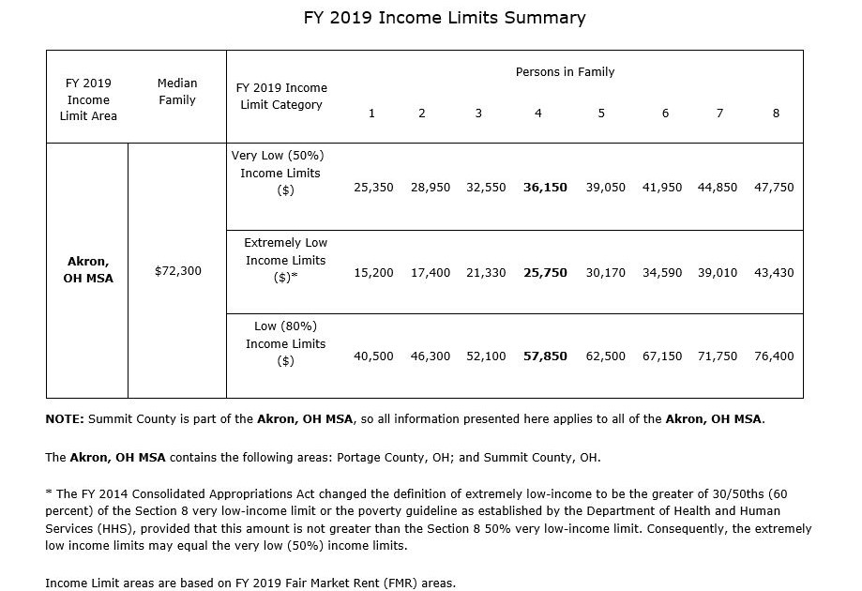
2. Summary of the objectives and outcomes identified in the Plan Needs Assessment Overview
During the development of this five-year plan, the City of Cuyahoga Falls identified the following objectives:
1. The Provision of Decent, Safe and Sanitary Housing.
To preserve, construct and increase the availability of affordable and livable housing conditions for low to moderate income individuals and families. This objective includes an AFH goal (Availability of Affordable Units).
2. The Provision of a Suitable Living Environment.
To enhance the quality of life and promote healthy neighborhoods for low to moderate income persons through a variety of public services, infrastructure projects and activities that address specific community needs.
3. The Provision of Expanded Economic Development.
To expand economic opportunities through the creation and/or preservation of jobs.
4. Programmatic Compliance.
To enhance the quality of life of low to moderate income persons through programmatic compliance. This Objective includes an AFH goal.

3. Evaluation of past performance
During the 2014 - 2019 Five Year Consolidated Strategic Plan, the following was accomplished:
The Provision of Decent, Safe and Sanitary Housing:
A total of $1,000,000 in CDBG funds was allocated to both minor and comprehensive home rehabilitation:
- 51 homes were rehabilitated, benefiting low- to moderate-income individuals and families;
- 12 homes were provided with lead remediation, benefiting low- to moderate-income individuals and families.
The Provision of Suitable Living Environment:
- $65,000 was allocated to fair housing services to 1,863 low- to moderate-income individuals;
- $80,000 was allocated to senior snow removal, benefiting 168 senior and/or disabled low- to moderate-income individuals; and
- $20,000 was allocated to homeless support services, supporting extremely poor individuals and families.
- $2,650 was allocated to the planting of trees and flowers along sidewalks in a low- to moderate-income area of the city, benefiting 1,135 residents.
- $100,000 was given for brownfield remediation and economic development of 6 acres located in a low- to moderate-income area of the city.
The Provision of Expanded Economic Opportunities:
A total of $2,000,000 in CDBG funds was allocated to Economic Development and resulted in:
- the creation and/or retention of 102 jobs for low- to moderate-income individuals; and
- provided assistance to 11 businesses; and
- provided a female minority business owner with a 2018 snow removal contract.

4. Summary of citizen participation process and consultation process
As part of the preparation for the Five-Year Consolidated Plan, the Department of Housing and Urban Development (HUD) requires all entitlement jurisdictions to develop a citizen participation plan. The citizen participation plan is developed as a means of encouraging citizens, community officials, and representatives from public and private agencies that provide housing, social and health services, or are interested in fostering economic growth and development, to provide input into the development of the Five-Year Consolidated Plan.
The regulations also require that entitlement jurisdictions obtain input from the public during the development of all Annual Updates and/or Amendments to the Consolidated Plan. Annual Updates to the Consolidated Plan identify the specific projects an entitlement community is going to implement in the upcoming program year to address the goals and objectives identified in the Five-Year Consolidated Plan. Amendments include any changes to the Consolidated Plan or to projects identified in the Annual Updates to the Consolidated Plan. The public comment period for the Five-Year Consolidated Plan, Annual Updates to the Consolidated Plan, and Amendments to the Consolidated Plan must be no less than 30 days. Comments from Citizens may be submitted orally, in writing, or at public meetings.
The regulations also require that citizens be given a minimum of 15 days to comment on the Consolidated Annual Performance and Evaluation Report (CAPER). The CAPER is submitted annually to HUD and is due 90 days after the completion of an entitlement community’s program year. The City of Cuyahoga Falls' program year ends on December 31st, which means that the CAPER is due by March 31st. The CAPER evaluates the progress made by an entitlement community toward the achievement of the goals and objectives identified in their Five-Year Consolidated Plan and the Annual Updates to the Consolidated Plan.
5. Summary of public comments
The public meeting held on May 14, 2019 was announced in the Cuyahoga Falls News Press and The City of Cuyahoga Falls Website, yielded verbal comments from one long time citizen. The gentleman who attended inquired about leveraging funds to help support the schools by deferring landscaping costs. It was also suggested that CDBG funds be used to offer showering locations to the homeless. An idea for acquisition of a closed school for housing development was briefly discussed. Finally as a way to attract more business, consumers and residents to our City, it was suggested that we light up Portage Trail Bridge, which is a main entry way into the City with the City's logo and lighted water arches in the Cuyahoga River.
The second public meeting held on June 6, 2019 and was attended by representatives from AMHA, HMIS (United Way) and NDS (Neighborhood Development Services). During this round table style meeting, United Way discussed homelessness initiatives and rapid rehousing methods, partnering with AMHA to help residents of Cuyahoga Falls and greater Summit County. AMHA spoke about waiting lists, public housing capital improvement projects and infrastructure needs. AMHA discussed possible disposal of scattered sites by implementing a low income homebuyer program that may require a partnership with the City to provide home rehabilitation. NDS explained fund leveraging with the HWAP program (Home Weatherization Assistance Program) to increase the amount of help provided to low income individual. They were also excited to report that there are many comprehensive housing rehabilitation projects in the pipeline. The group brain-stormed ideas to increase job creation for low income individuals. A representative from AMHA who was previously a resident of the State of Texas, offered ideas on helping local businesses, thereby possibly generating jobs for low to moderate income individuals by offering First Friday Brewery tours of the newly opened breweries on Front Street. AMHA also offered to help with public comments by linking the Community Needs Survey to their public housing Twitter Account.
Public Comments and Community Needs On-line Survey Responses may be found in the Citizen Participation Comments Appendix.
6. Summary of comments or views not accepted and the reasons for not accepting them
All comments were accepted.
7. Summary
Comments received from the community regarding the plan were reviewed and the plan was revised to address comments.

The Process

PR-05 Lead & Responsible Agencies 24 CFR 91.200(b)
1. Describe agency/entity responsible for preparing the Consolidated Plan and those responsible for administration of each grant program and funding source
The following are the agencies/entities responsible for preparing the Consolidated Plan and those responsible for administration of each grant program and funding source.
Agency Role | Name | Department/Agency

CDBG Administrator |  | Development Department
Table 1 – Responsible Agencies

Narrative
The Community Development Block Grant (CDBG) is administered by the City of Cuyahoga Falls Community Development Department. This Consolidated Plan submission covers the period for fiscal year 2019-2023 and includes a one year Action plan from January 1, 2019 to December 31, 2019.
Consolidated Plan Public Contact Information
Requested information and records will be made available by appointment only, Monday through Friday, between the hours of 8:00 A.M. and 4:00 P.M. in the City of Cuyahoga Falls, Development Department, located at 2310 Second Street, Cuyahoga Falls, Ohio 44221.
All records and information related to the 2019 – 2023 Five-Year Consolidated Plan will be maintained and will remain available for review for a minimum of 5 years.

City of Cuyahoga Falls
Community Development Department
(330) 971-8135
development@cityofcf.com

PR-10 Consultation - 91.100, 91.200(b), 91.215(l)
1. Introduction
The City of Cuyahoga Falls, Development Department staff met with representatives from the local public housing authority, Akron Metropolitan Housing Authority (AMHA), Summit County Continuum of Care (CoC), Homeless Management Information System (HMIS) managed by United way of Summit County and the local Fair Housing Authority, Fair Housing Advocates Association (FHAA). The Development Department invited various local organizations and governments to participate in two different discussion sessions to get input on needs present in the community. Staff from the Development Department collected community and agency comments through public meetings, phone consultation, electronically through email and on-line survey. Copies of public notices, local agency invitation, the surveys and the data collected are available in the Citizen Participation Comments and Grantee Unique Appendices.

Provide a concise summary of the jurisdiction’s activities to enhance coordination between public and assisted housing providers and private and governmental health, mental health and service agencies (91.215(I)).
The City of Cuyahoga Falls, Development Department invited local government and agency representatives to attend planning meetings for the Five-Year Consolidated Strategic Plan. Sign-in sheets, agendas, hand-outs, and comments from the two meetings, which were held on May 14, 2019, at 10:00 am and June 6, 2019 at 7:00 pm, are available in the Citizen Participation Comments and Grantee Unique Appendices. In addition to these two meetings, which sought public input for the creation of the 2019-2023 Five-Year Consolidated Strategic Plan, an online survey was used to solicit citizen response from those who were unable to attend. The survey and results are also available in the Citizen Participation Comments and Grantee Unique Appendices.
The City of Cuyahoga Falls, Development Department staff participates in the Summit County Continuum of Care (CoC). The CoC is comprised of not-for-profit social service agencies, faith-based organizations and government agencies within Summit County. The CoC is committed to eliminating homelessness and improving housing options through the implementation of a comprehensive Continuum of Care. The CoC brings in approximately four and a half million dollars annually to address the needs of the homeless population.
The City of Cuyahoga Falls, Development Department provides funding to the Homeless Management Information System (HMIS) of Summit County, which supports the CoC. The HMIS enables participating agencies to have accurate information about the clients they serve, saves staff and management time needed to gather client data and complete funding reports, enables agencies to track client outcomes and measure the success of the services provided during a given time period, and helps agencies, improve the quality of the services provided. It also informs government and the community about the extent and nature of homelessness in the state and the community and enables better communication about housing and support needs to potential funders and policy-makers.

Participating agencies include:
- ACCESS Inc.
- Akron Metropolitan Housing Authority
- Community Aids Network (CAN)
- Community Health Center
- Community Support Services (CSS)
- Family & Community Services
- Family Promise
- Haven of Rest
- H.M. Life Opportunity Services
- Legacy III
- North Coast Community Homes
- Oriana House
- Ohio Multi County Development Corporation (OMCDC)
- Shelter Care
- Summit County Children Services
- Tarry House
United Way formerly known as Infoline, the host agency of Summit County’s HMIS system, operates a centralized intake for the local shelters. Individuals calling 211 for any assistance are screened and referred to the appropriate services and agencies.
Describe coordination with the Continuum of Care and efforts to address the needs of homeless persons (particularly chronically homeless individuals and families, families with children, veterans, and unaccompanied youth) and persons at risk of homelessness
The Summit County Continuum of Care represents a broad collaborative effort of homeless service providers, support service providers, hospitals, the University of Akron, banks and foundations. Homeless providers work together to further enhance a system providing emergency, transitional and permanent shelter options to homeless individuals, families, families with children, veterans, unaccompanied youth and other special needs populations. The Continuum of Care system provides the homeless with shelters as well as supportive services to equip them with the tools necessary to overcome homelessness. The City of Cuyahoga Falls as part of the Continuum of Care Committee meets regularly to continuously evaluate the needs within the community and to identify any gaps.
Describe consultation with the Continuum(s) of Care that serves the jurisdiction's area in determining how to allocate ESG funds, develop performance standards and evaluate outcomes, and develop funding, policies and procedures for the administration of HMIS
HUD began to implement the ESG program in FY2011 and the CoC program in FY2012, and it released proposed regulations for the Rural Housing Stability (RHS) grants in March 2013. Funds for the ESG program, in addition to being available for homelessness prevention and rapid rehousing, can be used for emergency shelter and supportive services. CoC program funds can be used to provide permanent supportive housing, transitional housing, supportive services, and rapid rehousing. The RHS program gives rural communities greater flexibility in who they are able to serve (those assisted may not necessarily meet HUD’s definition of “homeless individual”), and may use funds for a variety of housing and services options.
As the lead ESG agency, the City of Akron consults and collaborates with the Continuum of Care Community Committee to determine how to allocate ESG funds, as well as to develop performance standards and evaluate outcomes. The City of Akron held several meetings to establish basic written standards for the provisions of ESG assistance.
In August 2006, Infoline, Inc. (Now United Way of Summit County) and the Continuum of Care established a HMIS policy and procedures manual. The HMIS Advisory Committee meets bi-monthly to review the document and make appropriate changes.

2. Describe Agencies, groups, organizations and others who participated in the process and describe the jurisdictions consultations with housing, social service agencies and other entities

Table 2 – Agencies, groups, organizations who participated
1 | Agency/Group/Organization | Fair Housing Advocates Association
 | Agency/Group/Organization Type | Housing  Service-Fair Housing
 | What section of the Plan was addressed by Consultation? | Housing Need Assessment  Public Housing Needs
 | How was the Agency/Group/Organization consulted, and what are the anticipated outcomes of the consultation or areas for improved coordination? | City of Cuyahoga Falls, Development Department staff met with Fair Housing Advocates Association, Executive Director Vince Curry on May 8, 2019 to discuss current impediments such as support animal discrimination and ideas for projection to prospective residents that Cuyahoga Falls is an inclusive community as well as impediments that continue to be an issue. During the consultation, ideas were shared and goals were set in the realm of landlord education on discrimination and incorporating more advertising that reflects the city's growing diversity. Achievements were also discussed regarding hiring of a female owned business and diversity in the previous year's advertising on the City's website and program flyers.
2 | Agency/Group/Organization | Akron Metropolitan Housing Authority
 | Agency/Group/Organization Type | PHA
 | What section of the Plan was addressed by Consultation? | Public Housing Needs
 | How was the Agency/Group/Organization consulted, and what are the anticipated outcomes of the consultation or areas for improved coordination? | City of Cuyahoga Falls, Community Development staff consulted with AMHA staff on June 6, 2019 to look at statistics regarding public housing needs, homelessness, senior housing, and housing for individuals with disabilities. Staff also discussed how Fair Housing and Continuum of Care are related to the Housing Authority and how each depends on the other to further fair housing and homelessness goals. The City listened to the need for funding and rehabilitation of current housing, as well as AMHA's goals for the upcoming Five-Year Consolidated Plan.
3 | Agency/Group/Organization | United Way of Summit County
 | Agency/Group/Organization Type | Services - Housing  Services-Children  Services-Elderly Persons  Services-Persons with Disabilities  Services-Persons with HIV/AIDS  Services-Victims of Domestic Violence  Services-homeless  Services-Education  Services - Victims
 | What section of the Plan was addressed by Consultation? | Homelessness Strategy  Homeless Needs - Chronically homeless  Homeless Needs - Families with children  Homelessness Needs - Veterans  Homelessness Needs - Unaccompanied youth  Anti-poverty Strategy
 | How was the Agency/Group/Organization consulted, and what are the anticipated outcomes of the consultation or areas for improved coordination? | Cuyahoga Falls, Development Department Staff met with the United Way "HMIS & CoC" representative on June 6, 2019 to discuss current programs and areas of need. Recent success in housing the homeless of a local area termed "Tent City" was discussed. A positive outcome in the Tent City initiative created a more face to face and hands on approach to helping the homeless find permanent shelter. Staff discussed interconnected goals for furthering fair housing and alleviating homelessness.
4 | Agency/Group/Organization | NEIGHBORHOOD DEVELOPMENT SERVICES INC.
 | Agency/Group/Organization Type | Housing
 | What section of the Plan was addressed by Consultation? | Housing Need Assessment  Lead-based Paint Strategy
 | How was the Agency/Group/Organization consulted, and what are the anticipated outcomes of the consultation or areas for improved coordination? | Staff from Neighborhood Development Services (NDS) attended the June 6, 2019 public meeting. They joined in discussions regarding priority needs for the City of Cuyahoga Falls. NDS staff offered insight on leveraging funds by partnering with the County of Summit HWAP program to provide more service with less cost to the low income individual.
5 | Agency/Group/Organization | Habitat for Humanity of Summit County
 | Agency/Group/Organization Type | Regional organization
 | What section of the Plan was addressed by Consultation? | Housing Need Assessment  Anti-poverty Strategy
 | How was the Agency/Group/Organization consulted, and what are the anticipated outcomes of the consultation or areas for improved coordination? | Cuyahoga Falls staff met with the Director of Habitat for Humanity at the Akron Campus on June 26, 2019, to discuss possible ways to partner with the organization to provide additional housing for low- to moderate-income families in Cuyahoga Falls. Cuyahoga Falls previously partnered with Habitat for humanity to build 3 new homes (School & Magnolia Avenues) and provide the ABWK (A Brush With Kindness Program) for income qualified, City of Cuyahoga Falls Residents.
6 | Agency/Group/Organization | Summit County Public Health
 | Agency/Group/Organization Type | Services-Children  Services-Health  Other government - County
 | What section of the Plan was addressed by Consultation? | Lead-based Paint Strategy
 | How was the Agency/Group/Organization consulted, and what are the anticipated outcomes of the consultation or areas for improved coordination? | Cuyahoga Falls staff consulted with Summit County Public Health concerning their current partnership to reduce lead hazards in the Cuyahoga Falls jurisdiction. Coordination with Summit County Public Health is consistent and the City has partnered with this organization for the 2019-2023 plan period to again work to reduce the number of homes containing lead for our low to moderate income families.
7 | Agency/Group/Organization | Akron/Barberton/Summit County Continuum of Care
 | Agency/Group/Organization Type | Services-homeless  Regional organization  Business and Civic Leaders
 | What section of the Plan was addressed by Consultation? | Homelessness Strategy  Homeless Needs - Chronically homeless  Homeless Needs - Families with children  Homelessness Needs - Veterans  Homelessness Needs - Unaccompanied youth  Non-Homeless Special Needs
 | How was the Agency/Group/Organization consulted, and what are the anticipated outcomes of the consultation or areas for improved coordination? | Community Development staff serve on the Continuum of Care boards attending meetings on a monthly basis and are involved in coordination efforts to reduce or ameliorate homelessness in the County of Summit and the City of Cuyahoga Falls jurisdictions.
8 | Agency/Group/Organization | VANTAGE Aging, Inc.
 | Agency/Group/Organization Type | Services-Elderly Persons  Regional organization
 | What section of the Plan was addressed by Consultation? | Non-Homeless Special Needs  Anti-poverty Strategy
 | How was the Agency/Group/Organization consulted, and what are the anticipated outcomes of the consultation or areas for improved coordination? | Community Development Staff toured the Vantage Aging facility and met with staff to understand the organization and what it offers to the elderly in the local jurisdictions. Improved methods of communication and support were discussed and fine-tuned. The anticipated outcome for the 2019-2023 period is increased care and/or number of individuals helped.
9 | Agency/Group/Organization | Cuyahoga Falls Good Neighbors
 | Agency/Group/Organization Type | Public Service - Food Pantry  Neighborhood Organization
 | What section of the Plan was addressed by Consultation? | Non-Homeless Special Needs
 | How was the Agency/Group/Organization consulted, and what are the anticipated outcomes of the consultation or areas for improved coordination? | Consultation with Cuyahoga Falls Good Neighbors yielded a wealth of information about our residents, the number of people, number of families, ages and races of those who depend on the organization to meet their daily needs. The number of families served by the neighborhood organization was 900 in 2018. The consultation highlighted how important our coordination with this agency is.
10 | Agency/Group/Organization | City of Barberton
 | Agency/Group/Organization Type | Housing  Other government - Local
 | What section of the Plan was addressed by Consultation? | Housing Need Assessment  Economic Development
 | How was the Agency/Group/Organization consulted, and what are the anticipated outcomes of the consultation or areas for improved coordination? | Staff from the Community Development Department met with staff from Summit County and Barberton to discuss methods of CDBG administration. The three communities also discussed improved coordination efforts and ways to collaborate, making funds stretch further for low to moderate income individuals and families.
11 | Agency/Group/Organization | County of Summit Department of Community and Economic Development
 | Agency/Group/Organization Type | Housing  Other government - County
 | What section of the Plan was addressed by Consultation? | Housing Need Assessment  Economic Development
 | How was the Agency/Group/Organization consulted, and what are the anticipated outcomes of the consultation or areas for improved coordination? | Staff from the Community Development Department met with staff from Summit County and Barberton to discuss methods of CDBG administration. The three communities also discussed improved coordination efforts and ways to collaborate, making funds stretch further for low to moderate income individuals and families.

Identify any Agency Types not consulted and provide rationale for not consulting
No agency was deliberately omitted and staff members will continue to forge relationships with area service providers.

Other local/regional/state/federal planning efforts considered when preparing the Plan
Name of Plan | Lead Organization | How do the goals of your Strategic Plan overlap with the goals of each plan?
Continuum of Care | City of Akron | The City of Cuyahoga Falls works diligently to provide it's low to moderate income residents with programs geared towards alleviating costs due to maintaining an older home, providing better quality of life and program support to the food pantry, vantage aging and the Senior snow removal program which helps older and disabled residents to get out of their home in inclement weather. The City also supports economic development to create and/or retain jobs for the low to moderate income individual. These initiatives help to keep people from becoming homeless.
Table 3 – Other local / regional / federal planning efforts
Describe cooperation and coordination with other public entities, including the State and any adjacent units of general local government, in the implementation of the Consolidated Plan (91.215(l))
City of Cuyahoga Falls staff communicates with the Cities of Akron and Barberton, as well as with Summit County on projects and issues of mutual interest. Such communications include discussions about community needs, planning and programs.
Narrative (optional):

PR-15 Citizen Participation
1. Summary of citizen participation process/Efforts made to broaden citizen participation
Summarize citizen participation process and how it impacted goal-setting

The City of Cuyahoga Falls, Community Development Department hosted two public forums: One with residents on May 14, 2019 and one with residents, local governments and local agencies on June 6, 2019, to discuss priorities for the City of Cuyahoga Falls for the next five years. An electronic survey, was made available to residents of the city via email, the City of Cuyahoga Falls Website, AMHA's Twitter Account and through distribution at various public meetings. A summary of the Public Meeting & On-line Survey Responses can be found in the Citizen Participation Comments section of the appendix. Public Meeting documentation containing a 2019-2023 Consolidated Plan Summary, agenda and the sign-in sheets can be found in the Grantee Unique Appendices.

Citizen Participation Outreach
Sort Order | Mode of Outreach | Target of Outreach | Summary of  response/attendance | Summary of  comments received | Summary of comments not accepted and reasons | URL (If applicable)
1 | Public Meeting | Minorities  Non-English Speaking - Specify other language: Multiple  Persons with disabilities  Non-targeted/broad community  Residents of Public and Assisted Housing | The first public meeting for citizen participation was held on May 14, 2019, at 10:00 a.m. at Quirk Cultural Center. The Quirk Cultural Center is an ADA approved facility. The International Institute of Akron is available to accommodate those who require translation. See Citizen Participation Comments Appendix and Grantee Unique Appendices for Public Comments, Public Notices, sign-in sheets, meeting agenda and summary handout. | See Citizen Participation Comments Appendix for a summary of comments received. | All comments were accepted. | http://www.cityofcf.com/news/city-cuyahoga-falls-hold-public-hearing-discuss-community-development-block-grant-5-year-action
2 | Public Meeting | Minorities  Non-English Speaking - Specify other language: Multiple  Persons with disabilities  Non-targeted/broad community  Residents of Public and Assisted Housing  Local Agencies, Local Government & Broad Community | The second public meeting for citizen participation was held on June 6, 2019, at 7:00 p.m. at the Natatorium. The Cuyahoga Falls Natatorium is an ADA approved facility. The International Institute of Akron is available to accommodate those who require translation. See Citizen Participation Comments Appendix and Grantee Unique Appendices for Public Comments, Public Notices, sign-in sheets, meeting agenda and summary handout. | See Citizen Participation Comments Appendix for a summary of comments received. | All comments were accepted. | http://www.cityofcf.com/news/city-cuyahoga-falls-hold-public-hearing-discuss-community-development-block-grant-5-year-0
3 | Internet Outreach | Minorities  Persons with disabilities  Non-targeted/broad community  Residents of Public and Assisted Housing | See Citizen Participation Comments Appendix for a summary of comments received. | See Citizen Participation Comments Appendix for a summary of comments received for survey responses. | All comments were accepted | https://www.surveymonkey.com/r/PGBF7WX
Table 4 – Citizen Participation Outreach

Needs Assessment

NA-05 Overview
Needs Assessment Overview
The City of Cuyahoga Falls, Community Development Department will use CDBG funds to address the following:
- the need for expanded economic opportunities, which will be accomplished through CDBG funding of activities that create and/or retain jobs for low- to moderate-income individuals;
- the need for the creation of suitable living environments, which will be accomplished through the use of CDBG funding of public services for homeless individuals, victims of domestic violence, and affirmatively furthering fair housing; and
- the need for the provision of decent, safe and sanitary housing through CDBG funding of owner-occupied low- to moderate-income housing.
Per HUD Exchange Course (Incorporating the AFH into the Consolidated and Annual Action Plan), Disproportionate Housing Need is already undertaken in the AFH. Needs Assessment sections NA-15, NA-20, NA-25 and NA-30 were not requirements of the 2019-2023 Consolidated Plan. The following information is being provided as information for the residents of Cuyahoga Falls.
The following sections illustrate the need for more affordable housing for low- to moderate-income residents of the City of Cuyahoga Falls, as evidenced by the number of households that are:
Cost burdened - families paying more than 30% of their gross income for housing; or extremely cost burdened - families paying more than 50% of their gross income for housing.
The tables also document the need for home repair programs to address the growing number of households with housing problems, as well as the need for supportive services and housing for disabled residents of the City.

NA-10 Housing Needs Assessment - 24 CFR 91.205 (a,b,c)
Summary of Housing Needs
This section describes the needs of low-income homeowners and renters by household type and the housing and supportive service needs of people who are homeless and/or have special needs. All information below is based on data from HUD and the U.S. Census, unless otherwise noted. Due to the high number of elderly and very low-income households in the City of Cuyahoga Falls, there is a definite housing need.
CDBG funds will be used to preserve and/or increase the availability of decent, safe and affordable housing for low-to-moderate income individuals within the plan jurisdiction.
Addressing the need for affordable housing was a high priority identified in prior Consolidated Strategic Plan periods and it will remain a high priority strategy for the next five-year Consolidated Strategic Plan, which covers the period FY 2019-2023. The City of Cuyahoga Falls will address this need through Owner-occupied housing rehabilitation, including lead based paint abatement. The City of Cuyahoga Falls will also work with Summit County to leverage funds with their Home Weatherization Assistance Program.

Demographics | Base Year: 2009 | Most Recent Year: 2015 | % Change
Population | 49,652 | 49,285 | -1%
Households | 22,546 | 21,655 | -4%
Median Income | $47,625.00 | $50,832.00 | 7%
Table 5 - Housing Needs Assessment Demographics

Data Source: | 2005-2009 ACS (Base Year), 2011-2015 ACS (Most Recent Year)

Number of Households Table
 | 0-30% HAMFI | >30-50% HAMFI | >50-80% HAMFI | >80-100% HAMFI | >100% HAMFI
Total Households | 2,675 | 2,510 | 3,685 | 2,420 | 10,365
Small Family Households | 745 | 795 | 1,015 | 940 | 5,205
Large Family Households | 95 | 190 | 230 | 60 | 595
Household contains at least one person 62-74 years of age | 505 | 445 | 740 | 510 | 1,930
Household contains at least one person age 75 or older | 440 | 635 | 785 | 410 | 555
Households with one or more children 6 years old or younger | 309 | 369 | 490 | 310 | 730

Table 6 - Total Households Table
Data Source: | 2011-2015 CHAS

Housing Needs Summary Tables
1. Housing Problems (Households with one of the listed needs)
 | Renter |  |  |  |  | Owner
 | 0-30% AMI | >30-50% AMI | >50-80% AMI | >80-100% AMI | Total | 0-30% AMI | >30-50% AMI | >50-80% AMI | >80-100% AMI | Total
NUMBER OF HOUSEHOLDS
Substandard Housing - Lacking complete plumbing or kitchen facilities | 0 | 25 | 35 | 0 | 60 | 0 | 15 | 0 | 0 | 15
Severely Overcrowded - With >1.51 people per room (and complete kitchen and plumbing) | 0 | 0 | 0 | 0 | 0 | 0 | 0 | 0 | 0 | 0
Overcrowded - With 1.01-1.5 people per room (and none of the above problems) | 10 | 15 | 45 | 10 | 80 | 0 | 0 | 0 | 10 | 10
Housing cost burden greater than 50% of income (and none of the above problems) | 1,115 | 290 | 75 | 40 | 1,520 | 450 | 365 | 65 | 0 | 880
Housing cost burden greater than 30% of income (and none of the above problems) | 185 | 725 | 555 | 55 | 1,520 | 140 | 325 | 560 | 275 | 1,300
Zero/negative Income (and none of the above problems) | 125 | 0 | 0 | 0 | 125 | 90 | 0 | 0 | 0 | 90
Table 7 – Housing Problems Table
Data Source: | 2011-2015 CHAS

2. Housing Problems 2 (Households with one or more Severe Housing Problems: Lacks kitchen or complete plumbing, severe overcrowding, severe cost burden)
 | Renter |  |  |  |  | Owner
 | 0-30% AMI | >30-50% AMI | >50-80% AMI | >80-100% AMI | Total | 0-30% AMI | >30-50% AMI | >50-80% AMI | >80-100% AMI | Total
NUMBER OF HOUSEHOLDS
Having 1 or more of four housing problems | 1,125 | 325 | 155 | 50 | 1,655 | 450 | 380 | 65 | 10 | 905
Having none of four housing problems | 600 | 1,045 | 1,540 | 750 | 3,935 | 285 | 760 | 1,925 | 1,605 | 4,575
Household has negative income, but none of the other housing problems | 125 | 0 | 0 | 0 | 125 | 90 | 0 | 0 | 0 | 90
Table 8 – Housing Problems 2
Data Source: | 2011-2015 CHAS

3. Cost Burden > 30%
 | Renter |  |  |  | Owner
 | 0-30% AMI | >30-50% AMI | >50-80% AMI | Total | 0-30% AMI | >30-50% AMI | >50-80% AMI | Total
NUMBER OF HOUSEHOLDS
Small Related | 485 | 340 | 165 | 990 | 105 | 315 | 220 | 640
Large Related | 65 | 160 | 40 | 265 | 0 | 19 | 45 | 64
Elderly | 320 | 200 | 135 | 655 | 330 | 290 | 214 | 834
Other | 445 | 360 | 315 | 1,120 | 155 | 85 | 140 | 380
Total need by income | 1,315 | 1,060 | 655 | 3,030 | 590 | 709 | 619 | 1,918
Table 9 – Cost Burden > 30%
Data Source: | 2011-2015 CHAS

4. Cost Burden > 50%
 | Renter |  |  |  | Owner
 | 0-30% AMI | >30-50% AMI | >50-80% AMI | Total | 0-30% AMI | >30-50% AMI | >50-80% AMI | Total
NUMBER OF HOUSEHOLDS
Small Related | 400 | 160 | 15 | 575 | 105 | 215 | 10 | 330
Large Related | 65 | 15 | 0 | 80 | 0 | 15 | 0 | 15
Elderly | 280 | 100 | 65 | 445 | 205 | 85 | 29 | 319
Other | 385 | 30 | 20 | 435 | 140 | 65 | 20 | 225
Total need by income | 1,130 | 305 | 100 | 1,535 | 450 | 380 | 59 | 889
Table 10 – Cost Burden > 50%
Data Source: | 2011-2015 CHAS

5. Crowding (More than one person per room)
 | Renter |  |  |  |  | Owner
 | 0-30% AMI | >30-50% AMI | >50-80% AMI | >80-100% AMI | Total | 0-30% AMI | >30-50% AMI | >50-80% AMI | >80-100% AMI | Total
NUMBER OF HOUSEHOLDS
Single family households | 10 | 15 | 45 | 10 | 80 | 0 | 0 | 0 | 10 | 10
Multiple, unrelated family households | 0 | 0 | 0 | 0 | 0 | 0 | 0 | 0 | 0 | 0
Other, non-family households | 0 | 0 | 0 | 0 | 0 | 0 | 0 | 0 | 0 | 0
Total need by income | 10 | 15 | 45 | 10 | 80 | 0 | 0 | 0 | 10 | 10
Table 11 – Crowding Information – 1/2
Data Source: | 2011-2015 CHAS

 | Renter |  |  |  | Owner
 | 0-30% AMI | >30-50% AMI | >50-80% AMI | Total | 0-30% AMI | >30-50% AMI | >50-80% AMI | Total
Households with Children Present | 0 | 0 | 0 | 0 | 0 | 0 | 0 | 0
Table 12 – Crowding Information – 2/2

Data Source Comments:

Describe the number and type of single person households in need of housing assistance.
According to the 2008-2012 American Community Survey, there are 7,681 single person households located within the City of Cuyahoga Falls. This accounts for approximately 84% of all the nonfamily households in the city. Single person households are more likely to have lower household incomes than multi-person households. Therefore, they are more likely to need affordable housing, rental assistance, or assistance with home maintenance and/or repairs.
Estimate the number and type of families in need of housing assistance who are disabled or victims of domestic violence, dating violence, sexual assault and stalking.
According to 2017 American Community Survey 5 year estimates, there are approximately 5,867 individuals with disabilities living within the City of Cuyahoga Falls. This amounts to 12% of the City's total population of 48,898.
Almost 48% of the City’s disabled are over 65 years old. The majority of this sub-group report having difficulty with self-care (760) or independent living (1,222).
During 2017, Battered Women’s Shelter of Medina and Summit Counties reported providing a total of 30,410 shelter nights to a total of 5,537 adults and 1,721 children.

What are the most common housing problems?
The most common housing problems are cost burden and severe cost burden. In the City of Cuyahoga Falls, 14% of renters and 8% of homeowners are paying more than 30% of their gross household income on housing (rent or mortgage payment plus utilities). 7% of renters and 4% of homeowners are paying more than 50% of their gross household income on housing (rent or mortgage payment plus utilities). The elderly, age 62 and older, account for the largest group in both the renter and homeowner categories, for both cost burdened and severely cost-burdened.
Are any populations/household types more affected than others by these problems?
The elderly, age 62 and older, account for the largest group in both the renter and homeowner categories, for both cost burdened and severely cost-burdened.
Describe the characteristics and needs of Low-income individuals and families with children (especially extremely low-income) who are currently housed but are at imminent risk of either residing in shelters or becoming unsheltered 91.205(c)/91.305(c)). Also discuss the needs of formerly homeless families and individuals who are receiving rapid re-housing assistance and are nearing the termination of that assistance
The low- and extremely low-income who are currently housed but are at imminent risk of either residing in shelters or becoming unsheltered are great. They need affordable housing, utility assistance, food assistance, and medical assistance. The needs of formerly homeless families and individuals who are receiving rapid re-housing assistance and are nearing the termination of that assistance are basically the same.
If a jurisdiction provides estimates of the at-risk population(s), it should also include a description of the operational definition of the at-risk group and the methodology used to generate the estimates:
The City of Cuyahoga Falls Community Development Department did not provide estimates of the at-risk populations. The American Community Survey data was used.
Specify particular housing characteristics that have been linked with instability and an increased risk of homelessness
Specific housing characteristics that have been linked with instability and an increased risk of homelessness are: cost burdened and severely cost burdened. The burden these two characteristics place on the household finances of the low- to moderate-income leave little money for household maintenance or other necessities.
Discussion
According to the National Low Income Housing Coalition:
Across Ohio, there is a shortage of rental homes affordable and available to extremely low income households (ELI), whose incomes are at or below the poverty guideline or 30% of their area median income (AMI). Many of these households are severely cost burdened, spending more than half of their income on housing. Severely cost burdened poor households are more likely than other renters to sacrifice other necessities like healthy food and healthcare to pay the rent, and to experience unstable housing situations like evictions.

NA-15 Disproportionately Greater Need: Housing Problems – 91.205 (b)(2)
Assess the need of any racial or ethnic group that has disproportionately greater need in comparison to the needs of that category of need as a whole.
Introduction
The following information will be reflected in the regional analysis of Impediments to Fair Housing Choice which will be submitted with the 2020 Action Plan. Participation in the regional analysis was supported by FHEO. See Grantee Unique Appendices RE: Analysis of Impediments.
Per HUD guidelines, a disproportionately greater need of housing problems exists when an ethnic or racial group experiences housing problems at ten percentage points or greater than the population/income level as a whole. Incomes are based upon the percentage of Area Median Income (AMI). Racial and ethnic categories are defined by the U.S. Census and American Community Survey (ACS). Housing need is defined as the presence of physical defects, overcrowding and/or cost burden greater than 30 percent.
0%-30% of Area Median Income
Housing Problems | Has one or more of four housing problems | Has none of the four housing problems | Household has no/negative income, but none of the other housing problems
Jurisdiction as a whole | 1,900 | 555 | 215
White | 1,615 | 475 | 190
Black / African American | 150 | 65 | 0
Asian | 25 | 0 | 0
American Indian, Alaska Native | 50 | 0 | 0
Pacific Islander | 0 | 0 | 0
Hispanic | 10 | 15 | 10
Table 13 - Disproportionally Greater Need 0 - 30% AMI
Data Source: | 2011-2015 CHAS

*The four housing problems are:
1. Lacks complete kitchen facilities, 2. Lacks complete plumbing facilities, 3. More than one person per room, 4.Cost Burden greater than 30%

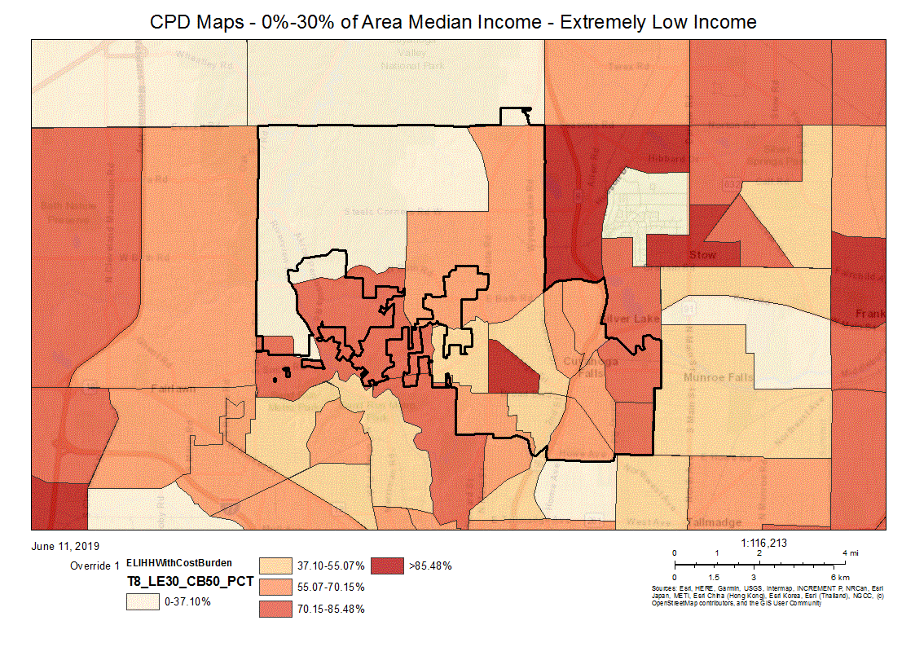
CPD Maps - 0%-30% of Area Median Income - Extremely Low Income

30%-50% of Area Median Income
Housing Problems | Has one or more of four housing problems | Has none of the four housing problems | Household has no/negative income, but none of the other housing problems
Jurisdiction as a whole | 1,755 | 755 | 0
White | 1,515 | 720 | 0
Black / African American | 70 | 10 | 0
Asian | 40 | 0 | 0
American Indian, Alaska Native | 0 | 0 | 0
Pacific Islander | 0 | 0 | 0
Hispanic | 120 | 20 | 0
Table 14 - Disproportionally Greater Need 30 - 50% AMI
Data Source: | 2011-2015 CHAS

*The four housing problems are:
1. Lacks complete kitchen facilities, 2. Lacks complete plumbing facilities, 3. More than one person per room, 4.Cost Burden greater than 30%

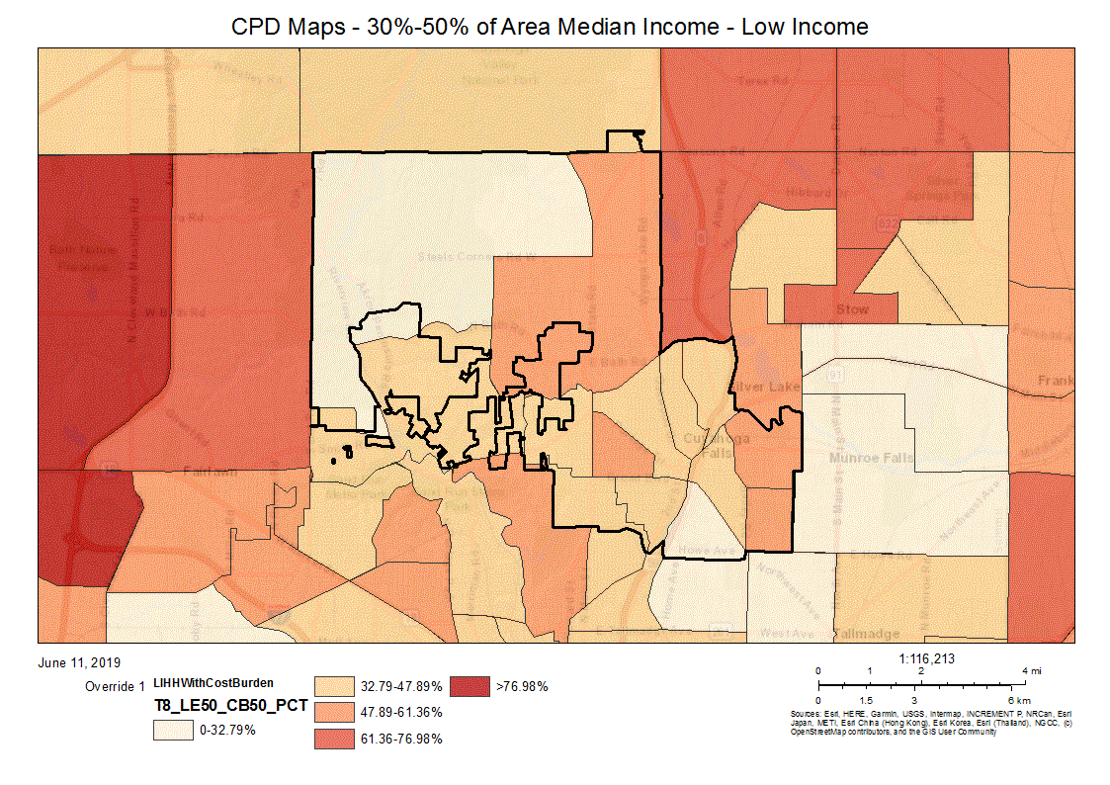
CPD Maps - 30%-50% of Area Median Income - Low Income

50%-80% of Area Median Income
Housing Problems | Has one or more of four housing problems | Has none of the four housing problems | Household has no/negative income, but none of the other housing problems
Jurisdiction as a whole | 1,330 | 2,350 | 0
White | 1,235 | 2,220 | 0
Black / African American | 45 | 35 | 0
Asian | 10 | 10 | 0
American Indian, Alaska Native | 0 | 0 | 0
Pacific Islander | 0 | 0 | 0
Hispanic | 35 | 80 | 0
Table 15 - Disproportionally Greater Need 50 - 80% AMI
Data Source: | 2011-2015 CHAS

*The four housing problems are:
1. Lacks complete kitchen facilities, 2. Lacks complete plumbing facilities, 3. More than one person per room, 4.Cost Burden greater than 30%
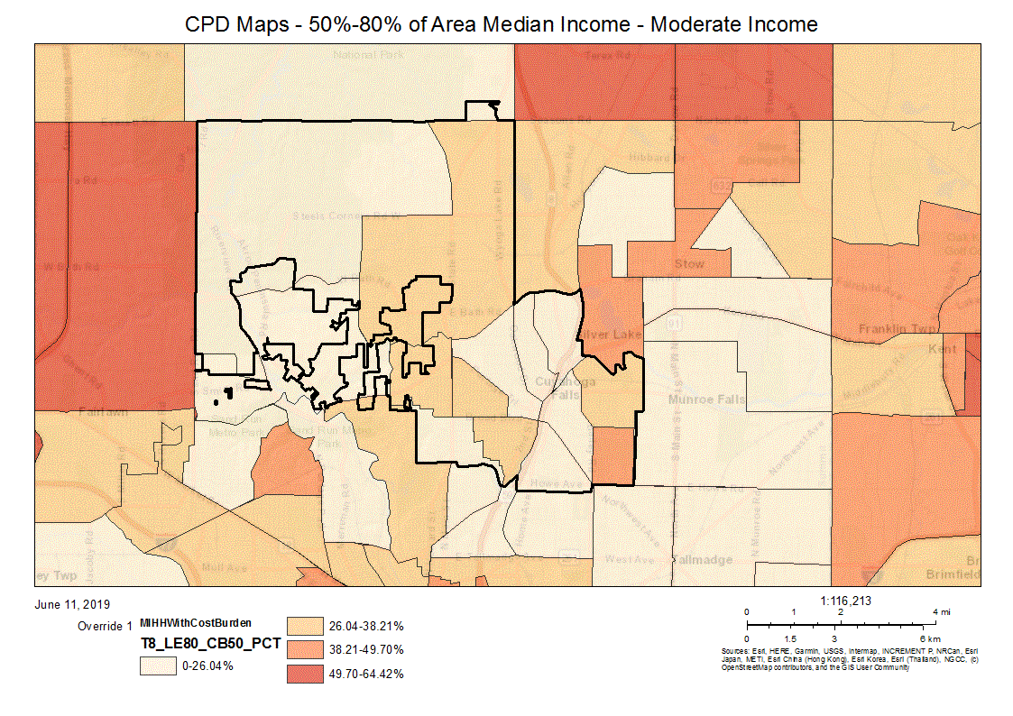
CPD Maps - 50%-80% of Area Median Income - Moderate Income
80%-100% of Area Median Income
Housing Problems | Has one or more of four housing problems | Has none of the four housing problems | Household has no/negative income, but none of the other housing problems
Jurisdiction as a whole | 395 | 2,025 | 0
White | 355 | 1,985 | 0
Black / African American | 10 | 20 | 0
Asian | 0 | 0 | 0
American Indian, Alaska Native | 0 | 0 | 0
Pacific Islander | 0 | 0 | 0
Hispanic | 20 | 25 | 0
Table 16 - Disproportionally Greater Need 80 - 100% AMI
Data Source: | 2011-2015 CHAS

*The four housing problems are:
1. Lacks complete kitchen facilities, 2. Lacks complete plumbing facilities, 3. More than one person per room, 4.Cost Burden greater than 30%
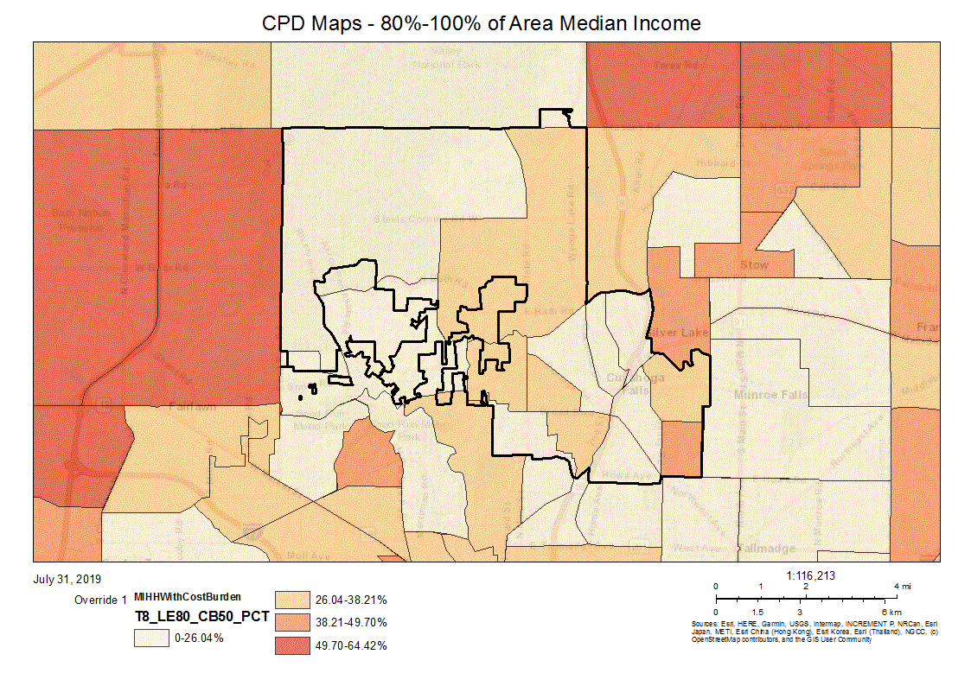
CPD Maps - 80%-100% of Area Median Income
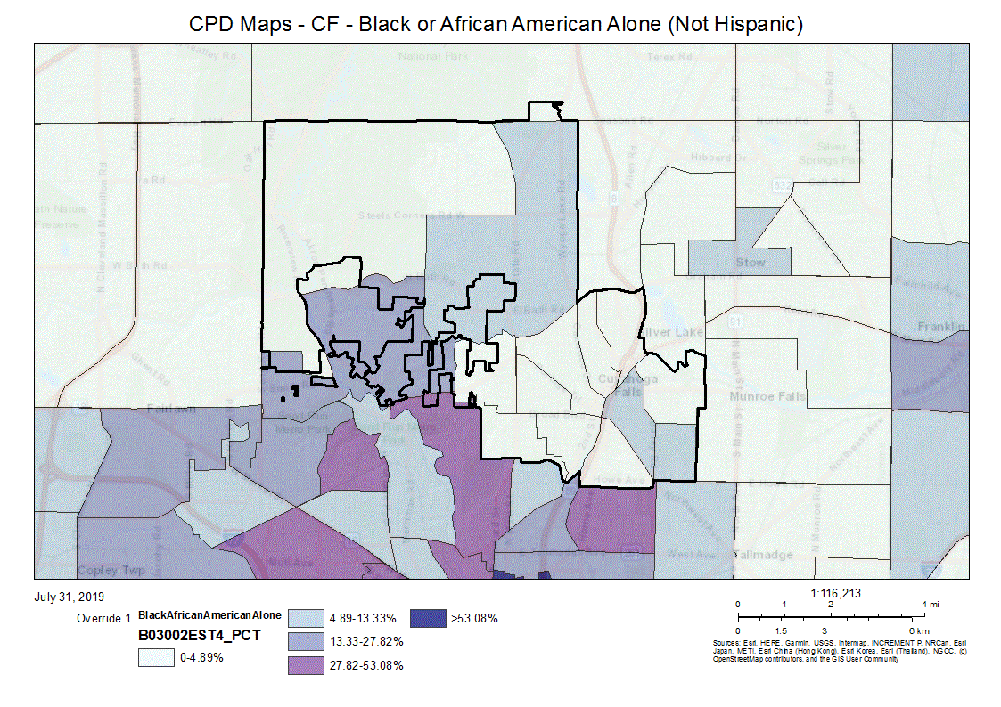
CPD Maps - CF Residents - Black or African American Alone (Not Hispanic)
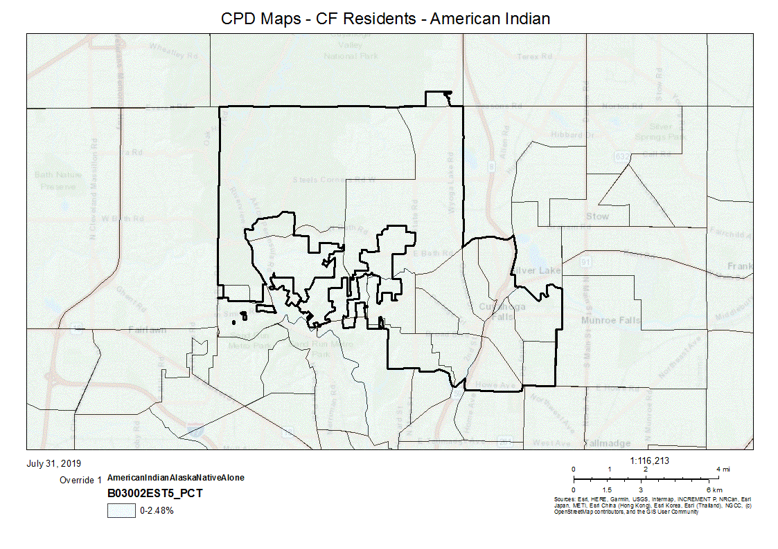
CPD Maps - CF Residents - American Indian Alone (Not Hispanic)
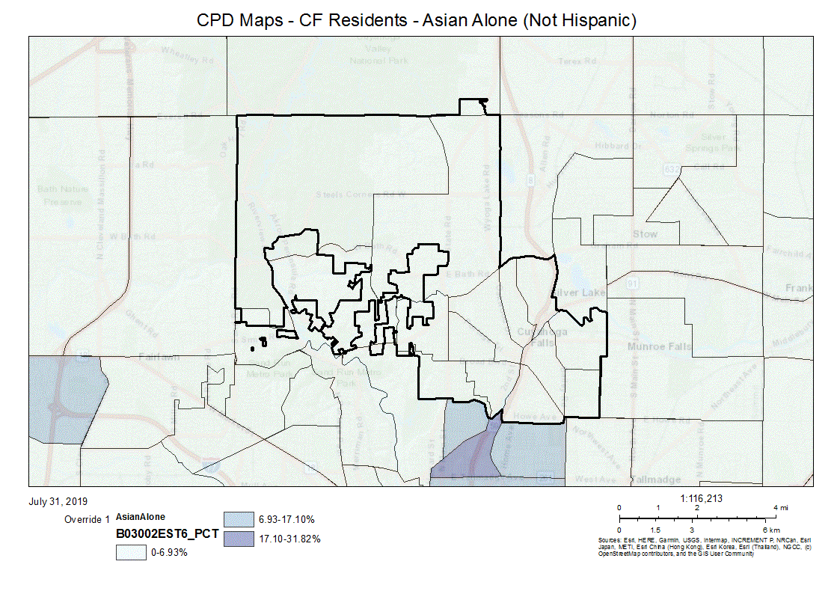
CPD Maps - CF Residents - Asian Alone (Not Hispanic)
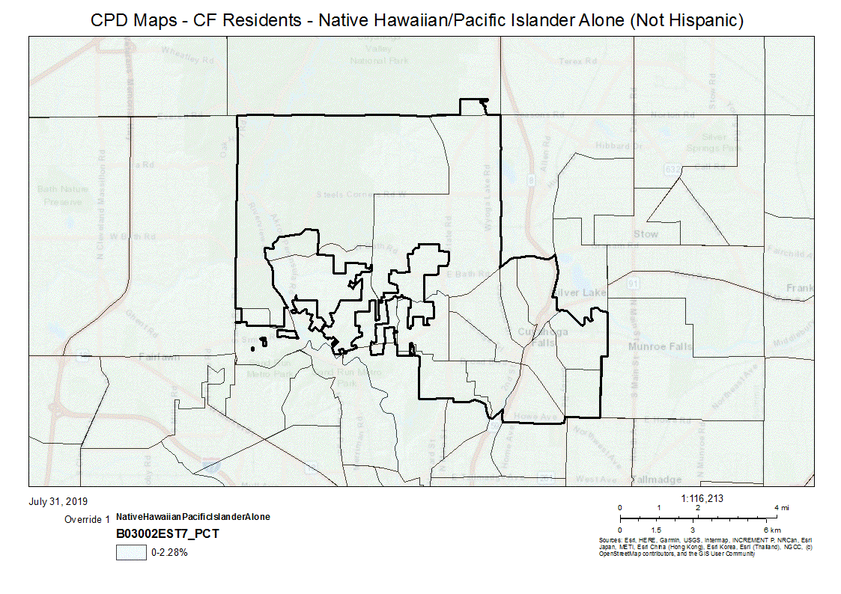
CPD Maps - CF Residents - Native Hawaiian/Pacific Islander Alone (Not Hispanic)
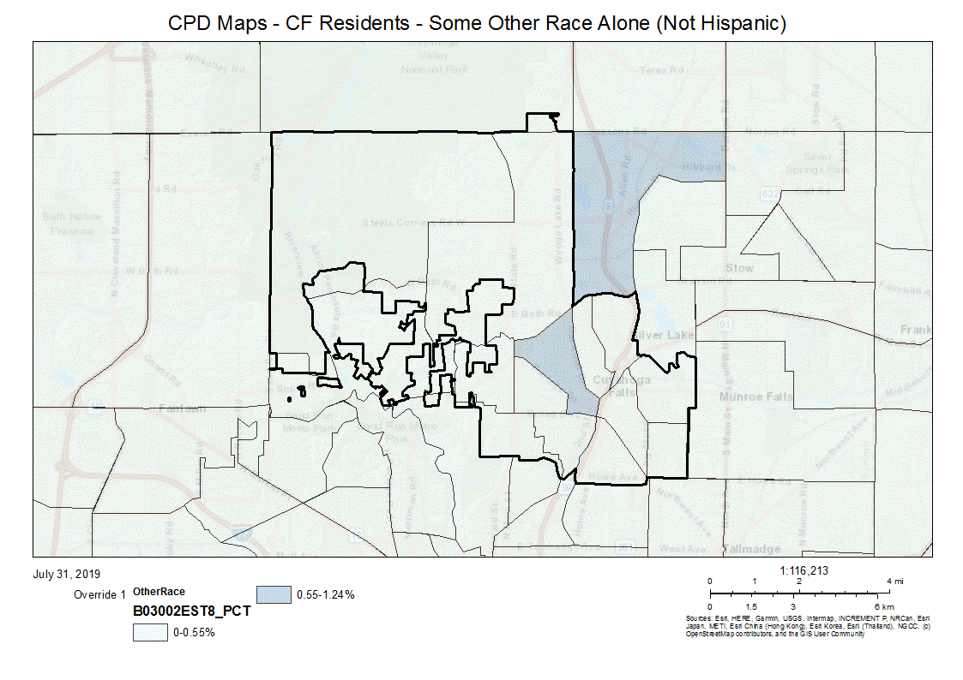
CPD Maps - CF Residents - Some Other Race Alone (Not Hispanic)
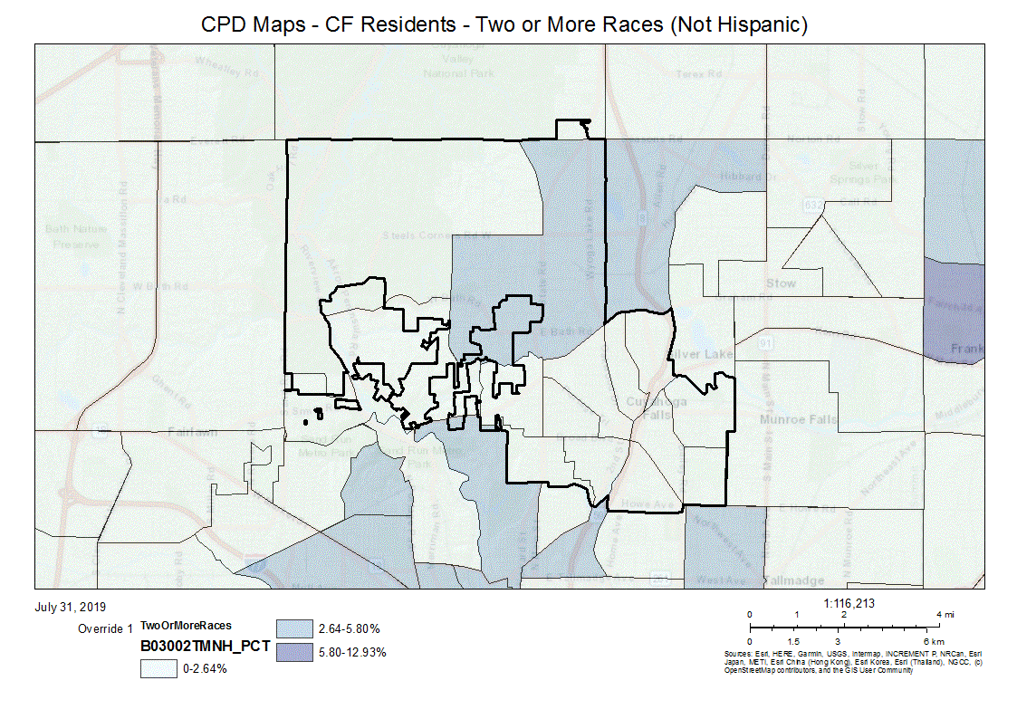
CPD Maps - CF Residents - Two or More Races (Not Hispanic)
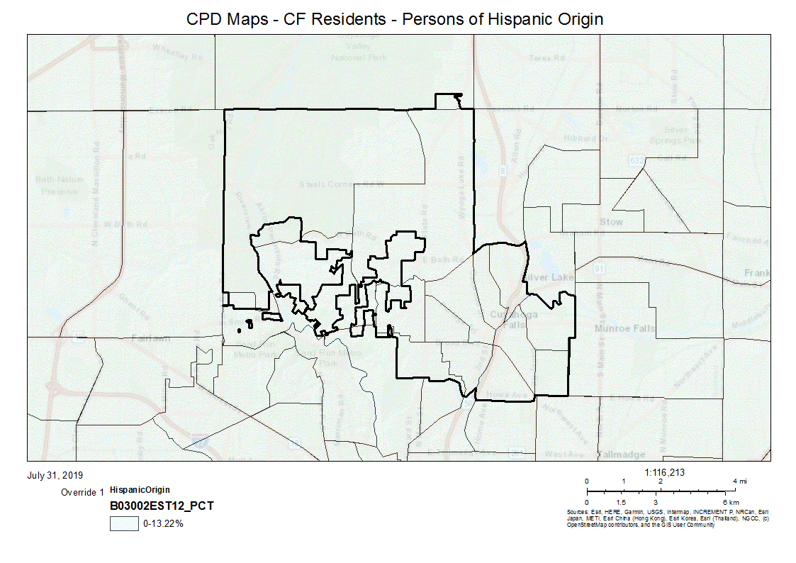
CPD Maps - CF Residents - Persons of Hispanic Origin
Discussion
The preceding tables illustrate the number of households having 1 or more of 4 housing problems by Area Median Income, Race, and Ethnicity. The 4 housing problems are:
- Lacks complete kitchen facilities;
- Lacks complete plumbing facilities;
- More than 1 person per room, and
- Cost burden greater than 30%.
A category of persons having a disproportionately greater need exists when the percentage of persons in a category of need who are members of a particular racial or ethnic group is at least 10 percentage points higher than the percentage of persons in a category as a whole.
In the 0 - 30% of Area Median Income group, of the homes having 1 or more of the 4 housing problems:
- the Jurisdiction as a whole had 71%;
- Whites had 71%
- Black/African Americans had 70%
- Asians had 100%
- American Indian, Alaskan Native 100%
- Hispanics had 29%
Asians, American Indian and Alaskan Natives have the greatest need in the 0 - 30% of Area Median Income Group.
In the 30 - 50% of Area Median Income group, of the homes having 1 or more of the 4 housing problems:
- the jurisdiction as a whole had 70%;
- Whites had 68%;
- Black/African Americans had 88%
- Asians had 100%, and
- Hispanics had 86%.
Black/African American, Asians and Hispanics have the greatest need in the 30 - 50% of Area Median Income Group.
In the 50 -80% of Area Median Income group, of the homes having 1 or more of the 4 housing problems:
- the jurisdiction as a whole had 36%;
- Whites had 36%;
- Black/African Americans had 56%;
- Asians had 50%, and
- Hispanics had 30%.
Black/African American and Asians have the greatest need in the 50 - 80% of Area Median Income Group.
In the 80 - 100% of Area Median Income group, of the homes having 1 or more of the 4 housing problems;
- the jurisdiction as a whole had 16%;
- Whites had 15%;
- Black/African Americans had 33%, and
- Asians had 0%.
- Hispanics had 44%.
Black/African American and Hispanics have the greatest need in the 80 - 100% of Area Median Income Group.

NA-20 Disproportionately Greater Need: Severe Housing Problems – 91.205 (b)(2)
Assess the need of any racial or ethnic group that has disproportionately greater need in comparison to the needs of that category of need as a whole.
Introduction
The following information will be reflected in the regional analysis of Impediments to Fair Housing Choice which will be submitted with the 2020 Action Plan. Participation in the regional analysis was supported by FHEO. See attachment RE: Analysis of Impediments.
A disproportionately greater number of severe housing problems occurs when a particular racial/ethnic group has at least a 10% or greater of needs than the needs of the population as a whole.
According to the 2010 Census, the total population of the City of Cuyahoga Falls was 49,652. Of this total:
- 91.6% were White;
- 4.4% were Black/African American;
- 1.7% were Asian;
- 0.2% were American Indian/Alaskan Native;
- 0.0% were Pacific Islander;
- 1.4% were Other, and
- 1.9% were Hispanic.

0%-30% of Area Median Income
Severe Housing Problems* | Has one or more of four housing problems | Has none of the four housing problems | Household has no/negative income, but none of the other housing problems
Jurisdiction as a whole | 1,575 | 885 | 215
White | 1,370 | 730 | 190
Black / African American | 135 | 80 | 0
Asian | 25 | 0 | 0
American Indian, Alaska Native | 0 | 50 | 0
Pacific Islander | 0 | 0 | 0
Hispanic | 0 | 25 | 10
Table 17 – Severe Housing Problems 0 - 30% AMI
Data Source: | 2011-2015 CHAS

*The four severe housing problems are:
1. Lacks complete kitchen facilities, 2. Lacks complete plumbing facilities, 3. More than 1.5 persons per room, 4.Cost Burden over 50%

30%-50% of Area Median Income
Severe Housing Problems* | Has one or more of four housing problems | Has none of the four housing problems | Household has no/negative income, but none of the other housing problems
Jurisdiction as a whole | 705 | 1,805 | 0
White | 690 | 1,545 | 0
Black / African American | 0 | 85 | 0
Asian | 4 | 35 | 0
American Indian, Alaska Native | 0 | 0 | 0
Pacific Islander | 0 | 0 | 0
Hispanic | 10 | 130 | 0
Table 18 – Severe Housing Problems 30 - 50% AMI
Data Source: | 2011-2015 CHAS

*The four severe housing problems are:
1. Lacks complete kitchen facilities, 2. Lacks complete plumbing facilities, 3. More than 1.5 persons per room, 4.Cost Burden over 50%

50%-80% of Area Median Income
Severe Housing Problems* | Has one or more of four housing problems | Has none of the four housing problems | Household has no/negative income, but none of the other housing problems
Jurisdiction as a whole | 220 | 3,465 | 0
White | 210 | 3,240 | 0
Black / African American | 0 | 80 | 0
Asian | 10 | 10 | 0
American Indian, Alaska Native | 0 | 0 | 0
Pacific Islander | 0 | 0 | 0
Hispanic | 0 | 115 | 0
Table 19 – Severe Housing Problems 50 - 80% AMI
Data Source: | 2011-2015 CHAS

*The four severe housing problems are:
1. Lacks complete kitchen facilities, 2. Lacks complete plumbing facilities, 3. More than 1.5 persons per room, 4.Cost Burden over 50%

80%-100% of Area Median Income
Severe Housing Problems* | Has one or more of four housing problems | Has none of the four housing problems | Household has no/negative income, but none of the other housing problems
Jurisdiction as a whole | 60 | 2,355 | 0
White | 40 | 2,300 | 0
Black / African American | 10 | 20 | 0
Asian | 0 | 0 | 0
American Indian, Alaska Native | 0 | 0 | 0
Pacific Islander | 0 | 0 | 0
Hispanic | 10 | 35 | 0
Table 20 – Severe Housing Problems 80 - 100% AMI
Data Source: | 2011-2015 CHAS

*The four severe housing problems are:
1. Lacks complete kitchen facilities, 2. Lacks complete plumbing facilities, 3. More than 1.5 persons per room, 4.Cost Burden over 50%

Discussion
The preceding tables illustrate the number of households having 1 or more of 4 severe housing problems by Area Median Income (AMI), Race, and Ethnicity. The 4 housing problems are:
- Lacks complete kitchen facilities,
- Lacks complete plumbing facilities,
- More than one person per room,
- Cost burden greater than 50%.
A category of persons having a disproportionately greater need exists when the percentage of persons in a category of need who are members of a particular racial or ethnic group is at least 10% higher than the percentage of persons in a category as a whole.
0 - 30% of AMI, of the homes having 1 or more of the 4 housing problems:
- the jurisdiction as a whole had 59%;
- Whites had 60%;
- Black/African Americans had 63%;
- Asians had 100%, and
- Hispanics had 0%.
Asians have a disproportionately greater need than any other racial or ethnic group of persons in the 0 - 30% of AMI category as a whole.
30 -50% of AMI, of the homes having 1 or more of the 4 severe housing problems:
- the jurisdiction as a whole had 28%:
- Whites had 31%;
- Black/African Americans had 0%;
- Asians had 10%, and
- Hispanics had 7%.
There was no disproportionately greater need by any racial or ethnic group of persons in the 30 - 50% of AMI category.
50 - 80% of AMI, of the homes having 1 or more of the 4 severe housing problems:
- the jurisdiction as a whole had 6%:
- Whites had 6%;
- Black/African Americans had 0%
- Asians had 1%; and
- Hispanics had 0%.
There was no disproportionately greater need by any racial or ethnic group of persons in the 50 - 80% of AMI category.

80% - 100%% of AMI, of the homes having 1 or more of the 4 severe housing problems:
- the jurisdiction as a whole had 2%:
- Whites had 2%;
- Black/African Americans had 3%, and
- Asians had 2%; and
- Hispanics had 0%.
There was no disproportionately greater need by any racial or ethnic group of persons in the 80 - 100% of AMI category.

NA-25 Disproportionately Greater Need: Housing Cost Burdens – 91.205 (b)(2)
Assess the need of any racial or ethnic group that has disproportionately greater need in comparison to the needs of that category of need as a whole.
Introduction:
The following information will be reflected in the regional analysis of Impediments to Fair Housing Choice which will be submitted with the 2020 Action Plan. Participation in the regional analysis was supported by FHEO. See attachment RE: Analysis of Impediments.
According to the 2010 Census, the total population of the City of Cuyahoga Falls was 49,652. Of this total:
- 91.6% were White;
- 4.4% were Black/African American;
- 1.7% were Asian;
- 0.2% were American Indian/Alaskan Native;
- 0.0% were Pacific Islander;
- 1.4% were Other, and
- 1.9% were Hispanic.
The Department of Housing and Urban Development (HUD) defines Cost Burden in 2 ways:
- A household that is cost burdened is one that pays more than 30% of their gross monthly income on their housing expense, including utilities, and
- A household that is severely cost burdened is one that pays more than 50% of their gross monthly income on housing expenses.
The following table depicts the number of households, broken down by race and ethnicity that pay:
- less than 30%,
- between 30-50%, and
- more than 50%
of their gross income on monthly housing expenses.
Housing Cost Burden
Housing Cost Burden | <=30% | 30-50% | >50% | No / negative income (not computed)
Jurisdiction as a whole | 15,885 | 3,100 | 2,460 | 215
White | 14,925 | 2,690 | 2,235 | 190
Black / African American | 395 | 130 | 135 | 0
Asian | 215 | 35 | 30 | 0
American Indian, Alaska Native | 0 | 50 | 0 | 0
Pacific Islander | 0 | 0 | 0 | 0
Hispanic | 295 | 165 | 10 | 10
Table 21 – Greater Need: Housing Cost Burdens AMI
Data Source: | 2011-2015 CHAS

Discussion:
According to the housing cost burden table, there are 21,660 households in the City of Cuyahoga Falls jurisdiction. Of these households:
- 73% are paying less than 30% of their gross income on monthly housing costs;
- 14% are paying between 30-50%, and
- 11% are paying more than 50% of their gross income on monthly housing costs.
- 1% Negative income (not computed)
Of the 73% of the total jurisdiction that are paying less than 30% of their gross income on monthly housing expenses, the percentage within each racial category paying less than 30% are as follows:
- 94% White;
- 2% Black/African American;
- 1% Asian;
- 0% American Indian/Native Alaskan;
- 0% Pacific Islander, and
- 2% Hispanic.
Of the 14% of the total jurisdiction that are paying between 30-50% of their gross income on monthly housing expenses:
- 87% are White;
- 4% are Black/African American;
- 1% are Asian;
- 2% are American Indian/Alaskan Native
- 0% are Pacific Islander, and
- 5% are Hispanic.
Of the 11% of the total jurisdiction that are paying more than 50% of their gross income on monthly housing expenses:
- 91% are White;
- 5% are Black/African American;
- 1% are Asian
- 0% are American Indian/Alaskan Native
- 0% are Pacific Islander, and
- 0.4% are Hispanic.

NA-30 Disproportionately Greater Need: Discussion – 91.205(b)(2)
Are there any Income categories in which a racial or ethnic group has disproportionately greater need than the needs of that income category as a whole?
A disproportionately greater need is when the needs of the subgroup are 10% or more, greater than the needs of the income category as a whole. Asians consistently showed a disproportionate need compared to the population as a whole. In terms of Housing Problems, 90% of the Asian population within the 0-30% AMI have a disproportionate need. Similarly, in terms of Severe Housing Problems and Housing Cost Burden Asians at 0-30% AMI show a disproportionately greater need than the needs of the other racial or ethnic groups within the 0-30% income category as a whole.
The 50-80% AMI and the 80-100% there does not appear to be a racial or ethnic group that has a disproportionately greater need than the needs of those income categories as a whole.
According to the 2010 Census, the Asian population grew faster than any other racial group in the United States between 2000 and 2010. Nationwide, this was observed for the population who reported Asian alone, as well as for the population who reported Asian alone or in combination with another race. On a local level, the 2010 Census shows that less than 1% of Summit County's total population is Asian and within the City of Cuyahoga Falls 1.2% of the population reports as being Asian alone.
If they have needs not identified above, what are those needs?
Many of these households have difficulty maintaining their homes. These households may need assistance with minor home repairs, ADA modifications, weatherization, and septic and well repairs or replacement (if applicable).
Are any of those racial or ethnic groups located in specific areas or neighborhoods in your community?
As reported in the previous Consolidated Plan, Housing Inspectors within the Department of Development indicate that there are in fact "pockets" of Asians, particularly people from Nepal, who tend to live in the area along Second, Fourth and Broad Streets as well as in the area surrounding Second and Northland Streets.

NA-35 Public Housing – 91.205(b)
Introduction
City of Cuyahoga Falls, Development Department staff met with representatives from the local Public Housing Authority, Akron Metropolitan Housing Authority (AMHA), to discuss public housing issues.
Akron Metropolitan Housing Authority (AMHA) is committed to building stronger neighborhoods by providing quality housing options and professional services for eligible residents of Summit County in partnership with the greater community. AMHA continues to rank in the top 2-3% of housing authorities in the United States, having been recertified, for the 5th consecutive year, as a High Performing Public Housing Agency.
AMHA has a total of 15 Senior Housing apartment complexes, with a total of 1,940 units. Only 1 of these Senior Housing apartment complexes is located within the City of Cuyahoga Falls jurisdiction. The 185 unit Sutliff Building. Of 20 Family Housing complexes that contain 2,211 Family Housing units, only 3 complexes, the 125 unit Honey Locust complex, the 105 unit Maplewood Villa & Garden and the 12 unit Lobello Lane are located within the City of Cuyahoga Falls jurisdiction. Of the AMHA scattered site units, only 5 units, located in Cuyahoga Falls, are within the County of Summit jurisdiction.
Totals in Use
Program Type
 | Certificate | Mod-Rehab | Public Housing | Vouchers
 |  |  |  | Total | Project -based | Tenant -based | Special Purpose Voucher
 |  |  |  |  |  |  | Veterans Affairs Supportive Housing | Family Unification Program | Disabled  *
# of units vouchers in use | 0 | 8 | 3,996 | 4,818 | 176 | 4,574 | 48 | 5 | 0

Table 22 - Public Housing by Program Type
*includes Non-Elderly Disabled, Mainstream One-Year, Mainstream Five-year, and Nursing Home Transition

Data Source: | PIC (PIH Information Center)

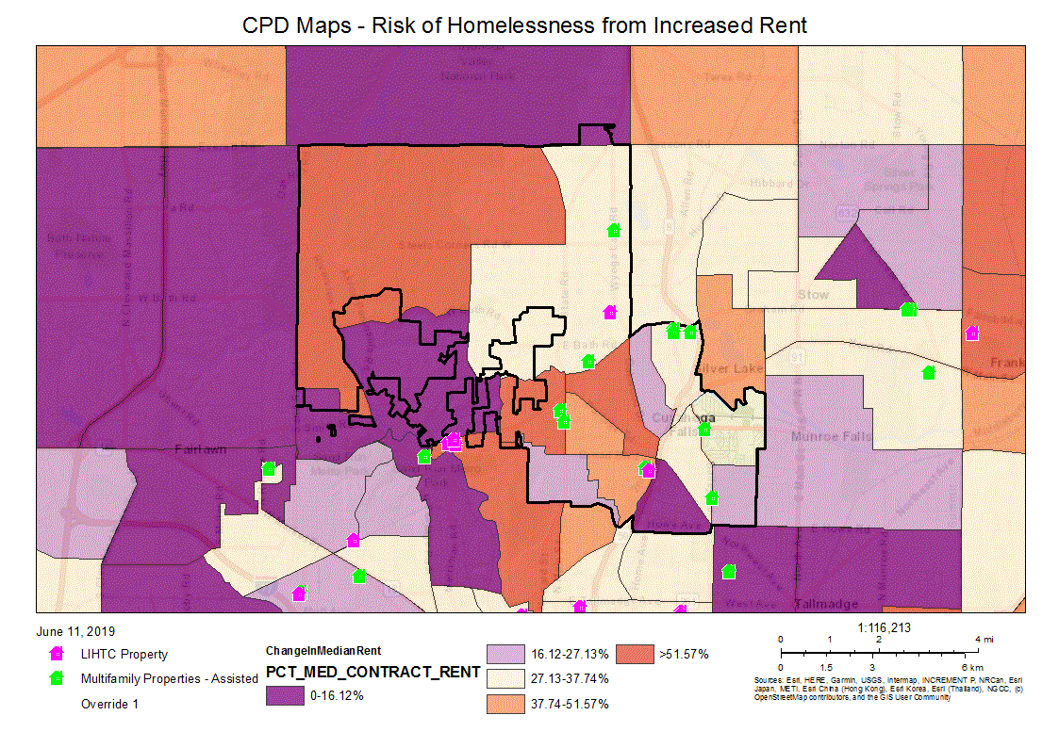
CPD Maps - AMHA Public Housing Developments
CPD Maps - Risk of Homelessness from Increased Rent
Characteristics of Residents

Program Type
 | Certificate | Mod-Rehab | Public Housing | Vouchers
 |  |  |  | Total | Project -based | Tenant -based | Special Purpose Voucher
 |  |  |  |  |  |  | Veterans Affairs Supportive Housing | Family Unification Program
Average Annual Income | 0 | 5,871 | 9,871 | 9,233 | 12,018 | 9,136 | 5,863 | 6,790
Average length of stay | 0 | 5 | 6 | 5 | 3 | 5 | 0 | 15
Average Household size | 0 | 3 | 2 | 2 | 1 | 2 | 1 | 1
# Homeless at admission | 0 | 0 | 0 | 0 | 0 | 0 | 0 | 0
# of Elderly Program Participants (>62) | 0 | 1 | 1,006 | 651 | 89 | 559 | 2 | 1
# of Disabled Families | 0 | 1 | 1,028 | 1,227 | 44 | 1,151 | 25 | 3
# of Families requesting accessibility features | 0 | 8 | 3,996 | 4,818 | 176 | 4,574 | 48 | 5
# of HIV/AIDS program participants | 0 | 0 | 0 | 0 | 0 | 0 | 0 | 0
# of DV victims | 0 | 0 | 0 | 0 | 0 | 0 | 0 | 0
Table 23 – Characteristics of Public Housing Residents by Program Type

Data Source: | PIC (PIH Information Center)

Race of Residents
Program Type
Race | Certificate | Mod-Rehab | Public Housing | Vouchers
 |  |  |  | Total | Project -based | Tenant -based | Special Purpose Voucher
 |  |  |  |  |  |  | Veterans Affairs Supportive Housing | Family Unification Program | Disabled  *
White | 0 | 0 | 1,675 | 1,717 | 93 | 1,587 | 28 | 4 | 0
Black/African American | 0 | 8 | 2,260 | 3,079 | 83 | 2,965 | 20 | 1 | 0
Asian | 0 | 0 | 55 | 15 | 0 | 15 | 0 | 0 | 0
American Indian/Alaska Native | 0 | 0 | 5 | 6 | 0 | 6 | 0 | 0 | 0
Pacific Islander | 0 | 0 | 1 | 1 | 0 | 1 | 0 | 0 | 0
Other | 0 | 0 | 0 | 0 | 0 | 0 | 0 | 0 | 0

*includes Non-Elderly Disabled, Mainstream One-Year, Mainstream Five-year, and Nursing Home Transition
Table 24 – Race of Public Housing Residents by Program Type
Data Source: | PIC (PIH Information Center)

Ethnicity of Residents
Program Type
Ethnicity | Certificate | Mod-Rehab | Public Housing | Vouchers
 |  |  |  | Total | Project -based | Tenant -based | Special Purpose Voucher
 |  |  |  |  |  |  | Veterans Affairs Supportive Housing | Family Unification Program | Disabled  *
Hispanic | 0 | 1 | 27 | 39 | 2 | 37 | 0 | 0 | 0
Not Hispanic | 0 | 7 | 3,969 | 4,779 | 174 | 4,537 | 48 | 5 | 0

*includes Non-Elderly Disabled, Mainstream One-Year, Mainstream Five-year, and Nursing Home Transition
Table 25 – Ethnicity of Public Housing Residents by Program Type
Data Source: | PIC (PIH Information Center)

Section 504 Needs Assessment: Describe the needs of public housing tenants and applicants on the waiting list for accessible units:
Public housing tenants and applicants on the wait list for accessible units require walk-in or roll-in showers, grab bars in the tub/shower area, and lower countertops in the kitchen and bathrooms.
Most immediate needs of residents of Public Housing and Housing Choice voucher holders
According to the local public housing authority, Akron Metropolitan Housing Authority (AMHA), they have 8,642 applicants on the wait list for Family Low Income Public Housing (LIPH) units, 954 on the wait list for Senior Low Income Public Housing (LIPH) units, and 19,521 on the wait list for the Housing Choice Voucher Program (HCVP). The majority of these applicants, across all programs, are extremely low income.
Nearly 3/4 of the applicants for the Family LIPH are waiting for units with 2 bedrooms or less. Fewer than 1,000 need a 3 bedroom unit, and fewer than 150 need 4 or more bedrooms. The Senior LIPH are available as 1 and 2 bedroom units. Of the 954 applicants on the Senior LIPH wait list, only 78 are requesting a 2 bedroom unit. Approximately 3/4 of the families on the HCVP wait list have applied for units with 2 or fewer bedrooms.
According to the April 1, 2013 through July 31, 2014 Resident Characteristics Report, 80% of AMHA residents are extremely low income, having household incomes at or below 30% of the Area Median Income. 24% are elderly; 14% are elderly and disabled; 28% are non-elderly and disabled. 39% are non-elderly, non-disabled and have children; 3% are non-elderly, disabled with children.
How do these needs compare to the housing needs of the population at large
Households assisted through AMHA programs are much lower income than the population at large. Their need for assistance is much greater. Families with children need assistance with basic necessities such as food, clothing, medical care, and utilities.
Discussion
During the preparation of the 2019 - 2023 Five Year Consolidated Strategic Plan, the City of Cuyahoga Falls, Development Department staff met with AMHA staff to discuss AMHA's plans and concerns for the next 5 years. Based on funding cuts, AMHA’s goal is to maintain their current housing stock. Their Capital fund for public housing is at its lowest level in 20 years, which makes it difficult to plan for new projects or major repairs. The Voucher side of their housing programs was hit the hardest. AMHA has been able to renew all existing vouchers, but their administration funds have been cut to 60% of their formula – the lowest level ever.
AMHA is working to create a new strategic plan for better alignment of services. They are looking to expand early childhood education and workforce development by partnering with Jobs and Family Services and others in the community. They plan to prioritize 12 to 15 agencies that they work with the most and develop those relationships further. Another focus will be succession planning, since 40% of AMHA employees are eligible for retirement which would lead to a loss of institutional knowledge. AMHA is assessing their personnel and putting together a management plan and determining who would be best suited to fill vacant positions.
NOTE: The information contained in the tables within this section is auto-populated by the Department of Housing and Urban Development (HUD). The information contained in the narratives was provided by the Akron Metropolitan Housing Authority (AMHA).

NA-40 Homeless Needs Assessment – 91.205(c)
Introduction:
The City of Cuyahoga Falls and the Summit County Continuum of Care represent a broad collaborative effort to provide housing and supportive service to homeless clients creating the CoC system network. Homeless providers meet on a regular basis to develop strategies to further enhance the local CoC system thru review and collaboration by providing homeless prevention, emergency, transitional, rapid re-housing, and permanent supportive housing to homeless individuals, families, and special needs populations.
The CoC Committee evaluates the needs in the community and identifies existing gaps. The Continuum of Care system provides the homeless with not only shelter, but supportive services to equip them with the tools necessary to assist them in overcoming this difficult period in their lives. CoC agencies are working closely to develop a communitywide central intake to encompass all homeless assistance systems. As part of this process, the City of Akron and the CoC has developed and use a system-wide common assessment tool for all homeless assistance systems and entry-points. The implementation of a centralized intake system streamlines the entry process and opens doors for homeless clients. With an established centralized intake system the CoC identifies system-wide barriers to entry in the CoC and work with CoC partners to address common barriers the homeless face when entering the system.
Screening tools are also in place to make determinations on client needs. The use of screening tools allows case managers to establish the immediate needs of the client, available resources, and housing options. This process allows case managers to make referrals to the appropriate service providers as determined by the initial screening. As the CoC develops a coordinated central intake system for our clients, members will develop a common screening tool for all front door and non-front door agencies.
For homeless prevention and rapid re-housing services the CoC has developed and utilizes a common screening tool during intake. The Home Again Housing Resource Specialists determines client eligibility for homeless prevention or rapid re-housing services. Clients are then referred to the appropriate service providing agency. Home Again partner agencies have established working relationships with area agencies that serve the homeless and clients at imminent risk of losing their housing.
Homeless Needs Assessment
Population | Estimate the # of persons experiencing homelessness on a given night |  | Estimate the # experiencing homelessness each year | Estimate the # becoming homeless each year | Estimate the # exiting homelessness each year | Estimate the # of days persons experience homelessness
 | Sheltered | Unsheltered
Persons in Households with Adult(s) and Child(ren) | 0 | 35 | 0 | 0 | 0 | 0
Persons in Households with Only Children | 0 | 14 | 0 | 0 | 0 | 0
Persons in Households with Only Adults | 115 | 315 | 0 | 0 | 0 | 0
Chronically Homeless Individuals | 8 | 38 | 0 | 0 | 0 | 0
Chronically Homeless Families | 0 | 0 | 0 | 0 | 0 | 0
Veterans | 8 | 56 | 0 | 0 | 0 | 0
Unaccompanied Child | 6 | 38 | 0 | 0 | 0 | 0
Persons with HIV | 3 | 1 | 0 | 0 | 0 | 0
Table 26 - Homeless Needs Assessment

Alternate Data Source Name:
Annual COC-HMIS PIT Count

Data Source Comments:

Indicate if the homeless population is: | Has No Rural Homeless

If data is not available for the categories "number of persons becoming and exiting homelessness each year," and "number of days that persons experience homelessness," describe these categories for each homeless population type (including chronically homeless individuals and families, families with children, veterans and their families, and unaccompanied youth):
Data from the National Alliance to End Homelessness suggests that 587 individuals are homeless on a given night. In the Summit County Jurisdiction, 10.8 persons may end up homeless per 10,000 of the general population.

Nature and Extent of Homelessness: (Optional)
Race: | Sheltered: | Unsheltered (optional)
White | 242 | 78
Black or African American | 194 | 39
Asian | 2 | 0
American Indian or Alaska Native | 1 | 5
Pacific Islander | 1 | 1
Ethnicity: | Sheltered: | Unsheltered (optional)
Hispanic | 3 | 5
Not Hispanic | 451 | 128

Alternate Data Source Name:
Annual COC-HMIS PIT Count

Data Source Comments:

Estimate the number and type of families in need of housing assistance for families with children and the families of veterans.
The 2018 Point-in-Time (PIT) Count estimated that there were a total of 587 overall homeless individuals on January 30, 2018. According to the PIT Count for 2018, 125 families were homeless, 64 homeless Veterans and 38 chronically homeless individuals counted on January 30, 2018.

Describe the Nature and Extent of Homelessness by Racial and Ethnic Group.
In the Summit County CoC Jurisdiction:
- 98.6% of the homeless population is of Non-Hispanic/Non-Latino Ethnicity.
- 39.7% of the homeless population are Black or African-American.
- 54.5% of the homeless population are white.
- 0.00% of the homeless population are Asian.
- 0.01% of the homeless population are American Indian or Alaska Native.
- 0.00% of the homeless population are Native Hawaiian or Other Pacific Islander.
- 0.04% of the homeless population are of Multiple Races.

Describe the Nature and Extent of Unsheltered and Sheltered Homelessness.
In the Summit County CoC Jurisdiction, 587 total persons were homeless in 2018. Of those that were homeless in 2018, 77.3% were either in Emergency or Transitional shelters. Of the 587 homeless, 133 total persons or 22.7% remained unsheltered.
Discussion:
There are several reasons for homelessness which the City of Cuyahoga Falls and CoC will strive to alleviate wherever possible. More than any other time, there is a lack of housing that low income people can afford. Without housing options, people face eviction, instability and homelessness. Low income households often do not earn enough to pay for food, clothing, transportation and a place to call home. Health and homelessness are inextricably linked. Health problems can cause a person's homelessness as well as be exacerbated by the experience. Housing is key to addressing the health needs of people experiencing homelessness. Many survivors of domestic violence become homeless when leaving an abusive relationship. And most minority groups in the United States (though not representative of the Summit County CoC) experience homelessness at higher rates than whites, and make up a disproportionate share of the homeless population.
Information gathered from endhomelessness.org
The City of Cuyahoga Falls works hard to help keeps its population from becoming homeless, through public services, housing rehabilitation and job creation/retention through economic development. The City of Cuyahoga Falls will continue to participate and work closely with the CoC to help those who are already homeless, find solutions that help them re-establish homes and be able to keep them.

NA-45 Non-Homeless Special Needs Assessment - 91.205 (b,d)
Introduction:
The needs of non-homeless populations, such as the elderly, persons with disabilities (mental, physical and developmental), persons with alcohol or drug addictions, dually diagnosed persons, battered women and their children, and/or persons with HIV/AIDS and their families, are addressed by the various agencies identified throughout this report.

Describe the characteristics of special needs populations in your community:
Elderly - The Department of Housing and Urban Development (HUD) defines individuals who are age 62 and over as elderly. According to the 2017 American Community Survey, there were 9774 elderly residing in the City of Cuyahoga Falls jurisdiction, of which 567 (5.8%) had household incomes at or below the poverty level estimate. Approximately one third of the elderly population has hearing, vision, cognitive, ambulatory, self-care, or independent living difficulties.
Disabled - HUD defines a disabled individual as, "any person who has a physical or mental impairment that substantially limits one or more major life activities; has a record of such impairment; or is regarded as having such an impairment." These impairments include the following: hearing, mobility and visual impairments, chronic alcoholism, chronic mental illness, AIDS, AIDS Related Complex, and mental retardation that substantially limits one or more major life activities. Major life activities include walking, talking, and hearing, seeing, breathing, learning, performing manual tasks, and caring for oneself. According to the 2017 American Community Survey, there are an estimated 5,867 (12% of the jurisdiction's total population of 49,272).
Veterans - The HUD definition of a veteran is someone who "has served on active duty in the Armed Forces of the United States. This does not include inactive military reserves or the National Guard unless the person was called up to active duty." According to 2017 American Community Survey data there were approximately 3,115 veterans living in Cuyahoga Falls. Of the 3,115, veterans living in the City of Cuyahoga Falls, 95.6% are male; 4.6% are female.
Chronic Substance Abusers - Chronic substance abuse can be defined as alcohol abuse and/or drug abuse that is habitual abuse to the extent that the abuse substantially injures a person's health or substantially interferes with his or her social or economic functioning. According to the 2018 Summit County Point in Time Count, there are 80 homeless persons with chronic substance abuse issues.
Victims of Domestic Violence - 1 in every 4 women will experience domestic violence in her lifetime, with females who are 20-24 years of age at the greatest risk for intimate partner violence. In addition to physical abuse, many of these victims of physical violence have also experienced psychological abuse.
What are the housing and supportive service needs of these populations and how are these needs determined?
The housing needs of special populations such as the elderly, persons with disabilities (mental, physical and developmental), persons with alcohol or drug additions, dually diagnosed persons, battered women and their children and/or persons with HIV/AIDS and their families are addressed by the various agencies identified throughout this report. Various federal, state and local funds are available to these agencies for the construction of housing, but often the high cost of construction appropriate for facilities (for special needs groups) requires additional financial assistance.
Discuss the size and characteristics of the population with HIV/AIDS and their families within the Eligible Metropolitan Statistical Area:
As of June 30, 2018, data from the State of Ohio Department of Health show that there are 965 reported cases of individuals with HIV/AIDS in Summit County. The Community AIDS Network offices outreach, supportive services and housing options for persons with HIV/AIDS. Housing Facilities include a Micah House (transitional housing) and two permanent supportive housing units that service 25 individuals and up to 5 families.
Community AIDS Network also works closely with Violet’s Cupboard to identify those with HIV/AIDS. Assistance includes food and medical supplies. Cuyahoga Falls residents in need may utilize either facility.
Discussion:
Agencies are experiencing an increase in the need for services and facilities and a decline in local state and federal funding. As a result there has been a rise in demand for Cuyahoga Falls' CDBG funds over the past few years. Staff capacity is also a significant obstacle to meeting underserved needs. Other factors include, zoning restrictions and NIMBYism.

NA-50 Non-Housing Community Development Needs – 91.215 (f)
Describe the jurisdiction’s need for Public Facilities:
The City of Cuyahoga Falls is rich in public facilities. The Natatorium, Quirk Cultural Center and the Riverfront Center are just a few of the amenities provided to residents of Cuyahoga Falls. At this time, there is not a great need for additional public facilities within the jurisdiction. As in the previous Consolidation Plan, the City of Cuyahoga Falls continues to have a need for storm water and infrastructure improvements as well as the redevelopment and/or rehabilitation of affordable housing. Supporting economic development opportunities, particularly those that create new jobs and efforts to revitalize the downtown area are also important.
How were these needs determined?
Needs were determined by using a variety of informational sources, including, but not limited to:
- CHAS Data
- US Census Data
- Surveys posted on the City's website
- Representatives from non-profit and housing agencies
- Public meetings
- Input from local elected officials and staff from the development department and other City departments.

Describe the jurisdiction’s need for Public Improvements:
Public improvements are the City's highest need overall. Cuyahoga Falls needs to replace aging waterlines and many of the public roads are in need of repair. Residents have lodged numerous complaints about the need for improvement, construction and/or reconstruction of older public roads, as well as the need for sidewalks. The City also has significant issues with storm water drainage and subsequent flooding.

How were these needs determined?
Needs were determined by using a variety of informational sources, including, but not limited to:
- CHAS Data
- US Census Data
- Surveys posted on the City's website
- Representatives from non-profit and housing agencies
- Public meetings
- Input from local elected officials and staff from the development, service, engineering and other City departments.

Describe the jurisdiction’s need for Public Services:
Assistance in the areas of affordable housing, supportive services and assistance for seniors were identified as categories of need for public services.
Assisting residents with emergency shelter is one of the biggest needs in the County as discussed in the homeless sections of the Plan. Assistance for seniors is needed in many areas such as affordable medications and care. An increase in case management would be helpful for seniors as well. This Action Plan period the City will again provide snow removal to lower income seniors.
How were these needs determined?
Needs were determined by using a variety of informational sources, including, but not limited to:
- CHAS Data
- US Census Data
- Surveys posted on the City's website
- Representatives from non-profit and housing agencies
- Public meetings
- Input from local elected officials and staff from the development department.

Housing Market Analysis

MA-05 Overview
Housing Market Analysis Overview:
According to the 2013-2017 American Community Survey 5-Year Estimates, there are approximately 23,562 residential properties located within the City of Cuyahoga Falls. Of these, nearly 74% (17,459) were built before 1979, and 64% (15,080) of these units are single unit, detached structures.
Most housing units located within the City of Cuyahoga Falls are owner-occupied (63%). These units are predominantly (96%) 3 or more bedroom units. There are a total of 8,162 rental units located within the City. The majority of these units have 2 bedrooms.

MA-10 Number of Housing Units – 91.210(a)&(b)(2)
Introduction
According to the 2017 American Community Survey data, there are approximately 23,859 residential properties located within the City of Cuyahoga Falls. Of these, nearly 74% (17,463) were built before 1979, and 64% (15,091) of these units are single unit, detached structures.
Most housing units located within the City of Cuyahoga Falls are owner-occupied (63.6%). These units are predominantly (96%) 3 or more bedroom units. There are a total of 8,162 rental units located within the jurisdiction. The majority of these units have 2 or more bedrooms.
All residential properties by number of units
Property Type | Number | %
1-unit detached structure | 15,105 | 65%
1-unit, attached structure | 1,520 | 6%
2-4 units | 1,810 | 8%
5-19 units | 2,175 | 9%
20 or more units | 2,600 | 11%
Mobile Home, boat, RV, van, etc | 180 | 1%
Total | 23,390 | 100%
Table 27 – Residential Properties by Unit Number
Data Source: | 2011-2015 ACS

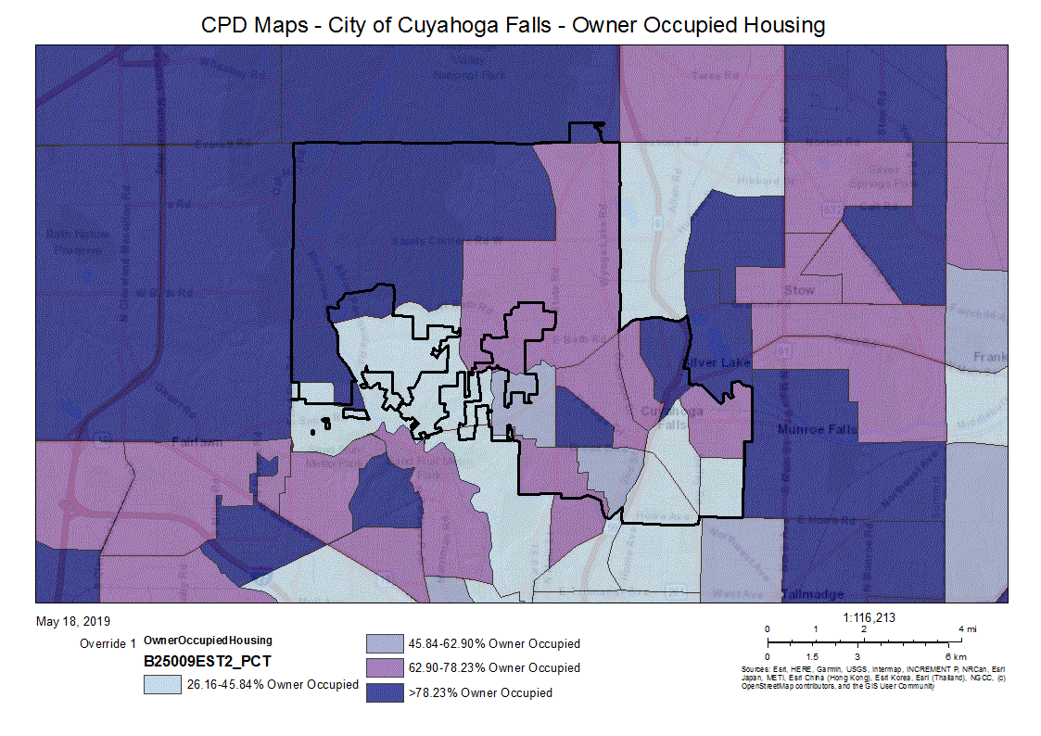
CPD Maps - City of Cuyahoga Falls - Owner Occupied Housing
Unit Size by Tenure
 | Owners |  | Renters
 | Number | % | Number | %
No bedroom | 20 | 0% | 325 | 4%
1 bedroom | 185 | 1% | 2,570 | 30%
2 bedrooms | 2,550 | 19% | 3,615 | 43%
3 or more bedrooms | 10,460 | 79% | 1,930 | 23%
Total | 13,215 | 99% | 8,440 | 100%
Table 28 – Unit Size by Tenure
Data Source: | 2011-2015 ACS

Describe the number and targeting (income level/type of family served) of units assisted with federal, state, and local programs.
Within the city of Cuyahoga Falls, there are 197 subsidized family units, owned and operated by AMHA:
- 12 units at the Lobello Lane Apartments, on Prange Drive;
- 125 units at the Honey Locust Apartments, on Prange Drive, and
- 60 units at the Maplewood Gardens Apartments, on Hardman Drive.
Additionally, the City of Cuyahoga Falls has 1 AMHA owned and operated Subsidized apartment complex for seniors and/or disabled individuals.
- 185 units at the Ray C. Sutliff Towers, on 2nd Street;
Provide an assessment of units expected to be lost from the affordable housing inventory for any reason, such as expiration of Section 8 contracts.
The Akron Metropolitan Housing Authority (AMHA), is the local public housing authority serving the residents of the City of Cuyahoga Falls. AMHA does not anticipate the loss of any Section 8 contracts.
Does the availability of housing units meet the needs of the population?
As in most communities, the availability of housing units for very low income persons is not adequate. This is demonstrated by waiting lists for the AMHA’s rental units, as well as for homeless beds, transitional and supportive housing. These needs are being further analyzed as noted above.
Describe the need for specific types of housing:
There is a significant need for more affordable housing both in public and assisted housing and single-family rental units throughout Cuyahoga Falls. Additionally, there is a need for additional substantially rehabilitated single family homes and public and assisted housing units in the City.
Discussion
The thousands of individuals on the wait lists for Akron Metropolitan Housing Authority (AMHA) housing reveal a great need for more subsidized and affordable housing.
NOTE: The information contained in the tables within this section was auto-populated by the Department of Housing and Urban Development (HUD). The information contained in the narratives was provided by the Akron Metropolitan Housing Authority (AMHA).

MA-15 Housing Market Analysis: Cost of Housing - 91.210(a)
Introduction
As documented in the ACS tables, the 2015 median household income was $50,832, an increase of $8,569, which is 16.9%, since 2000 ($42,263). As illustrated in the Fair Market Rents by Unit Bedrooms from 2000 to 2015, the increase in Area Median Incomes (16.9%) did not keep pace with the increase in fair market rents (23.2% to 37.2%), depending on number of bedrooms).
Families paying more than 30% of their gross income for housing are considered cost burdened and may have difficulty affording necessities such as food, clothing, transportation and medical care. Families paying more than 50% of their gross income for housing are considered severely cost burdened. Nationwide, an estimated 12 million renter and homeowner households pay more than 50% of their annual incomes for housing. A family with one full-time worker earning the minimum wage cannot afford the local fair-market rent for a 2 bedroom apartment anywhere in the United States.
Cost Burdened: In the County of Summit jurisdiction, homeowners were nearly twice as likely as renters to pay more than 50% of their gross income for housing, and more than twice as likely to pay more than 30% of their gross income for housing.
Housing Problems - There are 4 housing problems identified in the CHAS data:
- Housing unit lacks complete kitchen facilities;
- Housing unit lacks complete plumbing facilities;
- Household is overcrowded; and
- Household is cost burdened.
A household is said to have a housing problem if they have 1 or more of any of these 4 problems. As illustrated in the following tables, County of Summit jurisdiction renters are two and a half times more likely than homeowners to have substandard housing, twice as likely to experience severe overcrowding, and twice as likely to experience overcrowding.
Cost of Housing
 | Base Year: 2009 | Most Recent Year: 2015 | % Change
Median Home Value | 128,200 | 118,700 | (7%)
Median Contract Rent | 598 | 680 | 14%
Table 29 – Cost of Housing

Data Source: | 2005-2009 ACS (Base Year), 2011-2015 ACS (Most Recent Year)

Rent Paid | Number | %
Less than $500 | 1,670 | 19.8%
$500-999 | 6,240 | 74.0%
$1,000-1,499 | 345 | 4.1%
$1,500-1,999 | 80 | 1.0%
$2,000 or more | 100 | 1.2%
Total | 8,435 | 100.0%
Table 30 - Rent Paid
Data Source: | 2011-2015 ACS

Housing Affordability
% Units affordable to Households earning | Renter | Owner
30% HAMFI | 635 | No Data
50% HAMFI | 2,010 | 1,235
80% HAMFI | 4,945 | 3,835
100% HAMFI | No Data | 5,515
Total | 7,590 | 10,585
Table 31 – Housing Affordability
Data Source: | 2011-2015 CHAS

Monthly Rent
Monthly Rent ($) | Efficiency (no bedroom) | 1 Bedroom | 2 Bedroom | 3 Bedroom | 4 Bedroom
Fair Market Rent | 0 | 0 | 0 | 0 | 0
High HOME Rent | 0 | 0 | 0 | 0 | 0
Low HOME Rent | 0 | 0 | 0 | 0 | 0
Table 32 – Monthly Rent

Data Source Comments:

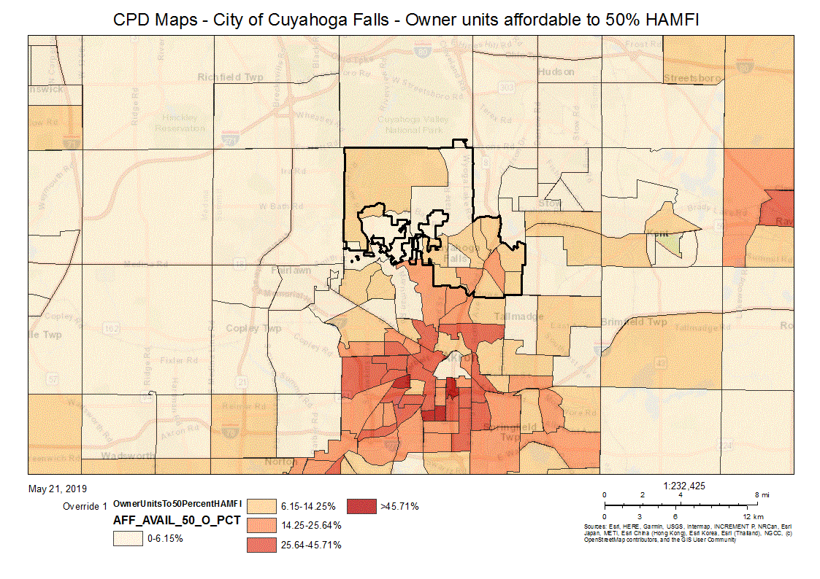
CPD Maps - City of Cuyahoga Falls - Owner units affordable to 50% HAMFI

Is there sufficient housing for households at all income levels?
As illustrated by the Housing Cost Burden map, many residents of the City of Cuyahoga Falls are paying more than 30% of their household income for housing. The greatest need is for affordable housing for the extremely low- and low-income homeowners and renters. As is evident in the Owner units affordable to 50% HAMFI map, 0.00 - 6.15% of owner units are affordable to low-income homeowners in a third of the City.
The lengthy wait lists and wait times (see section NA-35 Public Housing) document a great need for affordable housing for the extremely low- and low-income residents of the City.
How is affordability of housing likely to change considering changes to home values and/or rents?
According to ACS data between 2008-2012 and 2013-2017, Median House Value dollars decreased overall by .32%, showing that our local housing market is still rebounding from the Great Recession and foreclosure crisis.
Despite the decrease in home values, rental rates as discussed have continued to increase, possibly in response to the greater demand for rental housing precipitated by the foreclosure crisis. The rental rates have resulted in an even greater shortage of affordable housing.
How do HOME rents / Fair Market Rent compare to Area Median Rent? How might this impact your strategy to produce or preserve affordable housing?
According to the National Low Income Housing Coalition:
Across Ohio, there is a shortage of rental homes affordable and available to extremely low income households (ELI), whose incomes are at or below the poverty guideline or 30% of their median income (AMI). Many of these households are severely cost burdened, spending more than half of their income on housing. Severely cost burdened poor households are more likely than other renters to sacrifice other necessities like healthy food and healthcare to pay the rent, and to experience unstable housing situations like evictions.
In the Akron MSA, which Cuyahoga Falls is a part of, the Fair Market Rent (FMR) for a 2 bedroom apartment is $826.00 as of 2018. The annual income needed to afford a 2 bedroom apartment is $33,040. The local estimated renter median household income is $29,468. The rent affordable at minimum wage is $432 a month.
In Akron MSA as well as Summit County, Minimum wage is $8.30. The Renter would need to earn $15.25 per hour in order to afford the FMR for a 2-bedroom apartment. At minimum wage ($8.30), the earner must work 77 hours per week, 52 weeks per year.
Although the City of Cuyahoga Falls, Development Department does not produce affordable rental units at this time, the City is focused on job creation through economic development. It is the City's hope that full-time positions aimed at low-mod individuals, prospectively earning higher than the minimum wage, will help to alleviate some of the current cost burdens for local residents.
Discussion
The recovery from the recession and housing market collapse has been very slow. The lack of affordable housing and the number of renters and homeowners who are cost-burdened are increasing. The wait lists for public, section 8, and Housing Choice Voucher units far exceed the supply. The Akron Metropolitan Housing Authority (AMHA) reports that due to cuts to their funding, their goal is to maintain their current housing stock because their Capital fund for public housing is at its lowest level in 20 years, which makes it difficult to plan for new projects or major repairs. They also reported their administrative budget for the Housing Choice Voucher program was hit the hardest it has been cut to 60% of their formula the lowest level ever.

MA-20 Housing Market Analysis: Condition of Housing – 91.210(a)
Introduction
The charts below outline the existing housing units within the City of Cuyahoga Falls. The first chart outlines the condition of units based on the number of units and percentage of units that are owner occupied versus the number of units and percentage of units that are renter-occupied. The second chart shows the number of units and percentage of owner-occupied units versus the number of renter-occupied units and percentage of renter-occupied units and year in which the units were built. The third chart shows the number of owner-occupied and renter-occupied units built prior to 1980. The third chart also shows the owner-occupied units and renter-occupied units built prior to 1980 with children present.
Definitions
The City of Cuyahoga Falls' definition of a unit in substandard condition would be one that has too many safety and health concerns to address with the smaller amount of CDBG funds allocated per housing unit. A unit in substandard condition, but suitable for rehabilitation would be a unit that we would be able to address safety and health concerns with the CDBG allocated funds.
Condition of Units
Condition of Units | Owner-Occupied |  | Renter-Occupied
 | Number | % | Number | %
With one selected Condition | 2,450 | 19% | 3,180 | 38%
With two selected Conditions | 15 | 0% | 55 | 1%
With three selected Conditions | 0 | 0% | 15 | 0%
With four selected Conditions | 0 | 0% | 0 | 0%
No selected Conditions | 10,750 | 81% | 5,185 | 61%
Total | 13,215 | 100% | 8,435 | 100%
Table 33 - Condition of Units
Data Source: | 2011-2015 ACS

Year Unit Built
Year Unit Built | Owner-Occupied |  | Renter-Occupied
 | Number | % | Number | %
2000 or later | 894 | 7% | 435 | 5%
1980-1999 | 1,805 | 14% | 2,340 | 28%
1950-1979 | 6,170 | 47% | 4,165 | 49%
Before 1950 | 4,350 | 33% | 1,500 | 18%
Total | 13,219 | 101% | 8,440 | 100%
Table 34 – Year Unit Built
Data Source: | 2011-2015 CHAS

Risk of Lead-Based Paint Hazard
Risk of Lead-Based Paint Hazard | Owner-Occupied |  | Renter-Occupied
 | Number | % | Number | %
Total Number of Units Built Before 1980 | 10,520 | 80% | 5,665 | 67%

Housing Units build before 1980 with children present | 724 | 5% | 400 | 5%
Table 35 – Risk of Lead-Based Paint
Data Source: | 2011-2015 ACS (Total Units) 2011-2015 CHAS (Units with Children present)

Vacant Units
 | Suitable for Rehabilitation | Not Suitable for Rehabilitation | Total
Vacant Units | 0 | 0 | 0
Abandoned Vacant Units | 0 | 0 | 0
REO Properties | 0 | 0 | 0
Abandoned REO Properties | 0 | 0 | 0
Table 36 - Vacant Units
Data Source: | 2005-2009 CHAS

Need for Owner and Rental Rehabilitation
Based on the data above, roughly 724 owner-occupied units in the City of Cuyahoga Falls have children and have a risk for lead based paint (LBP) hazards and may need to be abated and rehabilitated. Currently the City of Cuyahoga Falls focuses rehab and lead abatement for owner-occupied housing only.
Estimated Number of Housing Units Occupied by Low or Moderate Income Families with LBP Hazards
Based on the data above, around 1,124 low-to-moderate income households are living in units with Lead Based Paint (LBP) hazards.
Discussion
The City is committed to allocating a significant amount of resources to abate lead based paint (LBP) hazards for our residents and have collaborated with the Summit County Health District to do so this Consolidated Plan period as in the previous period. In addition to collaborating with the Summit County Health Department, the City offers guidance on lead safe practices in conjunction with all home rehabilitation programs. The City will continue to educate its residents on the hazards of lead based paint and utilize lead-safe practices in all of its housing programs.
Individuals living in homes with lead based paint (LBP) hazards may be eligible to receive a 5 year forgivable loan with an average amount of $10,000.00 through the Summit County Public Health District. Individuals who receive assistance from the Summit County Public Health District may also be eligible to receive Healthy Homes assistance. To be eligible, the homeowner must have a child living in the home under the age of 6 or have a child visiting the home more than 6 hours a week or 62 hours a year.

MA-25 Public and Assisted Housing – 91.210(b)
Introduction
The Akron Metropolitan Housing Authority (AMHA) is the only public housing authority located within Summit County. The majority of AMHA units are located in the Cities of Akron, Barberton, and Cuyahoga Falls.
Totals Number of Units
Program Type
 | Certificate | Mod-Rehab | Public Housing | Vouchers
 |  |  |  | Total | Project -based | Tenant -based | Special Purpose Voucher
 |  |  |  |  |  |  | Veterans Affairs Supportive Housing | Family Unification Program | Disabled  *
# of units vouchers available | 0 | 8 | 4,285 | 4,975 | 204 | 4,771 | 229 | 45 | 0
# of accessible units

*includes Non-Elderly Disabled, Mainstream One-Year, Mainstream Five-year, and Nursing Home Transition
Table 37 – Total Number of Units by Program Type
Data Source: | PIC (PIH Information Center)

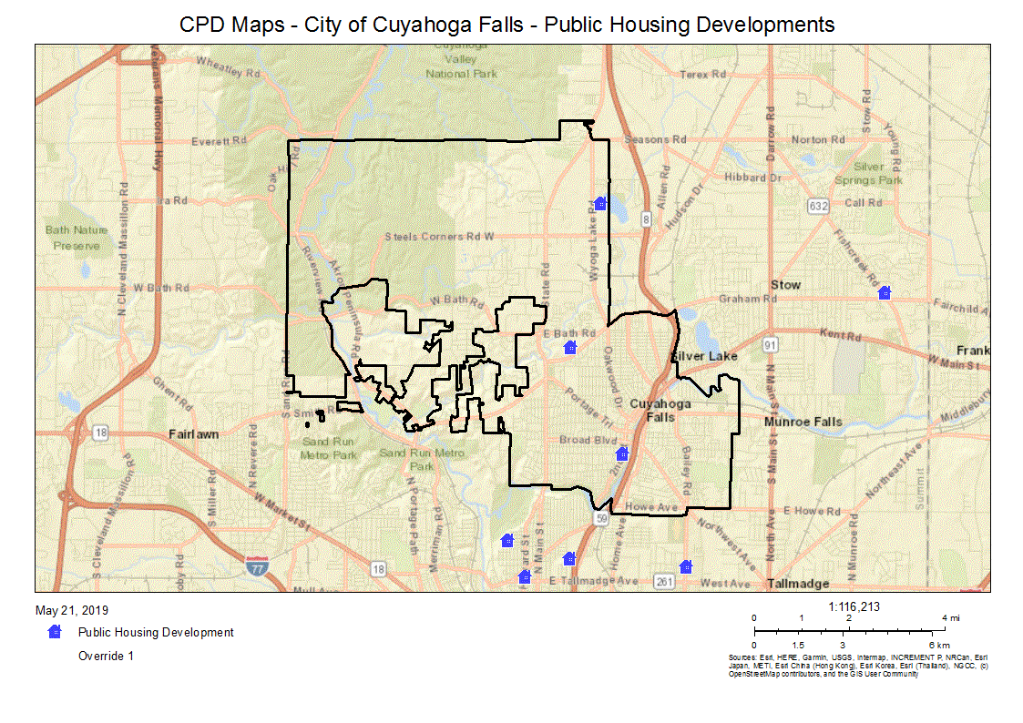
CPD Maps - City of Cuyahoga Falls - Public Housing Developments
Describe the supply of public housing developments:
Describe the number and physical condition of public housing units in the jurisdiction, including those that are participating in an approved Public Housing Agency Plan:

Public Housing Condition
Public Housing Development | Average Inspection Score
Akron Metropolitan Housing Authority currently has a cumulative score of: | 96.36
Table 38 - Public Housing Condition

Describe the restoration and revitalization needs of public housing units in the jurisdiction:
Kitchen and bathroom refurbishment, roofing and infrastructure modernization are the primary needs of AMHA’s aging portfolio.
Describe the public housing agency's strategy for improving the living environment of low- and moderate-income families residing in public housing:
AMHA Resident Services has developed a Strategic Plan to focus on 5 specific areas that will improve the living environment for residents living in affordable housing with AMHA.
Goal 1: Maintain a stable community within AMHA developments.
Goal 2: Encourage economic independence of residents by extending self-sufficiency program elements to all residents, create partnerships to provide a program to develop general works skills and job placement, and provide a transition program to support the advancement of public housing.
Goal 3: Support AMHA residents’ educational achievement.
Goal 4: Enhanced quality of life for residents by targeting health education and services in relation to residents’ needs, provide immediate referral to those with mental health issues and develop a program to maintain seniors in their apartments.
Goal 5: Develop adequate resources to support Resident Services initiatives.
Discussion:
The Akron Metropolitan Housing Authority (AMHA) administers both a public housing and Section 8 housing voucher program. The housing authority has ownership interest in 32 developments and manages 31 projects which contain 4,295 affordable rental units. It also administers 4,975 Section 8 housing vouchers.
According to HUD, AMHA is determined to be a large public housing authority, meaning it manages between 1,250 - 9,999 public housing units. Also according to the Department of Housing and Urban Development, the housing authority is designated as large, meaning it administers 1,250 - 9,999 Section 8 vouchers.
Comparing the housing assistance distribution of AMHA between Public Housing Units (46%) and Section 8 Housing Vouchers (54%) to that of all housing authorities in Ohio, AMHA has a larger proportion of public housing units than the average housing authority. The housing authority’s proportion of Section 8 vouchers under management is larger than the average housing authority in Ohio.
Each year HUD reviews and scores the housing authority’s Section 8 program management based on 14 different criteria. This score is a reflection of how well the housing authority manages the Section 8 wait list, the physical quality of housing assisted with Section 8 and the financial management of the program.
According to their 2019 PHA Five Year and Annual Action Plan, AMHA scored an average of 103% on the Section 8 Management Assessment Program (SEMAP), qualifying them as a high performer. Their PHAS (Public Housing Assessment System) score of 93% also qualifies them as a high performer.
AMHA has an average score that is more than the average Ohio housing authority. Higher SEMAP scores indicate more effective financial management, a smoother waiting list process and higher quality physical conditions at assisted properties (affordablehousingonline.com).
Statistics courtesy of www.akronhousing.org

MA-30 Homeless Facilities and Services – 91.210(c)
Introduction
The Akron/Summit County/Barberton/Cuyahoga Falls community has in place a Continuum of Care that addresses the immediate needs of families and individuals at risk of becoming homeless. Community organizations have developed resource manuals to assist individuals and families in locating appropriate services. Street Cards, or “quick guides” that explain available services to people on the street have been made available at local agencies and libraries.

Facilities and Housing Targeted to Homeless Households
 | Emergency Shelter Beds |  | Transitional Housing Beds | Permanent Supportive Housing Beds
 | Year Round Beds (Current & New) | Voucher / Seasonal / Overflow Beds | Current & New | Current & New | Under Development
Households with Adult(s) and Child(ren) | 86 | 0 | 272 | 31 | 0
Households with Only Adults | 190 | 0 | 319 | 296 | 60
Chronically Homeless Households | 0 | 0 | 0 | 0 | 0
Veterans | 6 | 0 | 36 | 87 | 0
Unaccompanied Youth | 24 | 0 | 5 | 0 | 0
Table 39 - Facilities and Housing Targeted to Homeless Households

Data Source Comments:

Describe mainstream services, such as health, mental health, and employment services to the extent those services are use to complement services targeted to homeless persons
In addition to shelter, an array of services are available at no or very low cost:
- Open M provides a free medical clinic;
- AxessPointe Community Health Center provides low cost medical and dental care with proof of indigence;
- The Akron Community Based Outpatient Clinic, provided by the United States Department of Veterans Affairs, provides Free or low cost medical or dental care for military veterans and their immediate families;
- The Community Health Center offers free services and/or a sliding fee scale to clients with a primary diagnosis of mental health or substance abuse;
- The University of Akron Nursing School offers free medical care through their Mary Gladwin Clinic;
- The Barberton Community Health Clinic offers free medical care, and
- The Alphonso Turner Homeless Outreach Center has a lobby with comfortable seating, showers, laundry facilities and a telephone for homeless individuals to use, and they offer support to those who are homeless and likely in need of mental health services.
List and describe services and facilities that meet the needs of homeless persons, particularly chronically homeless individuals and families, families with children, veterans and their families, and unaccompanied youth. If the services and facilities are listed on screen SP-40 Institutional Delivery Structure or screen MA-35 Special Needs Facilities and Services, describe how these facilities and services specifically address the needs of these populations.
The City of Cuyahoga Falls, in partnership with Continuum of Care, has in place a system of services and housing options that address the immediate needs of families and individuals that are homeless or at risk of becoming homeless. Community organizations have developed resource manuals to assist individuals and families in locating appropriate services.
Homeless Prevention and Rapid Re-Housing
United Way of Summit County, The Salvation Army and H.M. Life Opportunity Services coordinate and implement the homeless prevention rapid re-housing program for the CoC. The Home Again program is available to all individuals and families residing within the CoC Services Area who are currently homeless or at-risk of becoming homeless but for this assistance.
Veterans
AMHA received 60 permanent housing certificates designated specifically for homeless veterans (HUD-VASH). The VA provides case management services to homeless Veterans. All 60 HUD-VASH vouchers are fully utilized. The Commons at Madaline Park, a permanent supportive housing project, will designate 6 units to veterans. In 2013, Valor Home opened its doors providing a 30-bed GPD facility for homeless veterans. CSS received a grant to open a Community Resource and Referral Center (CRRC) Project to outreach to homeless veterans.
Chronically Homeless
Our CoC will continue to work with the VA and Housing Authority to increase the number of vouchers available to the chronically homeless population. HMIS client data will be analyzed to determine housing status and eligibility for classification as chronically homeless. PSH providers will prioritize housing needs/availability to those identified and meeting eligibility criteria as chronically homeless. Partnerships with local developers and supportive service providers will continue to provide housing needs. A key component to any housing project is funding. Creation of PSH beds is only part of the solution. CoC’s must commit to providing coordinated case management services to ensure that clients remain stable and able to maintain housing.
Youth
The Youth Emancipation Task Force, a collaboration between social service agencies and non-profits, focuses on improving the quality of life for youth and young adults. YETF concentrates on housing, employment/education, and health/mental health to develop programs to help young adult’s access resources. Youth Resource Guides are available for emancipated or homeless young adults to access resources. OMCDC and CSB operate housing programs to address homelessness in the 16-21 year old population. Both offer supportive services designed to empower and assist the youth in obtaining employment, continuing their education, and finding permanent housing. OMCDC’s Horizon House offers 16 units of group housing while CSB has a capacity of 20 one-bedroom units for young adults previously in CSB custody. Safe Landing Shelter operates a Street Outreach program providing supportive case management services to youth between the ages of 18-22 who are homeless or at risk of becoming homeless.

MA-35 Special Needs Facilities and Services – 91.210(d)
Introduction
City of Cuyahoga Falls, Development Department staff met with representatives from the local Public Housing Authority, Akron Metropolitan Housing Authority (AMHA), to discuss public housing issues.
Akron Metropolitan Housing Authority (AMHA) is committed to building stronger neighborhoods by providing quality housing options and professional services for eligible residents of Summit County in partnership with the greater community. AMHA continues to rank in the top 2-3% of housing authorities in the United States, having been recertified, for the 5th consecutive year, as a High Performing Public Housing Agency.
AMHA has a total of 15 Senior Housing apartment complexes, with a total of 1,940 units. Only 1 of these Senior Housing apartment complexes is located within the City of Cuyahoga Falls jurisdiction. The 185 unit Sutliff Building. Of 20 Family Housing complexes that contain 2,211 Family Housing units, only 3 complexes, the 125 unit Honey Locust complex, the 105 unit Maplewood Villa & Garden and the 12 unit Lobello Lane are located within the City of Cuyahoga Falls jurisdiction. Of the AMHA scattered site units, only 5 units, located in Cuyahoga Falls, are within the County of Summit jurisdiction.

Including the elderly, frail elderly, persons with disabilities (mental, physical, developmental), persons with alcohol or other drug addictions, persons with HIV/AIDS and their families, public housing residents and any other categories the jurisdiction may specify, and describe their supportive housing needs
Elderly - the elderly and frail elderly may need assistance to "age in place" or remain in their homes, rather than in an assisted living facility. These residents may need ADA accessibility features, such as ramps, grab bars, and nonskid flooring to remain in their homes. They may also need housekeeping, lawn maintenance, and shopping assistance, as well as nutrition and meal preparation. Because many are on a fixed income, they may need financial assistance to pay for food, medicine, medical costs, utilities, or rent.
Disabled - the services required by a disabled individual will vary by disability:
- Wheelchair users may need: Gates which are easy to open and close, with catches that are easy to reach and operate, additional space on parking spaces to transfer from their car to their chair, Accessible toilets, handrails at appropriate heights with views unrestricted by handrails or walls, surfaces which are firm, level and nonslip, and space to turn corners.
- People with Walking Difficulties or Dexterity/Balance Problems may need: level even surfaces on paths, steps with handrails and even treads and risers, minimum gaps in the path surface, and minimum gradients along and across paths.
- Visually Impaired People may need: clear edges to paths, even and clearly marked steps, warning of hazards at head height, even path surfaces, and easy to use catches on gates.
- People with hearing impairment will need smoke detectors and alarms with flashing lights.
Chronic Substance Abusers - in addition to rehabilitation, they may need housing in a group home setting with supportive services, such as counseling, job training, and life skills training.
HIV / AIDS - these individuals may need counseling, or they may need financial assistance for housing, food, utilities, and medical care.
Veterans - in particular homeless veterans and their families, may need housing assistance, including utility assistance, job training, mental health counseling, drug or alcohol counseling, and assistance finding employment.
Victims of Domestic Violence - these individuals may need housing assistance, counseling, job training, childcare, and medical assistance.

Describe programs for ensuring that persons returning from mental and physical health institutions receive appropriate supportive housing
The City of Cuyahoga Falls, Development Department does not oversee any post release programs. Through staff participation in the Continuum of Care, the City of Cuyahoga Falls participates in the creation of policies and procedures to address the needs of these individuals.
Specify the activities that the jurisdiction plans to undertake during the next year to address the housing and supportive services needs identified in accordance with 91.215(e) with respect to persons who are not homeless but have other special needs. Link to one-year goals. 91.315(e)
The City of Cuyahoga Falls, Development Department will address the housing and supportive services needs for persons who are not homeless, but have other special needs through collaboration with and/or funding provided to:
- United Way's 211, for emergency call buttons and 24 hour monitoring provided to elderly and/or disabled individuals;
- Vantage Aging, assists older adults with the challenges associated with remaining in their homes as they age;
- Good Neighbors of Cuyahoga Falls, helping families and individuals with clothing, emergency food and support;
- The County of Summit, Department of Community and Economic Development, for Home Weatherization assistance Program, lowering heating bills by correcting energy deficiencies;
- Neighborhood Development Services, comprehensive rehab of Cuyahoga Falls homes belonging to low to moderate income individuals.
For entitlement/consortia grantees: Specify the activities that the jurisdiction plans to undertake during the next year to address the housing and supportive services needs identified in accordance with 91.215(e) with respect to persons who are not homeless but have other special needs. Link to one-year goals. (91.220(2))

MA-40 Barriers to Affordable Housing – 91.210(e)
Negative Effects of Public Policies on Affordable Housing and Residential Investment
Barriers to affordable housing exist in every community. While some of these barriers can be addressed through legislative or procedural changes, others are very difficult to alter because they are the result of societal, financial, and/or market conditions.
Analysis shows the following barriers to affordable housing exist in the City of Cuyahoga Falls' jurisdiction:
- Limited supply of affordable single-family housing units that make it difficult for low-to moderate-income first-time home buyers to make the transition from renting to homeownership.
- The average price for many of the houses on the market in Cuyahoga Falls ($121,700) are below the national average ($193,500); however, this average price frequently exceeds the affordability level of many low- to moderate-income households.
- Housing rehabilitation is often costly, making it difficult for low- to moderate-income households to afford necessary repairs.
- Provisions within existing local zoning codes that tend to favor conventional site design rather than cluster or planned residential developments, and that require separation of housing types which can hinder the development of mixed use housing. Additionally, provisions that stipulate minimum lot sizes make the development of smaller, more affordable housing difficult.
- Resistance to the development of affordable housing, particularly affordable housing developments. This is frequently labeled as NIMBYism (Not in My Back Yard), and has been the subject of fair housing law for years.
- Cost prohibitive local ordinances for storm water systems, sidewalks, and landscaping that often add unnecessary costs to affordable housing development projects.
- Lack of Transportation or lack of public transportation options has a negative effect on affordable housing location choice.

MA-45 Non-Housing Community Development Assets – 91.215 (f)
Introduction
According to CFR 91.215 (f), if the Jurisdiction seeks assistance under the Community Development Block Grant (CDBG) program, the consolidated plan must provide a concise summary of the Jurisdiction's priority non-housing community development needs eligible for assistance under HUD's community development programs by CDBG eligibility category, in accordance with a table prescribed by HUD. This community development component of the plan must state the Jurisdiction's specific long-term and short-term community development objectives (including economic development activities that create jobs), which must be developed in accordance with the primary objective of the CDBG program to develop viable urban communities by providing decent housing and a suitable living environment and expanding economic opportunities, principally for low-income and moderate-income persons.
The City of Cuyahoga Falls has placed a high importance on economic development projects in its CDBG program. The City has maintained a revolving loan fund, using CDBG dollars in conjunction with private investment, in order to support those businesses looking to create or retain jobs for low-to moderate-income persons in the City of Cuyahoga Falls.
Economic Development Market Analysis
Business Activity
Business by Sector | Number of Workers | Number of Jobs | Share of Workers  % | Share of Jobs  % | Jobs less workers  %
Agriculture, Mining, Oil & Gas Extraction | 53 | 1 | 0 | 0 | 0
Arts, Entertainment, Accommodations | 2,436 | 2,624 | 12 | 15 | 3
Construction | 707 | 318 | 4 | 2 | -2
Education and Health Care Services | 4,122 | 4,172 | 20 | 23 | 3
Finance, Insurance, and Real Estate | 1,207 | 570 | 6 | 3 | -3
Information | 396 | 204 | 2 | 1 | -1
Manufacturing | 2,945 | 3,426 | 15 | 19 | 4
Other Services | 772 | 780 | 4 | 4 | 0
Professional, Scientific, Management Services | 2,602 | 1,493 | 13 | 8 | -5
Public Administration | 0 | 0 | 0 | 0 | 0
Retail Trade | 2,916 | 3,758 | 14 | 21 | 7
Transportation and Warehousing | 694 | 114 | 3 | 1 | -2
Wholesale Trade | 1,303 | 421 | 6 | 2 | -4
Total | 20,153 | 17,881 | -- | -- | --
Table 40 - Business Activity
Data Source: | 2011-2015 ACS (Workers), 2015 Longitudinal Employer-Household Dynamics (Jobs)

Labor Force
Total Population in the Civilian Labor Force | 26,830
Civilian Employed Population 16 years and over | 25,255
Unemployment Rate | 5.85
Unemployment Rate for Ages 16-24 | 19.24
Unemployment Rate for Ages 25-65 | 4.06
Table 41 - Labor Force
Data Source: | 2011-2015 ACS

Occupations by Sector | Number of People
Management, business and financial | 6,105
Farming, fisheries and forestry occupations | 1,300
Service | 2,280
Sales and office | 6,910
Construction, extraction, maintenance and repair | 1,875
Production, transportation and material moving | 1,545
Table 42 – Occupations by Sector
Data Source: | 2011-2015 ACS

Travel Time
Travel Time | Number | Percentage
< 30 Minutes | 17,760 | 73%
30-59 Minutes | 5,410 | 22%
60 or More Minutes | 1,070 | 4%
Total | 24,240 | 100%
Table 43 - Travel Time
Data Source: | 2011-2015 ACS

Education:
Educational Attainment by Employment Status (Population 16 and Older)
Educational Attainment | In Labor Force
 | Civilian Employed | Unemployed | Not in Labor Force
Less than high school graduate | 570 | 145 | 475
High school graduate (includes equivalency) | 6,105 | 400 | 2,050
Some college or Associate's degree | 6,670 | 455 | 1,780
Bachelor's degree or higher | 8,225 | 135 | 1,025
Table 44 - Educational Attainment by Employment Status
Data Source: | 2011-2015 ACS

Educational Attainment by Age
 | Age
 | 18–24 yrs | 25–34 yrs | 35–44 yrs | 45–65 yrs | 65+ yrs
Less than 9th grade | 10 | 25 | 60 | 150 | 395
9th to 12th grade, no diploma | 450 | 220 | 295 | 445 | 740
High school graduate, GED, or alternative | 1,195 | 1,605 | 1,685 | 5,260 | 3,100
Some college, no degree | 935 | 1,540 | 1,310 | 2,915 | 1,665
Associate's degree | 260 | 1,110 | 695 | 1,335 | 255
Bachelor's degree | 525 | 2,405 | 1,705 | 2,560 | 955
Graduate or professional degree | 70 | 950 | 715 | 1,060 | 655
Table 45 - Educational Attainment by Age
Data Source: | 2011-2015 ACS

Educational Attainment – Median Earnings in the Past 12 Months
Educational Attainment | Median Earnings in the Past 12 Months
Less than high school graduate | 16,108
High school graduate (includes equivalency) | 28,266
Some college or Associate's degree | 33,512
Bachelor's degree | 42,875
Graduate or professional degree | 56,205
Table 46 – Median Earnings in the Past 12 Months
Data Source: | 2011-2015 ACS

Based on the Business Activity table above, what are the major employment sectors within your jurisdiction?
The major employment sectors within City of Cuyahoga Falls are Education and health care services, retail trade and manufacturing. The City of Cuyahoga Falls is home to Western Reserve Hospital, one of its largest employers. The City has a large manufacturing corridor along State Road that employs not only Cuyahoga Falls residents but also county wide. The City's retail district includes the new Portage Crossings and the newly reopened Front Street with many boutique stores and restaurants that create both employment, area improvements and beautification flowing into a low mod area of the City.
Describe the workforce and infrastructure needs of the business community:
Workforce needs in the City vary from positions requiring highly skilled technical training such as nurses, pipe fitters, diesel mechanics, machine tool operators and CAD equipment operators to less skilled positions such as drivers, personal and home health aides, sales, maintenance and delivery persons and assembly line workers.
The most consistent requests from businesses regarding workforce are:
- Assistance finding a consistent pool of talented candidates, the “how do I find them?” question.
- Funding to train incumbent workers.
The total civilian labor workforce in the City totals 27,149 of which 25,391 of the employed population are 20 years of age to 65. Due to economic conditions many workers over the age of 65 are still working. Most of the work force drive less than 30 minutes to their employment while 20% drive on average of 30 to 59 minutes. A network of expressways and well-maintained streets surrounds the City making travel time much faster. Navigation throughout the City appears to be sufficient to meet the needs of the workforce; however, maintaining infrastructure is a high priority.
Infrastructure needs within the NEO consortium include the preservation of existing systems as well as their modernization to meet current standards and demands. This includes all types of infrastructure such as roads, public transit, sanitary and storm sewers, and electric, natural gas and water utilities.
The City’s Electric Department are continuously upgrading substations and transmission lines with smart technology to improve efficiency, decrease power outage durations and simplify operations by enabling remote operations.

Describe any major changes that may have an economic impact, such as planned local or regional public or private sector investments or initiatives that have affected or may affect job and business growth opportunities during the planning period. Describe any needs for workforce development, business support or infrastructure these changes may create.
As in all communities the need for economic development activities is paramount to the City’s maintenance and growth and this is no exception in Cuyahoga Falls. The City does not have an abundance of vacant commercial land, which means the City must focus on commercial development on sites within established neighborhoods. The City is striving to rebuild the central core of the community which often constitutes the first step in the regeneration of an older city and subsequently the region. Since the physical fabric of the community is largely intact, the combination of density and a walkable, urban texture with proximity to major institutions and employers creates significant opportunities for regeneration.
A number of public and private sector developments, including cooperative public/private initiatives, are occurring in the City. These include efforts that tie directly to existing industries in Cuyahoga Falls as well as projects seeking to take advantage of growing and future opportunities:
- French Mill Run Phase 2 will create 143 new apartments in 7 buildings across 10 acres. The Developer is putting in a public road with trees and landscaping. Although CDBG was not applied for in this project, the development will create jobs.
- Downtown is booming since the re-opening of Front Street, new businesses are continually opening. There are 2 new restaurants preparing to open, a new brewery, and offices.
- Historic Downtown District businesses along Front Street and Portage Trail are using CDBG funds to give facelifts to old buildings and business signs to draw business. These 2 grants come with job creation requirements.
- Falls Theater built in 1925 is undergoing historic preservation and removal of spot blight. The designated historic landmark will be converted to a mixed use building. Once finished, the building will be sold.
How do the skills and education of the current workforce correspond to employment opportunities in the jurisdiction?
County wide there is a need to increase the educational achievement for young adults entering the workforce. While 34% of the United States population of 25-29 year olds have received a bachelor’s degree or higher, only 30.5% of the same age group in Summit County have reached that level. This disparity reflects income levels. Employees who have bachelor’s degrees earn more than those who do not have a bachelor's degree. In the County, individuals with high school-level degrees earn 55% less than those with bachelor’s degrees, far less than the national average of 41.2%. Those with associate’s degrees or some college earn 36% less than those with bachelor’s degrees in the County, slightly less than the national average of 34.4%. Education and Healthcare is the leading industry sector within Cuyahoga Falls with 23% of the workforce. At 21% of total employment, the retail industry continues to be a strong sector with manufacturing closely following.
Describe any current workforce training initiatives, including those supported by Workforce Investment Boards, community colleges and other organizations. Describe how these efforts will support the jurisdiction's Consolidated Plan.
Ohio Means Jobs of Summit County currently serves as the workforce training hub for the City of Cuyahoga Falls, and supports the following programs:
Income, Education & Workforce Development (IEWD) - Reports through the Social Services Advisory Board. The committee is charged with providing employers a competitive and productive workforce. The committee works to improve the readiness of current and future employees of Summit County, as well as, increasing employers’ understanding of recruitment and retention initiatives. It has created and annually updates a Job Seekers Resource Guide and a Career Mapping Guide, as well as, an Employers Services Guide.
Able-bodied adults receiving OWF assistance are required to participate in a work activity. Ohio Means Jobs/Summit County staff evaluates clients and assigns them to various approved institutions for training and education or classes at the Summit County Center. These assignments aid the client in becoming self-sufficient before their 3 year limit for OWF assistance expires.
Summit County Occupational Preparation Experience (SCOPE) is a supervised assignment for work-required clients that carry out light work projects such as piece work or assembly. This environment is intended to teach clients soft skills, including proper dress, timeliness and effective communication.
Workforce Experience Program (WEP) enables clients to develop work skills that enhance their ability for gainful employment. These training assignments include internships such as volunteer work, hands-on training in a specific skill and placement in an organization.
Kent State University's Small Business Development Center provides technical and business training programs to low and moderate income persons who are business owners or hope to become business owners.
Does your jurisdiction participate in a Comprehensive Economic Development Strategy (CEDS)?
Yes
If so, what economic development initiatives are you undertaking that may be coordinated with the Consolidated Plan? If not, describe other local/regional plans or initiatives that impact economic growth.
The Northeast Four County Planning Organization (NEFCO) was formed in 1974 as a regional council of governments by the elected officials within Portage, Stark, Summit and Wayne Counties. NEFCO, in part, serves as a forum through which local, state and federal planning programs can be effectively coordinated, serving as the entity completing plans to meet requirements of Section 208 of the Federal
Clean Water Act as well as updating the CEDS document in order to meet requirements to maintain its designation as an Economic Development District by the U.S. Department of Commerce, Economic Development Administration (EDA). This designation gives member communities ongoing eligibility for economic assistance programs through the EDA. When projects arise, the City submits projects to NEFCO to be placed on the CEDS for potential EDA funding.
Discussion
The City of Cuyahoga Falls requires that any employers funded with CDBG dollars, post jobs through Ohio Means Jobs of Summit County which supports job training for low to moderate income individuals in the area. Cuyahoga Falls also recommends Akron Score workshops to individuals who have a small business or are seeking to start their own businesses using CDBG funds. Akron Score workshops provide training in writing business plans, marketing techniques and the fundamentals of financial management.

MA-50 Needs and Market Analysis Discussion
Are there areas where households with multiple housing problems are concentrated? (include a definition of "concentration")
Concentrated poverty is defined as the clustering of the residential locations of people with incomes below the relevant poverty threshold. A census tract with 20% poor residents involves a relatively high concentration of poverty; 40% poor is a very high concentration. According to the 2010 Census data, areas where households with multiple housing problems, appear to be concentrated in the lower income census tracts. The CPD Map for Cuyahoga Falls - Extreme Low Income Households indicates that there is a concentration of poverty in Ward 2, located in the neighborhood bordered between Second Street and Broad Boulevard.
Are there any areas in the jurisdiction where racial or ethnic minorities or low-income families are concentrated? (include a definition of "concentration")
The attached CPD Map indicates that of the 3 AMHA low income Housing complexes located in Cuyahoga Falls, Honey Locust & Maplewood Gardens have a higher concentration of minority populations.
According to HUD, an area of racial or ethnic concentration (also called a “minority impacted area”) is defined as where the percentage of persons in a particular race or ethnic group is a least 20 percentage points higher than the percentage of persons in the category for the city as a whole. According to the 2010 Census, it is apparent that the higher concentration of African American residents tend to be located in the northern sections of the City where the public housing complexes are located.
What are the characteristics of the market in these areas/neighborhoods?
The market characteristics in these areas generally include higher minority populations and lower income households with one or more housing problems. The housing stock in these areas is typically older and in many cases in need of rehabilitation.
Are there any community assets in these areas/neighborhoods?
The City of Cuyahoga Falls has numerous assets in the lower income neighborhoods. Such assets include the Cuyahoga Riverfront, beautiful historic churches, major manufacturing industries, hotels, excellent rated schools, a top of the line library, many fine restaurants, several park and recreation opportunities such as hike and bike trails and a historic downtown to name only a few. The City hosts free entertainment all year around for our residents and visitors such as Monday night car shows, Friday and Sunday concerts, Oktoberfest and Festa Italiana festivals, Thursday night outdoor movies at the amphitheater, ice skating and spray fountains.
Other community assets in the areas mentioned above range from affordable housing and affordable rental housing, affordable shopping, fast food restaurants, beautiful parks with wading pools, basketball courts and picnic areas for families. Another asset in the lower income areas are streets lined with sidewalks and beautiful street lighting. The walkable community is on a bus line which is also an amenity residents can enjoy.
Are there other strategic opportunities in any of these areas?
The City will continue to utilize community development funds such as CDBG loans or grants to conduct various programs pertaining to housing rehabilitation, affordable housing, anti-poverty initiatives and infrastructure improvement.
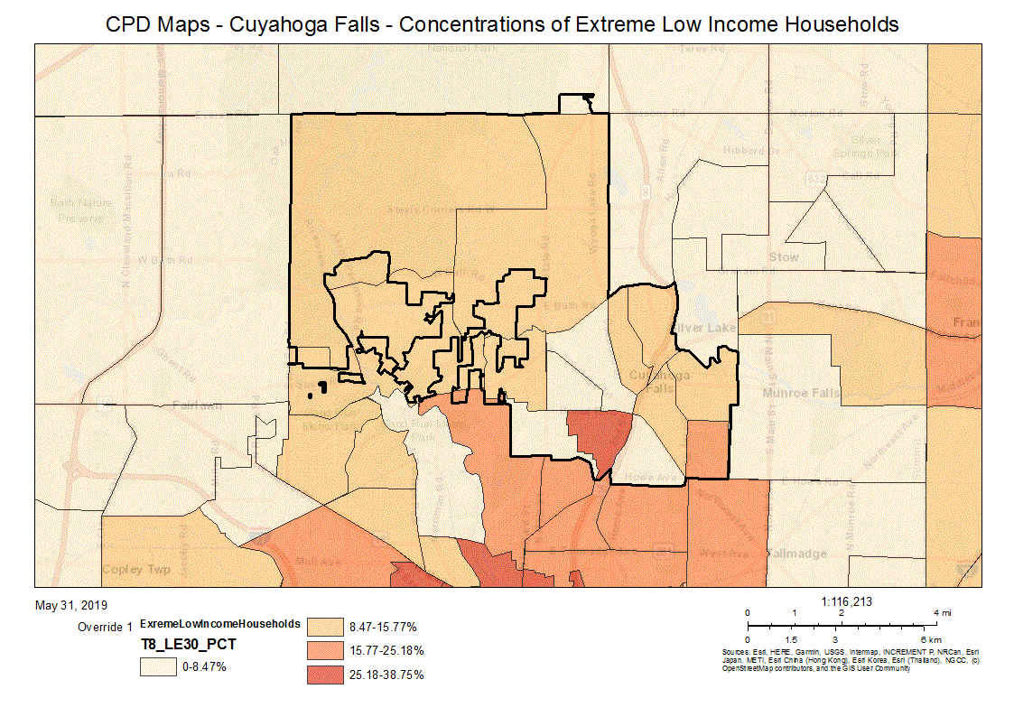
CPD Maps - Cuyahoga Falls - Concentrations of Extreme Low Income Households
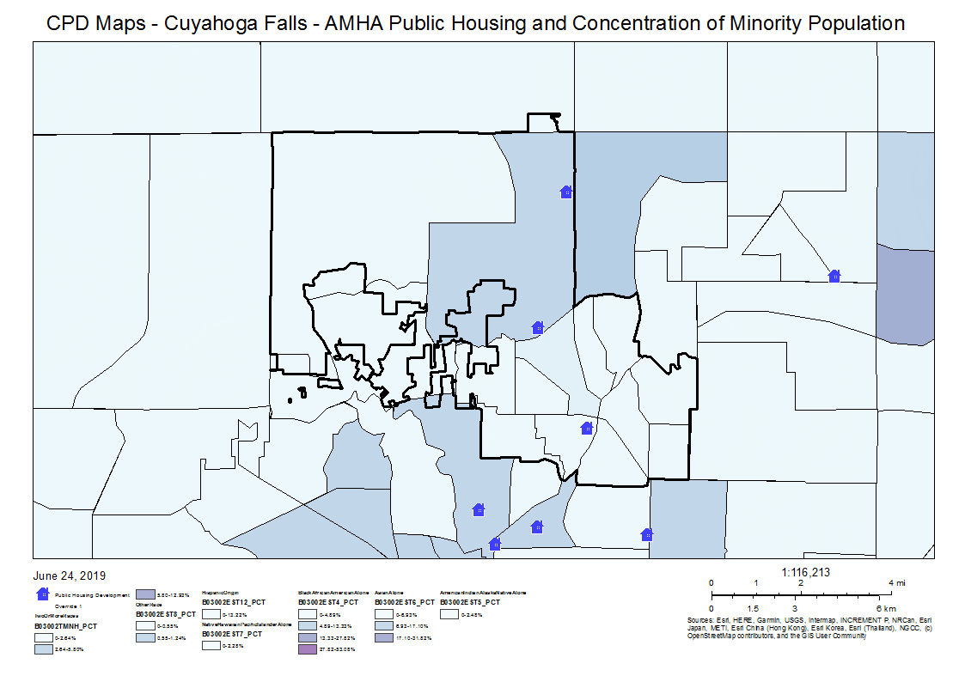
CPD Maps - Cuyahoga Falls - AMHA Public Housing and Concentration of Minority Population

Strategic Plan

SP-05 Overview
Strategic Plan Overview
It is the mission of the City of Cuyahoga Falls, Community Development Department to provide Cuyahoga Falls residents with programs that provide services to enhance the quality of life for low-to moderate-income residents.
In 1995, the U.S. Department of Housing and Urban Development (HUD) required all communities that receive funding from HUD programs to complete a Consolidated Plan. The Consolidated Plan was introduced as a planning tool by HUD to streamline the application process for 6 different grant programs and to provide communities with a comprehensive approach to addressing housing, community, and economic development needs. The Consolidated Plan establishes specific objectives and annual goals for a community that enables local citizens, as well as government officials, to monitor progress and implement amendments to the plan over a 5 year period.
The City of Cuyahoga Falls receives HUD entitlement program funds from the Community Development Block Grant (CDBG) program. Congress enacted the CDBG program in 1974 under Title 24, Part 570. The primary objective of the CDBG program is to meet the housing, community, and economic development needs of low-to moderate-income people, who are defined as persons with annual family incomes at 80% or below the area median family income. The CDBG program provides funding in the City of Cuyahoga Falls for single-family housing rehabilitation, community-based infrastructure, public services, and economic development.
This Consolidated Plan submission covers the period FY 2019 to 2023 and includes a 1 year Action Plan for FY 2019.

SP-10 Geographic Priorities – 91.215 (a)(1)
Geographic Area
Table 47 - Geographic Priority Areas
1 | Area Name: | CITY-WIDE
 | Area Type: | Local Target area
 | Other Target Area Description:
 | HUD Approval Date:
 | % of Low/ Mod:
 | Revital Type: | Comprehensive
 | Other Revital Description:
 | Identify the neighborhood boundaries for this target area. | This area encompasses all of Cuyahoga Falls.
 | Include specific housing and commercial characteristics of this target area. | Housing stock in the City of Cuyahoga Falls is mainly single family residences with detached garages. The majority of these houses were built before 1980. Businesses and manufacturers are concentrated mainly along Front Street, Portage Trail, Graham Road and State Road.
 | How did your consultation and citizen participation process help you to identify this neighborhood as a target area? | Consultation with organizations indicated there is still a need for home revitalization work for lower income residents. Citizen participation indicated a continued need to address street infrastructure.
 | Identify the needs in this target area. | Citizen participation pointed to infrastructure needs and the continuation of older housing stock rehabilitation.
 | What are the opportunities for improvement in this target area? | Each year the Development Department strives to rehabilitate at least 12 older homes for low- to moderate-income families.
 | Are there barriers to improvement in this target area? | There is a limitation on the number of improvements due to funding.
2 | Area Name: | HESLOP NEIGHBORHOOD
 | Area Type: | Local Target area
 | Other Target Area Description:
 | HUD Approval Date:
 | % of Low/ Mod:
 | Revital Type: | Housing
 | Other Revital Description:
 | Identify the neighborhood boundaries for this target area. | The Heslop Neighborhood is primarily located in the Bailey Road - Munroe Falls Avenue (BMF) area of Cuyahoga Falls.
 | Include specific housing and commercial characteristics of this target area. | The small, single family, Heslop style homes in this neighborhood were built in the early 1950's. The commercial characteristics include small strip malls and gas stations.
 | How did your consultation and citizen participation process help you to identify this neighborhood as a target area? | Citizen and City Council participation weighed heavily on the decision to include this neighborhood in the 2019-2023 Consolidated Plan. Several verbal comments were made concerning the need for investment in the BMF neighborhood.
 | Identify the needs in this target area. | This is an AFH specific goal target area. The BMF portion of Cuyahoga Falls contains older homes that are in need of rehabilitation. This area would also benefit from newly built larger single family homes.
 | What are the opportunities for improvement in this target area? | There are opportunities to offer the Housing Rehabilitation Program to low to moderate income homeowners in this target area. There may also be opportunities to acquire property from the Summit County Land Bank or other like organizations for the purpose of building newer single family homes in this neighborhood for the benefit of lower income families.
 | Are there barriers to improvement in this target area? | Acquisition and housing rehabilitation are often expensive and slow processes.
3 | Area Name: | SOUTH FRONT STREET
 | Area Type: | Local Target area
 | Other Target Area Description:
 | HUD Approval Date:
 | % of Low/ Mod:
 | Revital Type: | Comprehensive
 | Other Revital Description:
 | Identify the neighborhood boundaries for this target area.
 | Include specific housing and commercial characteristics of this target area. | The housing that exists in the South Front Street neighborhood, is older and the needs for housing rehabilitation are high. The commercial area, has seen an increase of new businesses that are taking advantage of facade grants and loans in exchange for employment to low income individuals. This area of Cuyahoga Falls has received street beautification which has enhanced the living area as well as commercial area. The City is promoting more growth in this area as well as other target areas of the City.
 | How did your consultation and citizen participation process help you to identify this neighborhood as a target area? | The Resident Survey and meeting with AMHA and CoC provided direction in development of this area as a priority for improvement. New development of housing is in addition to rehabilitation of older housing to assist this low-mod income area.
 | Identify the needs in this target area. | There is a need for additional housing in this target area. There is also need for commercial building development and renovation for new companies to promote employment opportunities.
 | What are the opportunities for improvement in this target area? | Developers have shown interest in building additional housing on South Front Street.
 | Are there barriers to improvement in this target area? | Yes, although it is crucial that the Cuyahoga Falls increase its affordable housing, often times residents are resistant to development that they see as changing the City they love.

General Allocation Priorities
Describe the basis for allocating investments geographically within the jurisdiction (or within the EMSA for HOPWA)
During the course of this five-year plan, Cuyahoga Falls will use funds throughout the City, including, but not limited to the four planning areas:
- The Cuyahoga River Area (CR)
- The State-Portage Trail Area (SPT)
- The Bailey-Munroe Falls Area (BMF), and
- The Northampton Area (NH).
The rationale for allocating investments on a city-wide basis stems from information gleaned as part of the Housing Needs and Market Analysis sections of this plan as well as input from residents, Development staff and local elected officials.
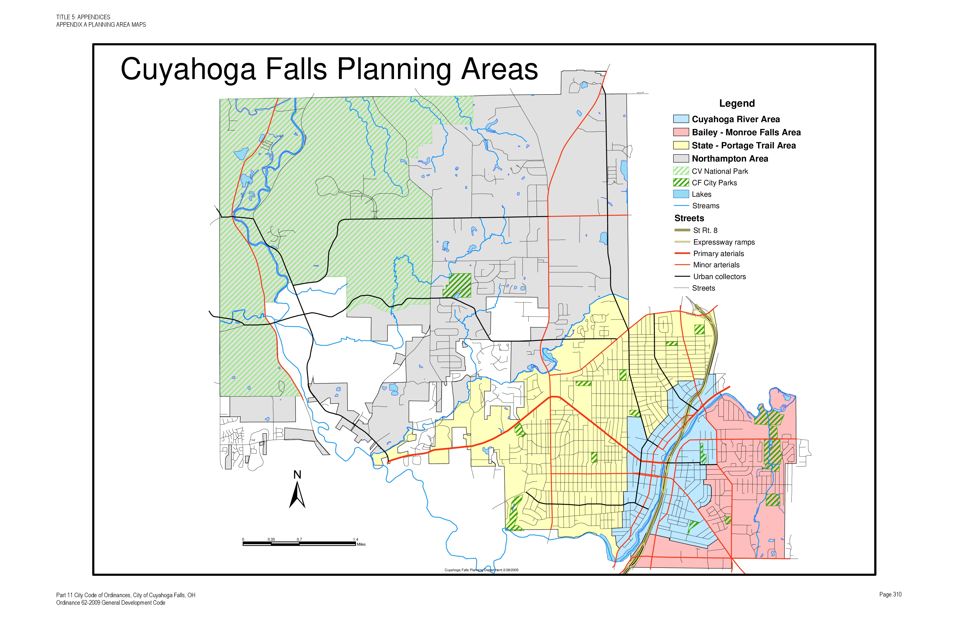
Planning Area

SP-25 Priority Needs - 91.215(a)(2)
Priority Needs
Table 48 – Priority Needs Summary
1 | Priority Need Name | AFH Factor: Community Opposition
 | Priority Level | High
 | Population | Extremely Low  Low  Moderate  Families with Children  Elderly
 | Geographic Areas Affected | CITY-WIDE
 | Associated Goals | AFH - NIMBYism
 | Description | (Impediment - NIMBYism)  The opposition of community members to proposed or existing developments—including housing developments, affordable housing, publicly supported housing (including use of housing choice vouchers), multifamily housing, or housing for persons with disabilities—is often referred to as “Not in my Backyard,” or NIMBY-ism. This opposition is often expressed in protests, challenges to land-use requests or zoning waivers or variances, lobbying of decision-making bodies, or even harassment and intimidation. Community opposition can be based on factual concerns (concerns are concrete and not speculative, based on rational, demonstrable evidence, focused on measurable impact on a neighborhood) or can be based on biases (concerns are focused on stereotypes, prejudice, and anxiety about the new residents or the units in which they will live). Community opposition, when successful at blocking housing options, may limit or deny housing choice for individuals with certain protected characteristics.
 | Basis for Relative Priority | Community opposition is an ongoing struggle for most communities. The City of Cuyahoga Falls strives to make sure that Fair Housing choice is a top priority.
2 | Priority Need Name | AFH Factor: Enforcement of Fair Housing Laws
 | Priority Level | High
 | Population | Extremely Low  Low  Moderate  Large Families  Families with Children  Elderly  Public Housing Residents  Elderly  Persons with Mental Disabilities  Persons with Physical Disabilities  Persons with Developmental Disabilities  Persons with Alcohol or Other Addictions  Persons with HIV/AIDS and their Families  Victims of Domestic Violence
 | Geographic Areas Affected | CITY-WIDE
 | Associated Goals | AFH - Programmatic Compliance
 | Description | (Impediment: Enforcement of Fair Housing Laws)  The term “local private fair housing outreach and enforcement” refers to outreach and enforcement actions by private individuals and organizations, including such actions as fair housing education, conducting testing, lawsuits, arranging and implementing settlement agreements. A lack of private enforcement is often the result of a lack of resources or a lack of awareness about rights under fair housing and civil rights laws, which can lead to under-reporting of discrimination, failure to take advantage of remedies under the law, and the continuation of discriminatory practices. Activities to raise awareness may include technical training for housing industry representatives and organizations, education and outreach activities geared to the general public, advocacy campaigns, fair housing testing and enforcement.  The term “local public fair housing enforcement” refers here to enforcement actions by State and local agencies or non-profits charged with enforcing fair housing laws, including testing, lawsuits, settlements, and fair housing audits. A lack of enforcement is a failure to enforce existing requirements under state or local fair housing laws. This may be assessed by reference to the nature, extent, and disposition of housing discrimination complaints filed in the jurisdiction.
 | Basis for Relative Priority | Local Public Fair Housing Enforcement is a high priority under Programmatic Compliance. The City of Cuyahoga Falls will continue to promote and support outreach and education through its partnership with Fair Housing Advocates Association.
3 | Priority Need Name | AFH Factor: Lending Discrimination
 | Priority Level | High
 | Population | Extremely Low  Low  Moderate
 | Geographic Areas Affected | CITY-WIDE
 | Associated Goals | AFH - Lack of Lending to Minority Groups
 | Description | (Impediment: Lack of Lending to Minority Groups)  The term “lending discrimination” refers here to unequal treatment based on protected class in the receipt of financial services and in residential real estate related transactions. These services and transactions encompass a broad range of transactions, including but not limited to: the making or purchasing of loans or other financial assistance for purchasing, constructing, improving, repairing, or maintaining a dwelling, as well as the selling, brokering, or appraising or residential real estate property. Discrimination in these transaction includes, but is not limited to: refusal to make a mortgage loan or refinance a mortgage loan; refusal to provide information regarding loans or providing unequal information; imposing different terms or conditions on a loan, such as different interest rates, points, or fees; discriminating in appraising property; refusal to purchase a loan or set different terms or conditions for purchasing a loan; discrimination in providing other financial assistance for purchasing, constructing, improving, repairing, or maintaining a dwelling or other financial assistance secured by residential real estate; and discrimination in foreclosures and the maintenance of real estate owned properties.
 | Basis for Relative Priority | The majority of minority groups are located in the public housing areas of the City. Lack of minority home ownership throughout the City has shone light on lending discrimination as a priority need.
4 | Priority Need Name | AFH Factor: Availability of Affordable Units
 | Priority Level | High
 | Population | Extremely Low  Low  Moderate  Large Families
 | Geographic Areas Affected | CITY-WIDE
 | Associated Goals | AFH - Provision of Decent, Safe & Sanitary Housing
 | Description | (Impediment: Lack of Affordable Rental Housing/Lack of Accessible Housing Stock)  The provision of affordable housing is often important to individuals with certain protected characteristics because groups are disproportionately represented among those who would benefit from low-cost housing. What is "affordable" varies by circumstance, but an often used rule of thumb is that low- or moderate-income family can afford to rent or buy a decent quality dwelling without spending more than 30 percent of its income. This contributing factor refers to the availability of units that a low- or moderate-income family could rent or buy, including one bedroom units and multi-bedroom units for larger families. When considering availability, consider transportation costs, school quality, and other important factors in housing choice. Whether affordable units are available with a greater number of bedrooms and in a range of different geographic locations may be a particular barrier facing families with children.
 | Basis for Relative Priority | This priority is based on the previous mitigation plan and current information gleaned from the Consolidation Plan Needs Assessment, consultation with Fair Housing Advocates Association, Akron Metropolitan Housing Authority, Continuum of Care, residents of Cuyahoga Falls and the Community Needs Survey.
5 | Priority Need Name | AFH Factor: Lack of Accessible Housing
 | Priority Level | High
 | Population | Extremely Low  Low  Moderate  Persons with Mental Disabilities  Persons with Physical Disabilities  Persons with Developmental Disabilities
 | Geographic Areas Affected | CITY-WIDE
 | Associated Goals | AFH - Emotional Disabilities (Service Animals)
 | Description | (Impediment: Discrimination against people with emotional disabilities, particularly those who have support and service animals)  Lack of affordable, accessible housing in a range of unit sizes  What is “affordable” varies by circumstance, but an often used rule of thumb is that a low- or moderate-income family can afford to rent or buy a decent-quality dwelling without spending more than 30 percent of its income. For purposes of this assessment, “accessible housing” refers to housing that accords individuals with disabilities equal opportunity to use and enjoy a dwelling. Characteristics that affect accessibility may include physical accessibility of units and public and common use areas of housing, as well as application procedures, such as first come first serve waitlists, inaccessible websites or other technology, denial of access to individuals with assistance animals, or lack of information about affordable accessible housing. The clustering of affordable, accessible housing with a range of unit sizes may also limit fair housing choice for individuals with disabilities.
 | Basis for Relative Priority | This is a common problem nation-wide. Landlords don't want to rent to people with service/support animals for various reasons, such as noise and destruction of property. Public education is a priority here.
6 | Priority Need Name | Program Administration & Planning
 | Priority Level | High
 | Population | Other
 | Geographic Areas Affected | CITY-WIDE
 | Associated Goals | AFH - Programmatic Compliance
 | Description | In order to successfully carry out the initiatives and projects outlined in this five-year plan, administrative and planning actions are necessary. The use of CDBG funds for administrative and planning activities (including Fair Housing Initiatives) will help to ensure that all activities are carried out in compliance with all applicable HUD regulations and requirements.
 | Basis for Relative Priority | To ensure compliance with all applicable HUD requirements.
7 | Priority Need Name | Public Services
 | Priority Level | Low
 | Population | Extremely Low  Low  Moderate  Families with Children  Elderly
 | Geographic Areas Affected | CITY-WIDE
 | Associated Goals | The Provision of a Suitable Living Environment
 | Description | Public services will be provided through the use of sub-recipients who are currently assisting low-to-moderate income persons and/or families within the City of Cuyahoga Falls. Such services will include, but are not limited to, Senior Snow Removal, a grant to Good Neighbors in order to provide additional food to people in need, and a grant to Vantage aging to better assist the City's elderly population.
 | Basis for Relative Priority | Although there is a need for Public Services, throughout the City and Summit County in general, there are a number of existing service providers.
8 | Priority Need Name | Preservation of Existing Housing Stock
 | Priority Level | High
 | Population | Extremely Low  Low  Moderate  Large Families  Families with Children  Elderly
 | Geographic Areas Affected | HESLOP NEIGHBORHOOD  CITY-WIDE  SOUTH FRONT STREET
 | Associated Goals | AFH - Provision of Decent, Safe & Sanitary Housing
 | Description | CDBG funds will be used to provide rehabilitation assistance to low-to-moderate income persons which will preserve and enhance our existing housing stock.
 | Basis for Relative Priority | Much of the City's housing stock is older and in need of repair. Addressing this need will also aid in city-wide code enforcement efforts.
9 | Priority Need Name | Economic Development
 | Priority Level | High
 | Population | Extremely Low  Low  Moderate  Middle  Non-housing Community Development
 | Geographic Areas Affected | CITY-WIDE
 | Associated Goals | The Provision of Expanded Economic Development
 | Description | Priority needs related to economic development, include, but are not limited to acquisition, disposition, demolition, rehabilitation of public or privately owned commercial/industrial space and/or other commercial/industrial improvements. Additional needs include providing loans to small businesses and non-residential historic preservation activities.
 | Basis for Relative Priority | Economic development initiatives increase sustainable communities.
10 | Priority Need Name | Infrastructure Improvements
 | Priority Level | High
 | Population | Non-housing Community Development
 | Geographic Areas Affected | CITY-WIDE
 | Associated Goals | The Provision of a Suitable Living Environment  The Provision of Expanded Economic Development
 | Description | Priority needs related to infrastructure include, but are not limited to, street and sidewalk improvements, other various upgrades to existing infrastructure.
 | Basis for Relative Priority | The City of Cuyahoga Falls continues to update very old infrastructure systems.

Narrative (Optional)
AFH Factors are derived from prior Analysis of Impediments to Fair Housing Choice. The City of Cuyahoga Falls was approved by FHEO May 15, 2019 to participate in the regional Analysis of Impediments and as such will submit its new AI with the 2020 Action Plan.
In order to determined priority needs and the basis for funding allocations, a number of agencies and/or data sources were consulted, including, but not limited to:
- Barberton/Akron/Summit Continuum of Care
- Summit County Department of Development
- United States Census Bureau
- Akron Metropolitan Housing Authority
- public hearings, council meetings and neighborhood Ambassadors
- Neighborhood survey’s
- Cuyahoga Falls Community investment Corporation (BCDC)
- Fair Housing Advocates Association (FHAA)
- Neighborhood Development Services (NDS)
- Private industry
- 2010 Census Additionally, while the factors listed above determined what we might need to address, staff capacity and estimated funding levels played an even larger role in determining what we can realistically undertake during the 2019-2023 Consolidated Strategic Plan period. Based on these factors housing, quality of life/suitably living environment issues and preservation activities will be the focus of this plan.
Geographically, funds will be used for projects located within the City of Cuyahoga Falls. Throughout the plan period, priority will be given to projects located in low-to-moderate income areas.

SP-30 Influence of Market Conditions – 91.215 (b)
Influence of Market Conditions
Affordable Housing Type | Market Characteristics that will influence  the use of funds available for housing type
Tenant Based Rental Assistance (TBRA) | Cuyahoga Falls does not receive HOME funds for Tenant Based Rental Assistance, but will continue to support public services such as the Good Neighbors, Vantage Aging and Fair Housing to help Cuyahoga Falls' low income residents.
TBRA for Non-Homeless Special Needs | Cuyahoga Falls does not receive HOME funds for Tenant Based Rental Assistance, but will continue to support public services such as the Good Neighbors, Vantage Aging and Fair Housing to help Cuyahoga Falls' low income residents.
New Unit Production | The City of Cuyahoga Falls supports new unit production through tax credit projects and support to Habitat for Humanity to assist elderly and low income residents and will continue to do so for the 2019-2023 Consolidated Plan Period.
Rehabilitation | There is a continuing need for rehabilitation of the City's older housing stock. Elderly and low income residents defer maintenance of their homes because of affordability issues. During the 2019-2023 Consolidated Plan period, the City will continue to promote its housing rehabilitation program and will utilize its Housing Code Enforcement Department to help more of its residents through the Housing Rehabilitation Program.
Acquisition, including preservation | A number of vacant and foreclosed homes have been identified in the City of Cuyahoga Falls. There is a growing need for acquisition, demolition and new housing construction in portions of the City. Acquisition and preservation are a must to increase housing stock and rejuvenate neighborhoods.
Table 49 – Influence of Market Conditions

SP-35 Anticipated Resources - 91.215(a)(4), 91.220(c)(1,2)
Introduction
During this Consolidated Plan period, the City will continue to leverage all resources made available for community development needs within the community, including any state, local, federal and/or private funding. The City will continue to develop stronger relationships with community development oriented agencies in order to maximize leveraging opportunities. Competitive CoC (McKinney-Vento) funding is not a direct funding source of the City and is therefore not included in projected funding. The City does not receive funding under the HOME or ESG programs and is therefore not included in projected funding.
The City also has NSP funds which need to be converted to Program Income. Cuyahoga Falls staff are working with HUD to identify and confirm the amount of funds to be converted. It is hoped that this will be completed within the 2019-2023 consolidated plan period and funds will be made usable for CDBG projects.
Anticipated Resources
Program | Source of Funds | Uses of Funds | Expected Amount Available Year 1 |  |  |  | Expected Amount Available Remainder of ConPlan  $ | Narrative Description
 |  |  | Annual Allocation: $ | Program Income: $ | Prior Year Resources: $ | Total:  $
CDBG | public - federal | Acquisition  Admin and Planning  Economic Development  Housing  Public Improvements  Public Services | 645,436 | 41,425 | 436,224 | 1,123,085 | 0 | Annual Allocations fluctuate each year. It is anticipated that the City will receive a total of $3,000,000 over the 2019-2023 Consolidated Plan period. This is an anticipated annual allocation of $605,000 per year. Program income is anticipated to yield approximately $470,000 over the same five year period.
Table 50 - Anticipated Resources

Explain how federal funds will leverage those additional resources (private, state and local funds), including a description of how matching requirements will be satisfied
The City of Cuyahoga Falls, Development Department strives to fund programs that maximize other funding sources as much as possible. County Health Department lead abatement funding, OPWC, EPA, ODNR, ODA, and the general fund are several of the funding sources the City will utilize this Plan period.
If appropriate, describe publically owned land or property located within the jurisdiction that may be used to address the needs identified in the plan
The City of Cuyahoga Falls will work with the Summit County Land Bank to acquire property throughout the City. These properties will be utilized to accomplish needs such as:
- Demolition of blighted properties for the purpose of constructing new single family homes and working with organizations geared towards providing home buying assistance to low to moderate income families.
- Creating green space while also eliminating slum and blight.
- Acquiring properties to assist with Economic Development needs, rehabilitating or razing slum and blighted properties so that new commercial buildings can be built to create jobs for low to moderate income individuals.
Discussion

SP-40 Institutional Delivery Structure – 91.215(k)
Explain the institutional structure through which the jurisdiction will carry out its consolidated plan including private industry, non-profit organizations, and public institutions.
Responsible Entity | Responsible Entity Type | Role | Geographic Area Served
Akron Metropolitan Housing Authority | PHA | Public Housing  Rental | Jurisdiction
NEIGHBORHOOD DEVELOPMENT SERVICES INC. | Non-profit organizations | Ownership | Jurisdiction
Cuyahoga Falls Good Neighbors | Non-profit organizations | public services | Jurisdiction
VANTAGE Aging, Inc. | Non-profit organizations | public services | Jurisdiction
United Way of Summit County | Non-profit organizations | Homelessness  Planning  public services | Jurisdiction
Table 51 - Institutional Delivery Structure
Assess of Strengths and Gaps in the Institutional Delivery System
The City of Cuyahoga Falls has a strong relationship with its HMIS Agency, United Way of Summit County. In July of 2018, United Way of Summit County announced a merger with InfoLine Inc. United Way of Summit County Housing Services administers the Homeless Hotline and coordinates access to homeless shelters, permanent supportive housing, and rent assistance for individuals and families living in Summit County who are homeless or facing eviction. The Homeless Hotline can be reached through 2-1-1, which conducts screening and intakes for most homeless shelters, permanent supportive housing programs and rent payment assistance programs.
One noticeable gap in in the institutional delivery system is the need for improved collaboration between AMHA and other non-profit community development agencies that serve lower income individuals. The City of Cuyahoga Falls will strive to further develop, increase and foster coordination with AMHA and other government, non-profit providers and private entities. The City will encourage homeownership, through relationships with local lenders.
Availability of services targeted to homeless persons and persons with HIV and mainstream services
Homelessness Prevention Services | Available in the Community | Targeted to Homeless | Targeted to People with HIV
Homelessness Prevention Services
Counseling/Advocacy | X | X | X
Legal Assistance | X | X | X
Mortgage Assistance | X | X | X
Rental Assistance | X | X | X
Utilities Assistance | X | X | X

Street Outreach Services
Law Enforcement | X |  | X
Mobile Clinics | X | X | X
Other Street Outreach Services | X | X | X

Supportive Services
Alcohol & Drug Abuse | X | X | X
Child Care | X | X | X
Education | X | X | X
Employment and Employment Training | X |  | X
Healthcare | X | X | X
HIV/AIDS | X | X | X
Life Skills | X | X | X
Mental Health Counseling | X | X | X
Transportation

Other
Table 52 - Homeless Prevention Services Summary
Describe how the service delivery system including, but not limited to, the services listed above meet the needs of homeless persons (particularly chronically homeless individuals and families, families with children, veterans and their families, and unaccompanied youth)
Housing providers in Summit County provide an array of housing from shelters to permanent supportive housing (PSH) that specifically serve homeless persons including chronically homeless, families with children, persons fleeing domestic violence and veterans. Category 1 (homeless), category 2 (at imminent risk of homelessness) and category 4 (victims fleeing domestic or dating violence) are served by shelters, rapid rehousing and transitional housing programs. Categories 1 and 4 are also served by PSH programs. All of these categories include persons from the subpopulations mentioned above. Wrap around services address specific issues for the same homeless subpopulations with services targeted to both issues identified as contributing to homelessness, and to enabling skill development and education in order to improve self-sufficiency. For example, the mental health providers offer counseling, group work and crisis intervention. The education system provides services to school age children, and to adults working toward skill development and employability. Childcare providers enable parents to work and/or go to school. METRO provides bus and door to door service (physically disabled). The wrap around model with individualized service plan targets specific needs and issues on a person by person basis.
Describe the strengths and gaps of the service delivery system for special needs population and persons experiencing homelessness, including, but not limited to, the services listed above
The City of Cuyahoga Falls, Community Development Department, coordinates efforts to address homelessness issues within the City of Cuyahoga Falls' jurisdiction with the Cities of Akron, Barberton and Summit County through their participation in and support of the Akron/Barberton/Summit County Continuum of Care (CoC). The City has a strong relationship with its HMIS host agency, United Way of Summit County. Client tracking, case management, service and referral management, bed availability for shelters, resource indexing and reporting are managed by a web-based information management system, giving the City up to date reports on the number and category of subpopulations being assisted.
Gaps identified in the Service Delivery System for special needs population and persons experiencing homelessness include the need for more affordable rental housing, more subsidized housing and more special needs housing, legal aid for evictions and for alternative sentencing, mental health services for persons who are not at the more severe levels of dysfunction or who have stabilized and then are graduated out of case management thereby becoming vulnerable to relapse.
Provide a summary of the strategy for overcoming gaps in the institutional structure and service delivery system for carrying out a strategy to address priority needs
The CoC has developed subcommittees of providers and others to target specific gaps such as increasing employment and youth homelessness. Subcommittees provide valuable insight on needs and challenges faced by providers. The CoC works proactively to identify new sources of funding to expand services and/or to address a specific gap and collaborate on securing identified funds. The City of Akron offers support to agencies that are either expanding their services or successfully partnering with other agencies to include the types of services identified above through their programs through support letters and higher scoring on the CoC pre-application. HMIS training takes place to ensure users are familiar with the requirements for the system. Training allows for the HMIS Intake questions to simply be reviewed rather than another form being completed and re-entered into HMIS. With improvements in internet capabilities, this strategy is now being implemented. This change will significantly decrease the length of time it takes to correctly input a client into HMIS as well as significantly increase the data quality and accuracy of client information. By reducing paperwork and data entry by service providers, staff time will be freed up for direct service to homeless persons.

SP-45 Goals Summary – 91.215(a)(4)
Goals Summary Information
Sort Order | Goal Name | Start Year | End Year | Category | Geographic Area | Needs Addressed | Funding | Goal Outcome Indicator
1 | AFH - NIMBYism | 2019 | 2023 | Affordable Housing  Public Housing  Homeless  Non-Homeless Special Needs  Non-Housing Community Development | HESLOP NEIGHBORHOOD  CITY-WIDE  SOUTH FRONT STREET | AFH Factor: Community Opposition | CDBG: $0 | Other:  1 Other
2 | AFH - Programmatic Compliance | 2019 | 2023 | Administration & Planning | CITY-WIDE | Program Administration & Planning  AFH Factor: Enforcement of Fair Housing Laws | CDBG: $145,800 | Other:  1 Other
3 | AFH - Lack of Lending to Minority Groups | 2019 | 2023 | Affordable Housing  Non-Housing Community Development | CITY-WIDE | AFH Factor: Lending Discrimination | CDBG: $0 | Other:  1 Other
4 | AFH - Provision of Decent, Safe & Sanitary Housing | 2019 | 2023 | Affordable Housing | HESLOP NEIGHBORHOOD  CITY-WIDE  SOUTH FRONT STREET | Preservation of Existing Housing Stock  AFH Factor: Availability of Affordable Units | CDBG: $266,425 | Homeowner Housing Added:  5 Household Housing Unit  Homeowner Housing Rehabilitated:  50 Household Housing Unit
5 | AFH - Emotional Disabilities (Service Animals) | 2019 | 2023 | Non-Homeless Special Needs | CITY-WIDE | AFH Factor: Lack of Accessible Housing | CDBG: $0 | Other:  1 Other
8 | The Provision of a Suitable Living Environment | 2019 | 2023 | Non-Housing Community Development | CITY-WIDE | Public Services  Infrastructure Improvements | CDBG: $15,000 | Public service activities other than Low/Moderate Income Housing Benefit:  100 Persons Assisted  Public service activities for Low/Moderate Income Housing Benefit:  2 Households Assisted
9 | The Provision of Expanded Economic Development | 2019 | 2023 | Non-Housing Community Development | CITY-WIDE | Infrastructure Improvements  Economic Development | CDBG: $695,860 | Public Facility or Infrastructure Activities other than Low/Moderate Income Housing Benefit:  5 Persons Assisted  Jobs created/retained:  100 Jobs  Businesses assisted:  5 Businesses Assisted
Table 53 – Goals Summary

Goal Descriptions

1 | Goal Name | AFH - NIMBYism
 | Goal Description | The U.S. Department of Housing and Urban Development defines NIMBYism (NIMBY stands for Not In My Back Yard) as “a mentality adopted by those who reject certain changes to their communities.”  The NIMBY mentality is dangerous to communities, as it represents a refusal to compromise, a refusal to recognize personal property rights, and/or consideration of alternatives all which can stifle growth and development.  Often, NIMBYism is reflective of residents’ fears of the “worst case scenario” effects of proposed development or falsehoods which are circulating amongst those who oppose the project.  It is the goal of the City of Cuyahoga Falls to combat NIMBYism by providing residents with information and public forums to discuss changes in the City. The goal is that this be met with cooperation and understanding rather than opposition and misinformation.
2 | Goal Name | AFH - Programmatic Compliance
 | Goal Description | CDBG Administrative funds will be used to ensure programmatic compliance with all activities that are undertaken during the course of the 2019-2023 year plan. Fair Housing Activities are also allocated from CDBG Administrative funds.  The City of Cuyahoga Falls will continue to market and promote the availability of Fair Housing Advocates Association as well as state and federal organizations that process housing discrimination complaints. Continue to make FHAA contact information available on the City's website, in newsletters and in local paper notices. Fund and support education and enforcement programs. Outcomes and accomplishments are easily managed through reporting by Fair Housing Advocates Association monthly reports.
3 | Goal Name | AFH - Lack of Lending to Minority Groups
 | Goal Description | The City will work with community partner, Fair Housing Advocates Association to identify and promote seminars on financial literacy and other lending resources. The City and FHAA will make referrals on the identified resources on an as needed basis.
4 | Goal Name | AFH - Provision of Decent, Safe & Sanitary Housing
 | Goal Description | To preserve, construct and/or increase the availability of affordable, decent and sanitary housing for low to moderate income individuals. This goal includes the AFH Factor: Lack of Accessible Housing Stock.
5 | Goal Name | AFH - Emotional Disabilities (Service Animals)
 | Goal Description | This goal includes people with disabilities, particularly those who require the aid of support or service animals. This goal is to increase awareness of the rights of disabled persons through increased and expanded outreach efforts via workshops and brochures with the help of community partner, Fair Housing Advocates Association. These outreach efforts are easily measured by monthly reporting received from FHAA.
8 | Goal Name | The Provision of a Suitable Living Environment
 | Goal Description | The Provision of a Suitable Living Environment through Public Services such as Good Neighbors, Senior Snow Removal, Vantage Aging, Beautification and Infrastructure Improvements and other activities to enhance quality of life of low to moderate income persons living and working in the City of Cuyahoga Falls.
9 | Goal Name | The Provision of Expanded Economic Development
 | Goal Description | Expanded Economic opportunities through creation and/or preservation of jobs mainly directed towards low-mod income individuals. Cuyahoga Falls leverages funds with developers, businesses and other agencies to create new local businesses, help expand economic opportunities for new business owners, create and maintain jobs for people who work and live in the City of Cuyahoga Falls.
Estimate the number of extremely low-income, low-income, and moderate-income families to whom the jurisdiction will provide affordable housing as defined by HOME 91.315(b)(2)
The City of Cuyahoga Falls does not currently receive HOME funds.

SP-50 Public Housing Accessibility and Involvement – 91.215(c)
Need to Increase the Number of Accessible Units (if Required by a Section 504 Voluntary Compliance Agreement)
Akron Metropolitan Housing Authority follows a "Reasonable Accommodation Policy." To assure compliance with the Fair Housing Act, Section 504 of the Rehabilitation Act (“Section 504”) and the applicable provisions of the Americans with Disabilities Act (the “ADA”), Management maintains a Reasonable Accommodation Policy, attached to this Policy as Exhibit C. The Reasonable Accommodation Policy provides for reasonable modifications to rules, policies, practices and services or make structural alterations when necessary to afford a qualified individual applicant or resident with disabilities an equal opportunity to use and enjoy a dwelling and participate in the housing, programs and services available at the Development. An accommodation will not be considered reasonable if it constitutes a fundamental alteration of the provider’s program, or creates an undue financial or administrative burden. The Reasonable Accommodation Policy includes the following elements:
- Reasonable accommodations will be made at the request of applicants and residents with disabilities to ensure the opportunity for equal access to housing, benefits and services.
- At the time of initial application and at any recertification, a notice will be provided to each applicant or resident that describes Section 504 requirements, including the right to request a reasonable accommodation.
- Intake, screening, recertification and other meetings will be conducted at accessible locations.
- Forms and other documents to be completed by applicants will be available in accessible formats. Sign language interpreters and other auxiliary aides will be provided if requested by the individual with disabilities.
- Any applicant or resident, whether or not a person with disabilities, may be assisted by a family member, friend or advocate in interviews and meetings with Management, and in the completion of written forms. Upon request, Management will help an individual complete written forms or explain written materials orally.
- An individual requesting a reasonable accommodation may be required to verify the existence of a disability, as defined by Section 504 and the ADA, and may also be required to document the relationship between the accommodation and the handicap or disability upon request.
It is AMHA's goal to convert approximately 5% of the dwellings being modernized to meet Section 504 requirements.
Activities to Increase Resident Involvements
Involvement in management is addressed through the “A-CAN” organization, which is a council of leadership from different resident councils. A-CAN reviews and approves AMHA’s annual Action Plans.
The following programs are provided by AMHA to increase resident involvement:
The Family Self-Sufficiency (FSS) program helps motivated individuals and families fulfill their goals, leading to total freedom from all forms of public assistance. FSS is a voluntary program, open to most Housing Choice Voucher Program and Public Housing residents receiving housing assistance. The FSS staff will assist participants in developing the skills and self-confidence needed to become self-sufficient. We will support you in setting and achieving your goals and refer you to other services as needed i.e. Child care, education, transportation, job training, substance abuse treatment, consumer credit counseling, utility assistance and other needed services.
Service Coordinators work with residents to develop a plan, provide referrals to community resources in support of their goals, and assist them in overcoming barriers. Promote self-sufficiency programming within the developments focusing on self-sufficiency of residents. Service Coordinators also provide crisis management and links to community resources that can provide assistance with basic needs such as food, clothing, healthcare, utilities and other pressing needs.
The AMHA Early Childhood Initiative has three parts: Family Events, Home Visitation, and Mom-ME Time. Home visitation includes the evidence-based Parents as Teachers program for children ages 0-3 and the SPARK program for children ages 3-4. At ECI family events, kids have a blast playing with children their age and parents have a chance to connect with community resources that will benefit their family. There are holiday events, animal shows, concerts, picnics, and more.
The Reach Opportunity Center is a community hub; a place Summit Lake residents use for support, resources, education, community and friendship. The center provides a variety of services from early childhood education and youth programs to workforce development, special interest workshops, support groups, family events and more.
Building for Tomorrow (BFT) provides residents of the Akron Metropolitan Housing Authority (AMHA) and other low income individuals with tools to reach their potential and to move beyond assisted housing and other public assistance. BFT focuses on educational success, economic self-sufficiency and independent living. BFT strives to create a supportive sense of community where residents, no matter their stage in life, are given the power to realize and obtain a brighter future.

Is the public housing agency designated as troubled under 24 CFR part 902?
No
Plan to remove the ‘troubled’ designation
AMHA continues to rank in the top 2-3% of housing authorities in the United States, having been recertified, for the 5th consecutive year, as a High Performing Public Housing Agency.

SP-55 Barriers to affordable housing – 91.215(h)
Barriers to Affordable Housing
Barriers to affordable housing exist in every community. While some of these barriers can be addressed through legislative or procedural changes, others are very difficult to alter because they are the result of societal, financial, and/or market conditions.
Analysis shows the following barriers to affordable housing exist in the City of Cuyahoga Falls' jurisdiction:
- Limited supply of affordable single-family housing units that make it difficult for low-to moderate-income first-time home buyers to make the transition from renting to homeownership.
- The average price for many of the houses on the market in Cuyahoga Falls ($121,700) are below the national average ($193,500); however, this average price frequently exceeds the affordability level of many low- to moderate-income households.
- Housing rehabilitation is often costly, making it difficult for low- to moderate-income households to afford necessary repairs.
- Provisions within existing local zoning codes that tend to favor conventional site design rather than cluster or planned residential developments, and that require separation of housing types which can hinder the development of mixed use housing. Additionally, provisions that stipulate minimum lot sizes make the development of smaller, more affordable housing difficult.
- Resistance to the development of affordable housing, particularly affordable housing developments. This is frequently labeled as NIMBYism (Not in My Back Yard), and has been the subject of fair housing law for years.
- Cost prohibitive local ordinances for storm water systems, sidewalks, and landscaping that often add unnecessary costs to affordable housing development projects.
- Lack of Transportation or lack of public transportation options has a negative effect on affordable housing location choice.
Strategy to Remove or Ameliorate the Barriers to Affordable Housing
The City strives to make housing decent, safe, sanitary and affordable through a variety of state and federally funded programs as well as through code enforcement. The AMHA ensures residents requiring affordable public housing have a place to call home in our community. The CoC ensures the homeless and potentially homeless population are matched with supportive services and temporary and /or permanent housing. The City will continue to collaborate with the AMHA, CoC and other public services agencies within Summit County.

SP-60 Homelessness Strategy – 91.215(d)
Reaching out to homeless persons (especially unsheltered persons) and assessing their individual needs
The City of Cuyahoga Falls reaches out to the homeless and especially unsheltered persons through its HMIS partnership with United Way of Summit County and promotes use of the 2-1-1 program to those individuals who are homeless or in danger of becoming homeless. The 2-1-1 program is a bridge between people who need services and the agencies that can help. The free and confidential service is available 24 hours a day, 7 days a week.
The City will also continue to reach out to the homeless and especially unsheltered persons, assessing their needs during the 2019-2023 Consolidated Plan period via its coordination efforts with local non-profit agencies. Some of the agencies include Veterans Administration, Access Inc., Community Aids Network (CAN), Community Support Services, Fair Housing Advocate Association, Fair Housing Contact Services, Haven of Rest, H.M. Life Opportunity Services, Family Promise of Summit County, Legacy III, North Coast Community Homes, Oriana House, Ohio Multi County Development Corporation (OMCDC), Shelter Care, Summit County Children's Services Board, Tarry House and the Salvation Army to name a few. The City also provides funding to Good Neighbors an organization dedicated to feeding and clothing those most in need.
Addressing the emergency and transitional housing needs of homeless persons
The City of Cuyahoga Falls reaches out to the homeless and especially unsheltered persons assessing their individual needs through staff involvement with the Continuum of Care Steering Committee, the Continuum of Care Review and Ranking Committee, the Homeless Management Information System (HMIS) Steering Committee, and the annual Point-in Time Count.
Helping homeless persons (especially chronically homeless individuals and families, families with children, veterans and their families, and unaccompanied youth) make the transition to permanent housing and independent living, including shortening the period of time that individuals and families experience homelessness, facilitating access for homeless individuals and families to affordable housing units, and preventing individuals and families who were recently homeless from becoming homeless again.
The City of Cuyahoga Falls helps homeless persons, including chronically homeless individuals and families, families with children, veterans and their families, and unaccompanied youth, make the transition to permanent housing and independent living, including shortening the period of time that individuals and families experience homelessness, facilitating access for homeless individuals and families to affordable housing units, and preventing individuals and families who were recently homeless from becoming homeless again through staff participation with the Continuum of Care Steering Committee, the Continuum of Care Review and Ranking Committee, and the Homeless Management Information System (HMIS) Steering Committee.
Help low-income individuals and families avoid becoming homeless, especially extremely low-income individuals and families who are likely to become homeless after being discharged from a publicly funded institution or system of care, or who are receiving assistance from public and private agencies that address housing, health, social services, employment, education or youth needs
The City of Cuyahoga Falls helps low-income individuals and families avoid becoming homeless, especially extremely low-income individuals and families and those who are: being discharged from publicly funded institutions and systems of care, such as health care facilities, mental health facilities, foster care and other youth facilities, and corrections programs and institutions; or, receiving assistance from public or private social services, employment, education, or youth needs through staff involvement in the Continuum of Care Steering Committee, the Continuum of Care Review and Ranking Committee, the Homeless Management Information System (HMIS) Advisory Committee, and the Summit County Reentry Network.

SP-65 Lead based paint Hazards – 91.215(i)
Actions to address LBP hazards and increase access to housing without LBP hazards
The City of Cuyahoga Falls has incorporated the Environmental Protection Agency’s (EPA) Lead-Based Paint Renovation, Repair, and Painting Program (RRP) requirements and HUD Title X Lead Rule into their Housing Rehabilitation Program. EPA’s 2010 Lead Rule requirements apply to anyone who is paid to perform work that disturbs paint in housing and child-occupied facilities built before 1978. The RRP mandates pre-renovation educational requirements; and effective April 22, 2010, requires the following training, certification, and work practices:
- Firms must be certified
- Renovators must be trained
- Lead-safe work practices must be followed
The City of Cuyahoga Falls leverages CDBG funds, used for Owner Occupied Rehabilitation with a Lead Hazard Demonstration Reduction Grant through the Summit County Public Health District.
Individuals living in homes with lead based paint hazards may be eligible to receive a forgivable loan with a maximum amount of $12,902.71 from the Summit County Public Health District. Individuals who receive assistance from the Summit County Public Health District may also be eligible to receive up to $6,955.24 in Healthy Home assistance. To be eligible, the homeowner must have a child living in the home under the age of 6 or have a child visiting the home more than 6 hours a week or 62 hours a year.
All Sub-Recipients engaged in The City of Cuyahoga Falls Housing Rehabilitation Program use contractors and sub-contractors that are EPA certified and registered with the EPA.
How are the actions listed above related to the extent of lead poisoning and hazards?
The City of Cuyahoga Falls ensures that if a home was built prior to 1978 and a child under the age of 6 resides in the home or visits the home more than 62 hours per year, the staff will automatically refer them to the Lead Hazard Demonstration Reduction Grant program through collaboration with Summit County or it's sub-recipients in order to eliminate the lead contamination in the home. The City will ensure that only contractors who are registered EPA/RRP certified firms, EPA/RRP trained, and practice lead safe work practices. Staff members who work on the Lead Hazard Demonstration Reduction Grant program and CDBG program sub-recipients have obtained their EPA/RRP certificates.
How are the actions listed above integrated into housing policies and procedures?
The Environmental Protection Agency (EPA) created a Lead-based Paint brochure for residents and contractors that highlights steps that should be taken to address LBP hazards and safety in the home. This brochure will be distributed to all rehab clients. The City or its designee will also require contractors to be licensed in the state of Ohio to handle LBP. Along those same lines, work-write ups for housing rehab projects will include language to address any lead issues.
Lead is considered a serious condition which is an immediate threat to the health and/or safety of the dwelling occupant(s). The City of Cuyahoga Falls considers these eligible applicants to be in an emergency situation and ensures that lead issues are given priority status.
LEAD BASED PAINT REGULATIONS - HOUSING REHAB POLICY
In accordance with the HUD Lead-Based Paint Regulation (24 CFR Part 35), rehabilitation work on housing built before 1978 that is financially assisted by the Federal government is subject to requirements that will control lead-based paint hazards.
All work performed as part of the housing rehabilitation program will be completed in a lead safe manner and in accordance with 24 CFR Part 35.
Program participants whose homes were built prior to 1978 will receive information about Lead Based Paint Hazards. This information will be provided by NDS and receipt of such information will be documentation by the homeowner’s signature.

SP-70 Anti-Poverty Strategy – 91.215(j)
Jurisdiction Goals, Programs and Policies for reducing the number of Poverty-Level Families
The City of Cuyahoga Falls will work to raise awareness of the availability of housing rehabilitation assistance and the Summit County Home Weatherization Assistance Program, which utilizes the Department of Energy, Healthy Homes, and State of Ohio funding in the form of grants to improve the overall weatherization of extremely low-income households.
The Development Department strives to leverage private capital in all CDBG funded activities. The City dedicates a significant amount of funding to maintain decent, safe and affordable housing. The City spends public service dollars on activities that will increase the quality of life for those living in poverty. Although Cuyahoga Falls does not run State or County programs, the City of Cuyahoga Falls understands that it takes collaborative effort between private business and federal, state and local officials, faith-based and non-profit organizations to significantly impact the lives of low-income individuals and families. When the City cannot help directly, it refers its residents to state, county and local programs through the use of United Way's 211 resource program or directly to programs that support the needs of the resident.
How are the Jurisdiction poverty reducing goals, programs, and policies coordinated with this affordable housing plan?
The City of Cuyahoga Falls focuses on economic development in an attempt to increase and/or retain jobs for low to moderate income individuals. The City focuses on housing rehabilitation which allows low to moderate income individuals to bring an aging home up to code, making it decent, safe and sanitary while also allowing the funds to be paid back at zero interest once the home is no longer owner occupied. Deferring housing rehabilitation loan repayment, allows poverty level families to use their income for other important needs. Cuyahoga Falls takes great pride in its public service programs, reaching out to poverty stricken families through food pantry support, low income senior citizens and disabled individuals with snow removal that they could not otherwise afford to remove, and Advantage Aging which allows low income seniors of Cuyahoga Falls to remain in their houses through this aging in place program.

SP-80 Monitoring – 91.230
Describe the standards and procedures that the jurisdiction will use to monitor activities carried out in furtherance of the plan and will use to ensure long-term compliance with requirements of the programs involved, including minority business outreach and the comprehensive planning requirements

Expected Resources

AP-15 Expected Resources – 91.220(c)(1,2)
Introduction
During this Consolidated Plan period, the City will continue to leverage all resources made available for community development needs within the community, including any state, local, federal and/or private funding. The City will continue to develop stronger relationships with community development oriented agencies in order to maximize leveraging opportunities. Competitive CoC (McKinney-Vento) funding is not a direct funding source of the City and is therefore not included in projected funding. The City does not receive funding under the HOME or ESG programs and is therefore not included in projected funding.
The City also has NSP funds which need to be converted to Program Income. Cuyahoga Falls staff are working with HUD to identify and confirm the amount of funds to be converted. It is hoped that this will be completed within the 2019-2023 consolidated plan period and funds will be made usable for CDBG projects.

Anticipated Resources
Program | Source of Funds | Uses of Funds | Expected Amount Available Year 1 |  |  |  | Expected Amount Available Remainder of ConPlan  $ | Narrative Description
 |  |  | Annual Allocation: $ | Program Income: $ | Prior Year Resources: $ | Total:  $
CDBG | public - federal | Acquisition  Admin and Planning  Economic Development  Housing  Public Improvements  Public Services | 645,436 | 41,425 | 436,224 | 1,123,085 | 0 | Annual Allocations fluctuate each year. It is anticipated that the City will receive a total of $3,000,000 over the 2019-2023 Consolidated Plan period. This is an anticipated annual allocation of $605,000 per year. Program income is anticipated to yield approximately $470,000 over the same five year period.
Table 54 - Expected Resources – Priority Table

Explain how federal funds will leverage those additional resources (private, state and local funds), including a description of how matching requirements will be satisfied
The City of Cuyahoga Falls, Development Department strives to fund programs that maximize other funding sources as much as possible. County Health Department lead abatement funding, OPWC, EPA, ODNR, ODA, and the general fund are several of the funding sources the City will utilize this Plan period.

If appropriate, describe publically owned land or property located within the jurisdiction that may be used to address the needs identified in the plan
The City of Cuyahoga Falls will work with the Summit County Land Bank to acquire property throughout the City. These properties will be utilized to accomplish needs such as:
- Demolition of blighted properties for the purpose of constructing new single family homes and working with organizations geared towards providing home buying assistance to low to moderate income families.
- Creating green space while also eliminating slum and blight.
- Acquiring properties to assist with Economic Development needs, rehabilitating or razing slum and blighted properties so that new commercial buildings can be built to create jobs for low to moderate income individuals.
Discussion

Annual Goals and Objectives

AP-20 Annual Goals and Objectives
Goals Summary Information
Sort Order | Goal Name | Start Year | End Year | Category | Geographic Area | Needs Addressed | Funding | Goal Outcome Indicator
1 | AFH - NIMBYism | 2019 | 2023 | Affordable Housing  Public Housing  Homeless  Non-Homeless Special Needs  Non-Housing Community Development | HESLOP NEIGHBORHOOD  CITY-WIDE | AFH Factor: Community Opposition | CDBG: $5,000 | Other: 1 Other
2 | AFH - Programmatic Compliance | 2019 | 2023 | Administration & Planning | CITY-WIDE | Program Administration & Planning  AFH Factor: Enforcement of Fair Housing Laws | CDBG: $130,800 | Other: 1 Other
3 | AFH - Lack of Lending to Minority Groups | 2019 | 2023 | Affordable Housing  Non-Housing Community Development | CITY-WIDE | AFH Factor: Lending Discrimination | CDBG: $5,000 | Other: 1 Other
5 | AFH - Emotional Disabilities (Service Animals) | 2019 | 2023 | Non-Homeless Special Needs | CITY-WIDE | AFH Factor: Lack of Accessible Housing | CDBG: $5,000 | Other: 1 Other
6 | AFH - Provision of Decent, Safe & Sanitary Housing | 2019 | 2023 | Affordable Housing | CITY-WIDE | Preservation of Existing Housing Stock | CDBG: $661,224 | Homeowner Housing Rehabilitated: 30 Household Housing Unit
7 | The Provision of a Suitable Living Environment | 2019 | 2023 | Non-Housing Community Development | CITY-WIDE | Public Services | CDBG: $15,000 | Public Facility or Infrastructure Activities for Low/Moderate Income Housing Benefit: 2 Households Assisted  Public service activities other than Low/Moderate Income Housing Benefit: 100 Persons Assisted
8 | The Provision of Expanded Economic Development | 2019 | 2023 | Non-Housing Community Development | CITY-WIDE | Infrastructure Improvements  Economic Development | CDBG: $259,200 | Jobs created/retained: 14 Jobs
Table 55 – Goals Summary

Goal Descriptions

1 | Goal Name | AFH - NIMBYism
 | Goal Description | The opposition of community members to proposed or existing developments—including housing developments, affordable housing, publicly supported housing (including use of housing choice vouchers), multifamily housing, or housing for persons with disabilities—is often referred to as “Not in my Backyard,” or NIMBY-ism. This opposition is often expressed in protests, challenges to land-use requests or zoning waivers or variances, lobbying of decision-making bodies, or even harassment and intimidation. Community opposition can be based on factual concerns (concerns are concrete and not speculative, based on rational, demonstrable evidence, focused on measurable impact on a neighborhood) or can be based on biases (concerns are focused on stereotypes, prejudice, and anxiety about the new residents or the units in which they will live). Community opposition, when successful at blocking housing options, may limit or deny housing choice for individuals with certain protected characteristics.  The City of Cuyahoga Falls combats NIMBYism whenever it arises, through community outreach efforts, public discussion and education. The City will continue its efforts to combat opposition based on stereotypes and prejudice against individuals with protected characteristics.
2 | Goal Name | AFH - Programmatic Compliance
 | Goal Description | To enhance the quality of life of low to moderate income persons through programmatic compliance.  Lack of local public fair housing enforcement  The term “local public fair housing enforcement” refers here to enforcement actions by State and local agencies or non-profits charged with enforcing fair housing laws, including testing, lawsuits, settlements, and fair housing audits. A lack of enforcement is a failure to enforce existing requirements under state or local fair housing laws. This may be assessed by reference to the nature, extent, and disposition of housing discrimination complaints filed in the jurisdiction.  The City of Cuyahoga Falls contracts with Fair Housing Advocates Association (FHAA). The City maintains information regarding Fair Housing on the City website at cityofcf.com. The City of Cuyahoga Falls will continue to market and promote the availability of FHAA, as well as state and federal organizations that process housing discrimination complaints. The contact information for FHAA will be available on the City of Cuyahoga Falls website, in the newsletter and in the local newspaper notices. The City will continue to fun and support education and enforcement programs.
3 | Goal Name | AFH - Lack of Lending to Minority Groups
 | Goal Description | The term “lending discrimination” refers here to unequal treatment based on protected class in the receipt of financial services and in residential real estate related transactions. These services and transactions encompass a broad range of transactions, including but not limited to: the making or purchasing of loans or other financial assistance for purchasing, constructing, improving, repairing, or maintaining a dwelling, as well as the selling, brokering, or appraising or residential real estate property. Discrimination in these transaction includes, but is not limited to: refusal to make a mortgage loan or refinance a mortgage loan; refusal to provide information regarding loans or providing unequal information; imposing different terms or conditions on a loan, such as different interest rates, points, or fees; discriminating in appraising property; refusal to purchase a loan or set different terms or conditions for purchasing a loan; discrimination in providing other financial assistance for purchasing, constructing, improving, repairing, or maintaining a dwelling or other financial assistance secured by residential real estate; and discrimination in foreclosures and the maintenance of real estate owned properties.  The City will work with Fair Housing Advocates Administration to identify seminars on financial literacy and other lending resources. The City will make referrals on the identified resources on an as needed basis. The City will also further marketing efforts of the Housing Rehabilitation Program to its minority residents, encouraging them to take part in program and the benefits of CDBG Owner Occupied 0% interest, deferred loans.
5 | Goal Name | AFH - Emotional Disabilities (Service Animals)
 | Goal Description | Analysis of Impediments shows a marked increase of discrimination against emotionally disabled persons, specifically those who require service/support animals.  Lack of affordable, accessible housing in a range of unit sizes  What is “affordable” varies by circumstance, but an often used rule of thumb is that a low- or moderate-income family can afford to rent or buy a decent-quality dwelling without spending more than 30 percent of its income. For purposes of this assessment, “accessible housing” refers to housing that accords individuals with disabilities equal opportunity to use and enjoy a dwelling. Characteristics that affect accessibility may include physical accessibility of units and public and common use areas of housing, as well as application procedures, such as first come first serve waitlists, inaccessible websites or other technology, denial of access to individuals with assistance animals, or lack of information about affordable accessible housing. The clustering of affordable, accessible housing with a range of unit sizes may also limit fair housing choice for individuals with disabilities.  With help from Fair Housing Advocates Association, the City of Cuyahoga Falls will continue to support education through marketing, development of public education workshops and/or seminars regarding discrimination against the emotionally disabled, specifically those who require service/support animals.
6 | Goal Name | AFH - Provision of Decent, Safe & Sanitary Housing
 | Goal Description | To preserve, construct and increase the availability of affordable and livable housing conditions for low to moderate income individuals.  The availability of affordable units in a range of sizes  The provision of affordable housing is often important to individuals with certain protected characteristics because groups are disproportionately represented among those who would benefit from low-cost housing. What is “affordable” varies by circumstance, but an often used rule of thumb is that a low- or moderate-income family can afford to rent or buy a decent-quality dwelling without spending more than 30 percent of its income. This contributing factor refers to the availability of units that a low- or moderate-income family could rent or buy, including one bedroom units and multi-bedroom units for larger families. When considering availability, consider transportation costs, school quality, and other important factors in housing choice. Whether affordable units are available with a greater number of bedrooms and in a range of different geographic locations may be a particular barrier facing families with children.  The City of Cuyahoga Falls provides Decent, Safe & Sanitary Housing through its Housing Rehabilitation Program and its partnerships with Neighborhood Development Services, Home Weatherization Assistance Program (Summit County) and Summit County Lead. The City will also endeavor to create new single family homes through acquisition and partnerships with building organizations. The City will also continue to promote it's CRA areas to Developers of multi-family housing.
7 | Goal Name | The Provision of a Suitable Living Environment
 | Goal Description | To enhance the quality of life and promote healthy neighborhoods for low to moderate income persons through a variety of public services, infrastructure projects and activities that address specific community needs.
8 | Goal Name | The Provision of Expanded Economic Development
 | Goal Description | To expand economic opportunities through the creation and/or preservation of jobs.

Projects

AP-35 Projects – 91.220(d)
Introduction
The 2019 Action Plan outlines the priorities and strategies of the federally funded Community Development Block Grant (CDBG) program. This 1 year Action Plan describes the activities, funding recommendations, and proposed accomplishments for each project.
In 2019, CDBG funds will be utilized by the City of Cuyahoga Falls to provide public services for low- to moderate-income individuals. Emphasis will be on home rehabilitation, services for seniors and disabled residents, public facilities improvements, economic development, and capital/infrastructure projects.
These activities will help further the following Consolidated Plan goals:

Projects
# | Project Name
1 | (AFH) Owner Occupied Housing Activities
2 | Public Services
3 | Economic Development
4 | (AFH) Programmatic Compliance
Table 56 – Project Information

Describe the reasons for allocation priorities and any obstacles to addressing underserved needs
The provision of Decent, Safe & Sanitary Housing has always been a City-wide project and goal. With the addition of the AFH designation to Strategic and Annual priority needs and goals, Owner Occupied Housing Activities will now be used to also measure goal attainment and Fair Housing Compliance. NIMBYism has always been an obstacle to meeting underserved needs, however this obstacle will be met with commitment to Fair Housing partnerships and education. Owner Occupied Housing Activities, Public Services, Economic Development and Programmatic compliance are projects that have consistently been used to provide the majority (70%) benefit to lower income residents of the City.

AP-38 Project Summary
Project Summary Information

1 | Project Name | (AFH) Owner Occupied Housing Activities
 | Target Area | HESLOP NEIGHBORHOOD  CITY-WIDE  SOUTH FRONT STREET
 | Goals Supported | AFH - Provision of Decent, Safe & Sanitary Housing
 | Needs Addressed | AFH Factor: Availability of Affordable Units  Preservation of Existing Housing Stock
 | Funding | CDBG: $266,425
 | Description | The City will utilize CDBG funds to maintain and/or increase the amount of decent, safe and sanitary housing. Efforts will include, but are not limited to owner-occupied rehab, as well as partnerships with non-profits to develop in-fill housing. In 2019, it's anticipated that 12 households will be assisted through housing programs and $485,135 in funding is dedicated to these efforts. This project is also an AFH goal associated with priority need - Availability of Affordable Units. (Impediment: Lack of Affordable Rental Housing/Lack of Accessible Housing Stock)
 | Target Date | 12/31/2019
 | Estimate the number and type of families that will benefit from the proposed activities | It is estimated that during the 2019 Action Plan period 12 low-to-moderate income households will be assisted through various housing-oriented activities.
 | Location Description | Housing rehabilitation efforts are generally carried out on a city-wide basis in order of application and approval. Land acquisition and new infill housing will be targeted as much as possible to the BMF Heslop Neighborhood but will not exclude other portions of the City. As such the individual activity locations will be identified in the 2019 CAPER.
 | Planned Activities | The City intends to continue working with its partners to offer exterior and emergency home repairs, as well as comprehensive housing rehab. Funds will also be used for subrecipient housing rehab administration activities. Funds to homeowners are provided as zero percent loans that are due upon sale or transfer of the property, or when the owner-applicant no longer occupies the home.  The City intends to work with local organizations to acquire properties where new homes can be built for the benefit of low-income families. The City will also continue to promote CRA areas to builders for single and multi-family use.  Develop land use zoning categories that will spur single-family residential revitalization in the Heslop, Tallmadge and Northmoreland neighborhoods. Zoning regulations that encourage new development and rehabilitation that would allow porches, additions, and garages on small lots.  Improvement of Studio City Neighborhood by implementation of zoning changes that will provide incentives to improve this area.
2 | Project Name | Public Services
 | Target Area | CITY-WIDE
 | Goals Supported | The Provision of a Suitable Living Environment
 | Needs Addressed | Public Services
 | Funding | CDBG: $15,000
 | Description | A variety of public services will be carried out to enhance the quality of life for low to moderate income persons. Such services include a senior snow removal program and grants to local no-profit agencies. Grants to these agencies include Good Neighbors to support their food pantry, and a grant to Vantage Aging to assist seniors trying to live independently in their homes.
 | Target Date | 12/31/2019
 | Estimate the number and type of families that will benefit from the proposed activities | It's anticipated that approximately 100 low to moderate income persons will be assisted during the 2019 Action Plan.
 | Location Description | Public service activities are carried out on a city-wide basis.
 | Planned Activities | Activities include funding for a senior snow removal program, assistance to a local food pantry and programming to help eligible seniors remain in their homes.
3 | Project Name | Economic Development
 | Target Area | CITY-WIDE
 | Goals Supported | The Provision of Expanded Economic Development
 | Needs Addressed | Economic Development  Infrastructure Improvements
 | Funding | CDBG: $695,860
 | Description | CDBG funds will be used to provide financial assistance to local businesses and/or to attract new businesses to Cuyahoga Falls for the purpose of creating or retaining jobs. The CDBG Loan and Grant Review committee will review applications and work with businesses to determine loan or grant terms and conditions. Funds may also be used for the acquisition of land to further business development and to offer facade improvement grants in the downtown.
 | Target Date | 12/31/2019
 | Estimate the number and type of families that will benefit from the proposed activities | It's estimated that approximately 14 jobs will be created as part of our economic development initiatives. These jobs will be made available to low-to-moderate income persons.
 | Location Description | Economic development initiatives will be carried out on a city-wide basis where and when opportunities arise.
 | Planned Activities | Activities include, but are not limited to, grants and/or loans to help attract and retain businesses, funds to aid in redevelopment of the theater, and monies to assist with acquisition of property for development purposes. The City will also continue to offer its facade improvement program. RLF funds may be used as working capital for job creation or retention. In addition to the CDBG-funds identified, $206,260 in converted NSP funds will be used for economic development activities.
4 | Project Name | (AFH) Programmatic Compliance
 | Target Area | CITY-WIDE
 | Goals Supported | AFH - Programmatic Compliance
 | Needs Addressed | AFH Factor: Community Opposition  AFH Factor: Enforcement of Fair Housing Laws  AFH Factor: Lending Discrimination  AFH Factor: Availability of Affordable Units  AFH Factor: Lack of Accessible Housing  Program Administration & Planning
 | Funding | CDBG: $145,800
 | Description | Funds will be used to carry out CDBG administration, as well as planning activities associated with promoting healthy neighborhoods, enhancing the quality of life for low-to-moderate income persons and to expand economic development opportunities. Funds will also be used to further fair housing oriented initiatives and supports all AFH goals. During this plan period, the Development Department will work to promote the availability of Fair Housing in the City of Cuyahoga Falls through the City website, newsletter, local newspaper notices, FHAA education and enforcement programs.
 | Target Date | 12/31/2019
 | Estimate the number and type of families that will benefit from the proposed activities | Programmatic Compliance benefits all low- to moderate-income individuals living in Cuyahoga Falls and the City as a whole.
 | Location Description | Programmatic Compliance is a City-wide activity.
 | Planned Activities | CDBG administrative funds will be used for things such as staff salaries and benefits and fair housing initiatives. Administrative monies may also be used to fund a master plan for public arts, potentially provide local match for a downtown bicycle network plan and support the local Continuum of Care's HMIS.

AP-50 Geographic Distribution – 91.220(f)
Description of the geographic areas of the entitlement (including areas of low-income and minority concentration) where assistance will be directed
The City of Cuyahoga Falls is home to approximately 50,000 residents. The City defines a concentration of low- to moderate-income persons as a census tract or block group in which 45.8 percent or more of the total population is low-to-moderate income according to HUD guidelines.
Minority concentrations within the City can be found near Prange Drive and Wyoga Lake Road which are in the northern part of the City.
The City does not have an NRSA, nor are CDBG funds allocated to a specific target area as defined by HUD and/or any areas that would be established locally. During the 2019 Action Plan Period, CDBG funds will be used on a city-wide basis.
Geographic Distribution
Target Area | Percentage of Funds
CITY-WIDE | 100
Table 57 - Geographic Distribution

Rationale for the priorities for allocating investments geographically
To varying degrees, there is a need for CDBG-assistance throughout the community, as such, the City does not focus on a specific geographic area. CDBG funds are utilized on a city-wide basis.
Discussion
As part of the yearly planning process, Development and Planning staff meet to discuss whether or not there is a benefit to targeting funds to a specific area. With so many diverse needs throughout the community, staff feel that making CDBG funds available for use throughout the community is the most prudent approach. This city-wide approach has been used successfully during the previous Action Plan periods of the current Consolidated Plan.

Affordable Housing

AP-55 Affordable Housing – 91.220(g)
Introduction
The City of Cuyahoga Falls continually strives to make housing decent, safe, sanitary and affordable. This program year, funds will be allocated toward rehabilitation of owner-occupied structures through the City's comprehensive housing rehabilitation program.
Additional activities will be completed through coordination with other agencies and includes a partnership with Summit County's program "Home Weatherization Assistance Program" (HWAP). This Summit County administered program helps under-resourced home owners address repairs related to energy efficiency. HWAP grants not only upgrade homes for low-to-moderate income families, but also reduces their utility bills making homeownership more affordable.
During the 2019 Action Plan period, the City may work with Habitat for Humanity (ABWK Program), Rebuilding Together, Neighborhood Development Services and Summit County (HWAP & Comprehensive Rehab) to expand housing rehabilitation efforts.
One Year Goals for the Number of Households to be Supported
Homeless | 0
Non-Homeless | 12
Special-Needs | 0
Total | 12
Table 58 - One Year Goals for Affordable Housing by Support Requirement

One Year Goals for the Number of Households Supported Through
Rental Assistance | 0
The Production of New Units | 0
Rehab of Existing Units | 12
Acquisition of Existing Units | 0
Total | 12
Table 59 - One Year Goals for Affordable Housing by Support Type
Discussion
Decent, safe and affordable housing continues to be an issue within Summit County as a whole and certainly the City of Cuyahoga Falls is no exception. Newer homes tend to exceed what is affordable for low-to-moderate income residents. As such, the City's housing rehabilitation program is vital to maintaining affordable housing stock that is decent, safe and sanitary. The City is proud to work with Summit County and Sub-recipient agencies such as NDS, Rebuilding Together and Habitat for Humanity to ensure that affordable housing is a reality within our community.

AP-60 Public Housing – 91.220(h)
Introduction
The City does not own or operate public housing. In Ohio, public housing is administered directly through local Public Housing Authorities (PHAs). Pursuant to HUD requirements, public housing authorities are not eligible to apply for CDBG funds directly. However, the City collaborates with Akron Metropolitan Housing Authority (AMHA) in regards to public housing concerns. The City provides fair housing services to all residents including those living in public housing.
There are three (3) Family Housing units and one (1) Senior Housing unit within Cuyahoga Falls.
- Lobello Lane - Family Housing - 12 units - Prange Drive
- Honey Locust Apartments - Family Housing - 125 units - Prange Drive
- Maplewood Gardens - Family Housing - 125 units - Prange Drive
- Ray C. Sutliff Towers - Senior Housing - 185 units - Second Street
Actions planned during the next year to address the needs to public housing
During the 2019 Action Plan period, the AMHA will continue repair initiatives on public housing located in Cuyahoga Falls. AMHA currently operates a project-based voucher (PBV) program and plans to continue working with community partners to identify specific target populations to be served through further project-basing of vouchers.
As units become vacant and are in need of comprehensive renovations, AMHA intends to request approval to renovate units utilizing Capital Funds, which will result in units being placed in "Approved Vacancy for Modernization" status.
Actions to encourage public housing residents to become more involved in management and participate in homeownership
The City does not administer PHA funds, or have any oversight over PHA tenants. As such, the City has no actions directed specifically to public housing residents; however, during 2019, AMHA will continue to monitor and implement a strategic plan for service delivery to include emphasis on stability and quality of life, economic independence, health and education.
If the PHA is designated as troubled, describe the manner in which financial assistance will be provided or other assistance
Akron Metropolitan Housing Authority is not designated as a troubled PHA.
Discussion
Not applicable.

AP-65 Homeless and Other Special Needs Activities – 91.220(i)
Introduction
Eliminating homelessness is a daunting task, but the Continuum of Care is working throughout Summit County to address the underlying causes of this issue and to assist individuals in overcoming the hardships that are causing recurrent episodes of homelessness. The primary obstacles include the inherently complicated nature of homelessness, the coordination necessary between all parties in order to assure the proper delivery of individuals through the system and the gross lack of funds.
As the national dialogue moved from one of “managing” homelessness to truly ending it, COC priorities have shifted, adding in the components of rapid re-housing and prevention. The economic downturn and collapse of the housing market increased the number of at-risk homeless and newly homeless, putting a greater strain on an already overburdened system.
With the exception of providing funds for the HMIS, the City of Cuyahoga Falls does not work directly with homeless populations; however, during the 2019 Action Plan we will continue to support efforts to increase the availability of affordable housing. Through our housing rehab program the City will work to ensure that those who are currently housed are not at greater risk of becoming homeless because they reside in housing that is not decent, safe or sanitary.
Describe the jurisdictions one-year goals and actions for reducing and ending homelessness including
Reaching out to homeless persons (especially unsheltered persons) and assessing their individual needs
Summit County actively seeks to address the needs of homeless persons through many collaborations between government, non-profit providers and the faith based community. As a result, programs exist that serve many different categories of homeless persons across varied populations. However, the need continues to outpace the housing and program stock available to homeless residents. Through the Summit County Continuum of Care (CoC), housing providers who receive Federal funding collaborate on policies and procedures to ensure that the housing funding supplied to the community are used in a proficient and cost-effective manner. These practices enable participating agencies to serve the homeless in a manner that reaches the largest number of persons with the appropriate assistance designed to propagate housing stability.
CoC providers manage and operate a variety of shelters designed to meet the short-term needs of homeless individuals and families in the County. The CoC is always looking for ways to improve the connection between providers and homeless persons through expansion of a Central Intake for housing placement for persons who are homeless or at immediate risk of becoming homeless. Central Intake provides homeless persons one number to contact and be assessed for need. Housing referrals can then be made ranging from short-term assistance to avoid eviction or acquire new housing to permanent supportive housing to placement in an emergency shelter.
Central intake Central Intake is fully functional and serving as the entry point for about 85 to 90% of the housing beds in the Continuum of Care Housing inventory. Additionally, Central Intake performs placement in Rapid Rehousing and Homeless Prevention programs funded outside of the CoC. Central Intake provides assessment of client needs and directs to the proper support within our service system. Summit County CoC agencies are trying to connect with the homeless population on many fronts, including:
Community Support Services (CSS) operates Street Outreach to homeless persons living in situations unfit for habitable conditions such as the street, parks, abandoned buildings and encampments in the community. Workers attempt to perform triage and provide referrals that connect people with supportive services for substance abuse and mental health issues. Additionally, Safe Landing Youth Shelter also performs street outreach to unaccompanied youth and young adults who are experiencing homelessness. Safe Landing and CSS both operate drop-in centers where their target homeless populations can receive food, showers and access to other services related to homelessness. Annually, CoC agencies participate in the HUD mandated Point in Time Count of sheltered and unsheltered persons in our community. These counts are also used as street outreach to make people aware of the resources in the community and to provide accurate numbers of homeless across different populations in our community.
Addressing the emergency shelter and transitional housing needs of homeless persons
Summit County has a limited amount of shelter beds available to serve individuals and families. ACCESS and Haven of Rest are the two largest providers of shelter beds in the community. Those agencies are the only providers for individuals, with Haven of Rest being the primary provider for individual males. Stays within the shelters can vary in length according to availability and client adherence to the rules in these facilities. Shelters for women with children are provided by ACCESS, Harvest Home and the Battered Woman’s Shelter (BWS); space is often limited at these locations. Shelter Care provides 24 beds for unaccompanied youth ages 10 through 17. HM Life Opportunity Services (HMLOS), the Ohio Multi County Development Corporation (OMCDC), CSS, Haven of Rest, BWS Shelter Care, Legacy III, and Summit County Children Services all provide transitional housing beds in our community. They prioritize those being served in their programs by taking referrals directly from shelters or those living on the streets whenever possible or target those with greatest needs such as drug and alcohol dependence, mental health, families, youth aging out of foster care or pregnant teens.
Helping homeless persons (especially chronically homeless individuals and families, families with children, veterans and their families, and unaccompanied youth) make the transition to permanent housing and independent living, including shortening the period of time that individuals and families experience homelessness, facilitating access for homeless individuals and families to affordable housing units, and preventing individuals and families who were recently homeless from becoming homeless again
Summit County relies on the aforementioned CoC housing stock to address the needs of those persons emerging from public institutions, health care centers, or emancipating from Foster Care. These persons often face a lengthy wait period between their discharge and the availability of housing, leaving them in a vulnerable state for recidivism and exploitation. Some faith-based organizations exist to serve a small percentage of those persons re-entering from corrections facilities, but there are often long wait lists for these beds. The Summit county community does operate various hotlines and support groups to connect people with services and opportunities that are available, but those resources remain very limited.
Helping low-income individuals and families avoid becoming homeless, especially extremely low-income individuals and families and those who are: being discharged from publicly funded institutions and systems of care (such as health care facilities, mental health facilities, foster care and other youth facilities, and corrections programs and institutions); or, receiving assistance from public or private agencies that address housing, health, social services, employment, education, or youth needs
The Summit CoC has at least 165 beds dedicated to the Chronic Homeless population including several programs that adopt a Housing First model designed to triage Chronic Homeless with housing as a first step towards stabilization. The Summit CoC and its Central Intake follow HUD policies regarding prioritization for those requiring housing assistance including placement of individuals with multiple barriers to otherwise secure housing. Once housed, residents can receive treatment for issues such as, substance abuse, mental illness or physical problems that often keep a person homeless. The CoC is adapted the policies set forth by HUD Release CPD-14-012, which sets a guideline for placement in CoC housing according to applicant need. Beds within the CoC housing stock should be prioritized for applicants that are Chronically Homeless and/or have multiple barriers to achieving housing stability. Moreover, the HUD release advises communities to rededicate Permanent Supportive Housing (PSH) beds to those that fit the criteria for classification as Chronic Homeless. They have initiated this process and a number of their PSH beds which are not currently allocated to serve the Chronically Homeless and will make them available upon bed turnover and if the need is still there. Through the use of Central Intake, applicants will be assessed with a Vulnerability Index to determine those with the greatest need for PSH or Transitional Housing. Those with the highest needs will be prioritized for available PSH beds and programs. Applicants with lower needs or barriers will be referred to programs such as Rapid Re-Housing and Homeless Prevention for short-term assistance designed to bridge the gap from a temporary crisis to housing stability. Currently, Summit County is operating both Homeless Prevention and Rapid Re-Housing (HPRP) for those individuals in shelter or facing eviction from existing housing. Additionally, RRHP programs for Veterans and Veteran families are being operated within the county. HPRP programs combine short-term assistance up to 9 months and Case Management and Life Skills programming designed to help residents stabilize from a housing crisis. Summit County currently has 27 CoC beds dedicated to homeless young adults and young adults emancipating from Children Services Custody. It is worth noting that the need for all these types of housing programs far exceeds the current supply.
Discussion
Not applicable.

AP-75 Barriers to affordable housing – 91.220(j)
Introduction:
Barriers to affordable housing exist in every community. While some of these barriers can be addressed through legislative or procedural changes, others are very difficult to alter because they are the result of socio-economic and/or market conditions. Analysis shows some of the following barriers to affordable housing exist in the City of Cuyahoga Falls:
- Smaller supply of affordable single-family housing units that make it difficult for low-to-moderate income, first time homebuyers to make the transition from renting to homeownership.
- The current average sales price of many of the homes on the market are below the national average, but still above the affordability level of many low-to-moderate income households.
- Housing rehabilitation is often costly making it difficult for low-to-moderate income households to afford necessary repairs. Bank financing to assist with such repairs is often more difficult for lower income individuals and families.
- Minimum lot sizes that increase the cost of land and decrease the feasibility of providing smaller, more affordable homes.
- Cost prohibitive local ordinances, zoning ordinances and building codes for storm water systems, sidewalks and landscaping that often add unnecessary costs to affordable housing development projects.
- Environmental conditions such as brownfields, eliminate the possibility of building homes in some of the more affordable areas of the community. Ohio brownfield remediation grant funding has been cut in recent years with the change in the State legislature.
- NIMBY attitudes often dictate where affordable housing projects are located. NIMBYism has been the subject of fair housing laws for years.
- Lack of Transportation or lack of public transportation options have a negative effect on affordable housing location choice.
Policies to market available housing opportunities could be further expanded to include measures ensuring housing information reaches traditionally underserved populations. Advertising in targeted media sources, distributing information at churches or community gatherings or conducting special outreach efforts to targeted groups are effective marketing tools for reducing barriers to affordable housing. The City will continue striving to address negative effects and barriers to affordable housing during the 2019 plan period.
Actions it planned to remove or ameliorate the negative effects of public policies that serve as barriers to affordable housing such as land use controls, tax policies affecting land, zoning ordinances, building codes, fees and charges, growth limitations, and policies affecting the return on residential investment
The City is committed to removing or reducing barriers to affordable housing whenever possible. During 2019, the City:
- will continue to assure the availability of adequate sites for the development of affordable housing and researched state and federal funding sources to support efforts to construct affordable housing;
- continue to support the AMHA as a valued business in our community;
- if funding is available the City and in conjunction with a housing provider, will develop affordable housing;
- the City will support Low-Income Housing Tax Credit projects as they arise;
- continue to utilize the Ohio and USEPA Brownfield programs to remediate underutilized sites; and
- the City will continue to offer CRA tax abatements to those homes located in an approved CRA District.
The City will also continue to provide housing rehabilitation assistance to preserve and improve the stock of affordable housing options.
Fair housing programming will also continue to play a critical role in addressing barriers to affordable housing. The City will continue to take appropriate actions to affirmatively further fair housing and reduce all negatives effects of public policies within the City. Additionally, the City of Cuyahoga Falls will be participating in the regional Analysis of Impediments to Fair Housing Choice (AI). The City will be submitting its new AI with the 2020 Action Plan. This effort will look at Summit County as a whole, as well as taking community-specific issues into consideration.

Discussion:
Not applicable.

AP-85 Other Actions – 91.220(k)
Introduction:
This section of the Consolidated Plan addresses the following:
- Affirmatively furthering fair housing. Actions it plans to take during the next year that address fair housing goals identified in the AFH.
- Other actions. Actions it plans to take during the next year to address obstacles to meeting underserved needs, foster and maintain affordable housing, evaluate and reduce lead-based paint hazards, reduce the number of poverty-level families, develop institutional structure, and enhance coordination between public and private housing and social service agencies.

Actions planned to address fair housing goals identified in the AFH:
The City of Cuyahoga Falls will work closely with its partner, Fair Housing Advocates Association to promote and further housing choice for protected classes of the community. The City of Cuyahoga Falls is dedicated to promoting an inclusive and diverse community that supports and does everything it can to provide access to resources and opportunity all citizens. Investment and inclusivity in communities is vital to the long-term economic success of the City and its residents. The City will work to eliminate all forms of discrimination and engage all citizens in decision making processes that affect everyone in the community. The City of Cuyahoga Falls' vision is to continue making its neighborhoods attractive, prosperous and inclusive places where its increasingly diverse community chooses to live, learn, work, invest and play. The City will work to ensure that its motto "Life is Better Here" is true for all.
The City will work to meet AFH Priorities by:
- combating Community Opposition where it removes, blocks, limits or denies housing choice to those of protected classes;
- enforcing local public Fair Housing Laws through education and outreach in partnership with Fair Housing Advocates Association;
- eliminating lending discrimination by partnering with local institutions and continuing its 0% interest deferred housing rehabilitations loans;
- providing Decent, Safe & Sanitary Housing by increasing where possible new single family housing for low-income families and encouraging investment in CRA areas of the City for multiple family housing;
- reducing lack of accessible housing for individuals with protected characteristics requiring service/assistance animals, through public education to reduce limitation of fair housing choice for individuals with disabilities;
- continuing its partnership with Fair Housing Advocates Association to meet and/or exceed expectations of Programmatic Compliance.

Actions planned to address obstacles to meeting underserved needs
The City plans to work with non-profit agencies, local governments (including the cities of Akron, Barberton, and Summit County), and AMHA in order to address the obstacles to meet underserved needs in the area. Staff members will continue to attend HUD and local training sessions in CDBG and LEAD programs that will help garner knowledge on how to better serve our underserved residents.
Actions planned to foster and maintain affordable housing
The City will continue to partner with non-profit agencies for its housing rehabilitation program. It will continue to offer an affordability subsidy to homebuyers in the form of a zero (0%) deferred loan of up to $30,000. These loans are deferred until the home is sold or is no longer owner occupied.
Actions planned to reduce lead-based paint hazards
The City of Cuyahoga Falls will leverage CDBG funds, used for Owner Occupied Rehabilitation with a Lead Hazard Reduction Grant from the Summit County Public Health District.
Individuals living in homes with lead based paint hazards may be eligible to receive a forgivable loan with a maximum amount of $12,902.71 from the Summit County Public Health District. Individuals who receive assistance from the Summit County Public Health District may also be eligible to receive up to $6,955.24 in Healthy Homes assistance. To be eligible, the homeowner must have a child living in the home under the age of 6 or have a child visiting the home more than 6 hours a week or 62 hours a year.
Actions planned to reduce the number of poverty-level families
The City’s anti-poverty strategy is to support State and other County organizations in their efforts to assist low-to-moderate income persons in achieving economic self-sufficiency or maximum level of economic independence. In instances where this may not be possible because of personal limitations or client’s experience, the goal is to enable them to achieve the maximum level of independence of which they are capable.
The City of Cuyahoga Falls will continue use the Department of Job & Family Services as a resource for needy families in the community. The City of Cuyahoga Falls, Development Department will work to raise awareness of the availability of housing rehabilitation assistance and the Summit County Home Weatherization Assistance Program, which utilizes State of Ohio funding in the form of grants to improve the overall weatherization of low-income households.
The Department of Job & Family Services determines applicant eligibility for participation in the following programs that assist extremely low- and low-income households and individuals:
Children and Families:
- Cash Assistance – OWF
- Child Care Services
- Food Assistance – FAP
- Healthy Start Medical Coverage
- Pregnancy Related Services
- Repairs and Expenses – PRC
Disabled and Seniors:
- Adult Protective Services
- Home Health Care – Ohio Home Choice Waivers
- Medicaid Transportation – NET
- Medicare Premium Payments
- Nursing Home Care
- Refugee Resettlement
- Supportive Services – PRC
- Age Blind and Disabled Medicaid Eligibility
Employment and training assistance is provided through Ohio Means Jobs- Summit County, where more than 13 workforce service providers are housed under the same roof to better serve the needs of both businesses and job seekers. The facility is the result of the Workforce Investment Act of 1998 which mandated that career centers be developed throughout the nation for the convenience of employers and job seekers.
- Ohio Means Jobs - Summit County
- Resource Room
- Fun Stop Daycare Center
- Unemployment Benefits
- Search for Employment
Actions planned to develop institutional structure
As they have in previous years, the City of Cuyahoga Falls, Development Department staff will continue to seek opportunities to work collaboratively with local nonprofit agencies and other municipalities in an attempt to maximize the impact of our Community Development projects and to leverage CDBG and HOME funds.
Actions planned to enhance coordination between public and private housing and social service agencies
The City has continued to financially support social services meeting the needs of Cuyahoga Falls lower income residents and that are consistent with Consolidated Plan goals. The City and other housing providers will continue their relationships to ensure continuation of the housing rehab program. AMHA administers the Section 8 and public housing programs for the City and will continue to collaborate to increase the quality of life for lower income residents.
Discussion:
Not applicable.

Program Specific Requirements
AP-90 Program Specific Requirements – 91.220(l)(1,2,4)
Introduction:
Program Income
Revolving loan program income (PI) is received through the repayment of loans issued for housing rehabilitation and economic development activities. Monthly payments from our loan portfolio will be routed to either the Housing Rehab Revolving Loan Fund (RLF) or the Economic Development RLF which is managed by the Finance Department. The City anticipates $40,190 of RL-PI this program year.
In addition to these funds, during the 2019 Action Plan period, the City will continue work to convert $206,260 in NSP funds into CDBG program income. Based on guidance from the HUD Columbus Field Office, those funds are only identified in this Action Plan in narrative form.
Although the required percentage of CDBG funds that will be utilized for activities benefitting lower income persons is 70 percent, during the 2019 Action Plan period, the City will strive to reach 80 percent.
Monitoring
Development staff will monitor its Subrecipient activities at least once annually to ensure programmatic compliance. Staff will utilize both desk monitoring and internal/on-site monitoring techniques to assess the quality and compliance of program performance over the duration of the agreement or contract. Financial and regulatory performance will be reviewed during monitoring visits. These visits will include a review of performance reports, records, audits, allowed costs, project eligibility and a review of the number of beneficiaries served. Staff will also monitor projects to ensure compliance with federal regulations and City program requirements. Although the City will predominantly rely on its project partners to ensure compliance with applicable housing codes, the CDBG Administrator will make regular on-site inspections to housing rehabilitation projects before releasing any final payments.
In addition to monitoring CDBG Subrecipients and partner agencies, City staff will regularly review activities to ensure compliance program requirements, including, but not limited to the timeliness of expenditures. For all loans and grants given, the CDBG Loan and Grant Review Committee will review project eligibility and measure the timeliness of each project in order to ensure that funds will be expended in a reasonable amount of time and within budget.
Community Development Block Grant Program (CDBG)
Reference 24 CFR 91.220(l)(1)
Projects planned with all CDBG funds expected to be available during the year are identified in the Projects Table. The following identifies program income that is available for use that is included in projects to be carried out.

1. The total amount of program income that will have been received before the start of the next program year and that has not yet been reprogrammed | 0
2. The amount of proceeds from section 108 loan guarantees that will be used during the year to address the priority needs and specific objectives identified in the grantee's strategic plan. | 0
3. The amount of surplus funds from urban renewal settlements | 0
4. The amount of any grant funds returned to the line of credit for which the planned use has not been included in a prior statement or plan | 0
5. The amount of income from float-funded activities | 0
Total Program Income: | 0

Other CDBG Requirements
1. The amount of urgent need activities | 0

2. The estimated percentage of CDBG funds that will be used for activities that benefit persons of low and moderate income. Overall Benefit - A consecutive period of one, two or three years may be used to determine that a minimum overall benefit of 70% of CDBG funds is used to benefit persons of low and moderate income. Specify the years covered that include this Annual Action Plan. | 80.00%

Consistent with the primary objective of the Act, section 104(b)(3)(A) of the Housing and Community Development Act of 1974 as amended requires each CDBG grantee to certify that, in the aggregate, at least 70% of CDBG funds to be expended, during a one, two, or three program year period specified by the grantee for this purpose, will be for activities meeting the L/M Income Benefit national objective. Although a 70% benefit is required for one, two or three years, the City of Cuyahoga Falls Development Department will strive to ensure that it exceeds this amount. The goal for this 2019-2023 Consolidated Plan period is 80%.

Attachments

Citizen Participation Comments
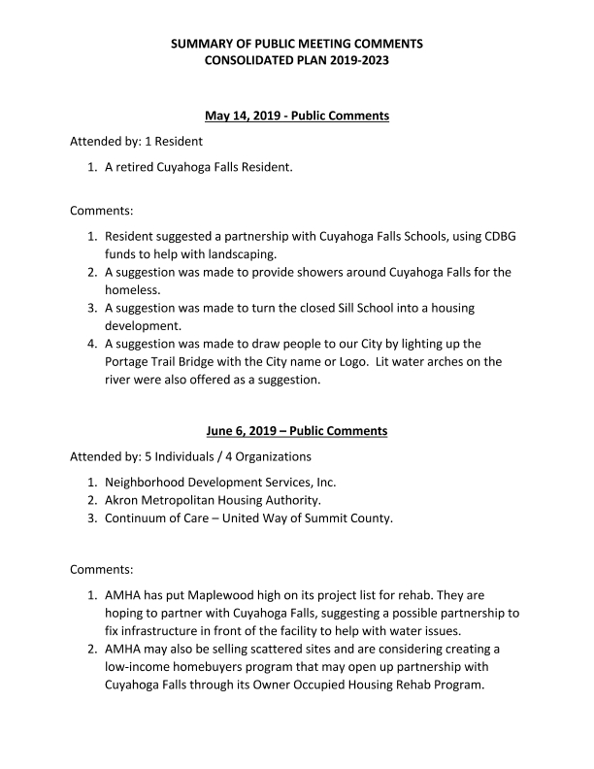
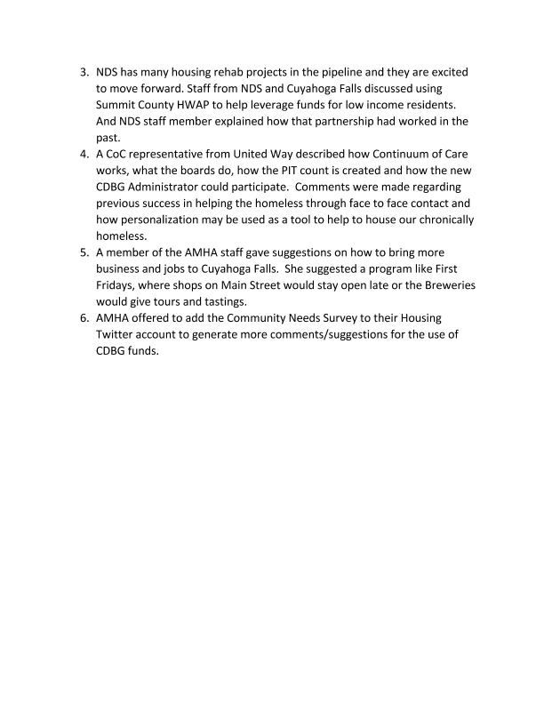
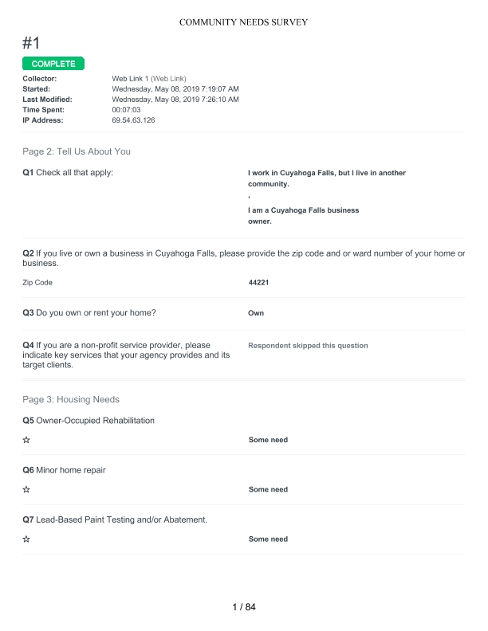
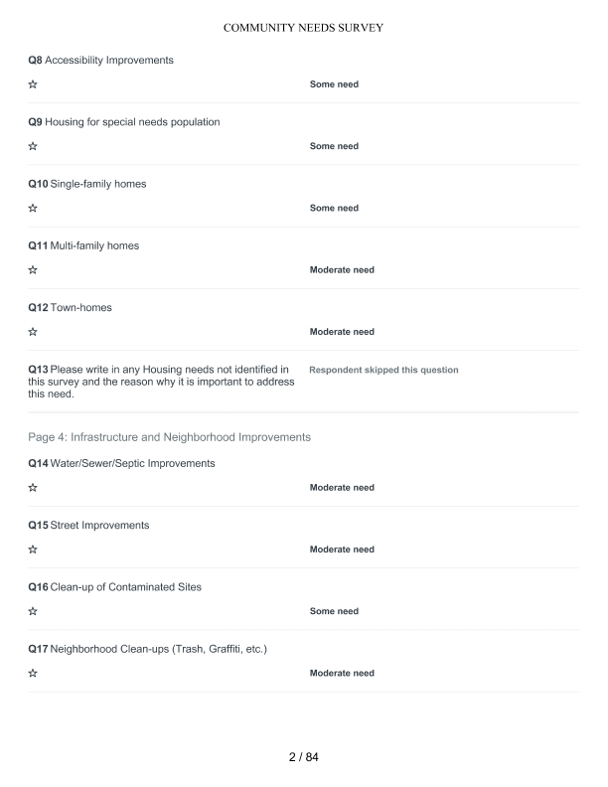
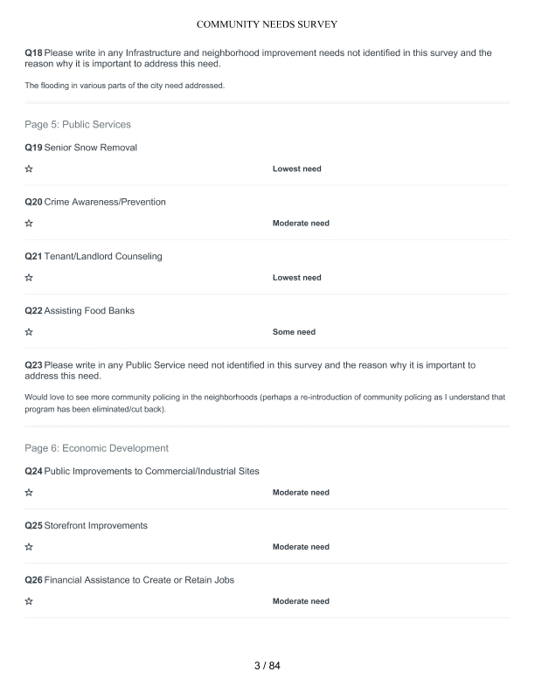
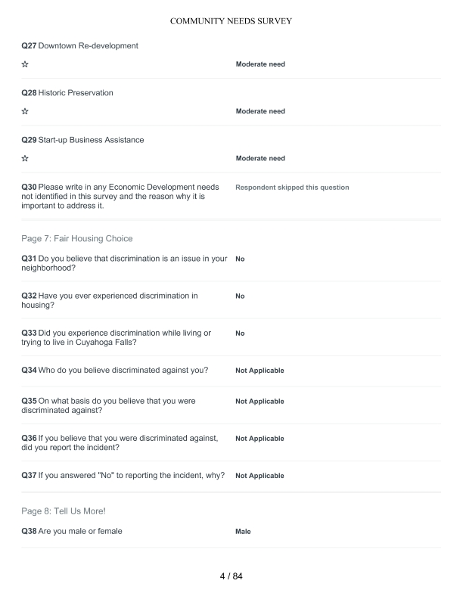
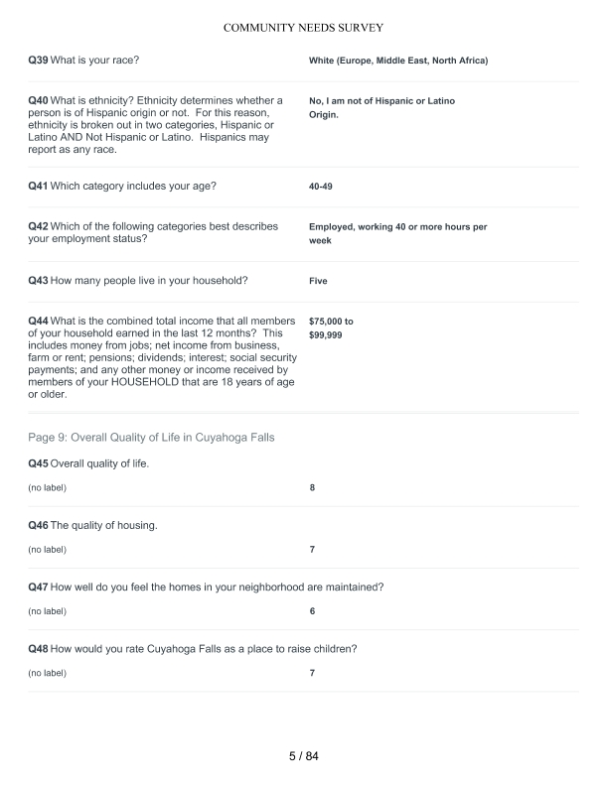
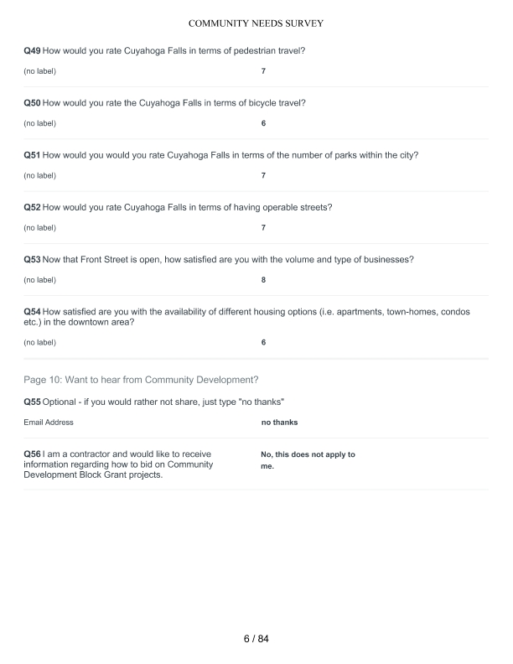
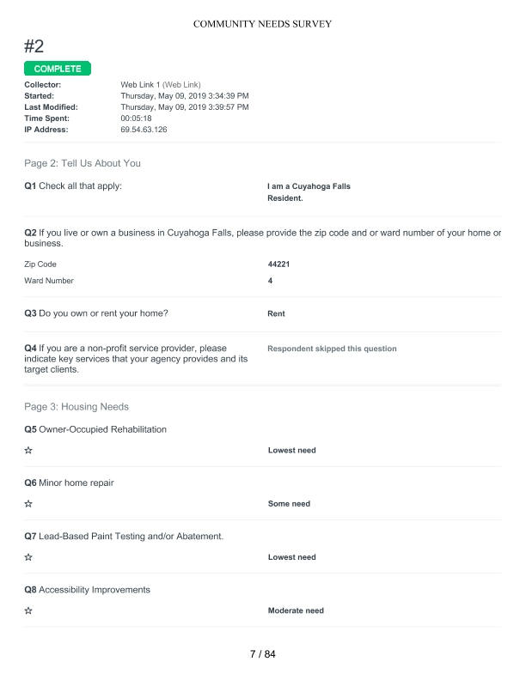
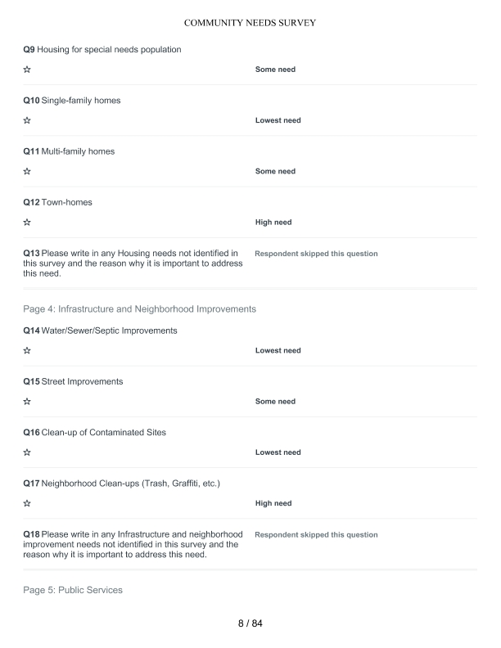
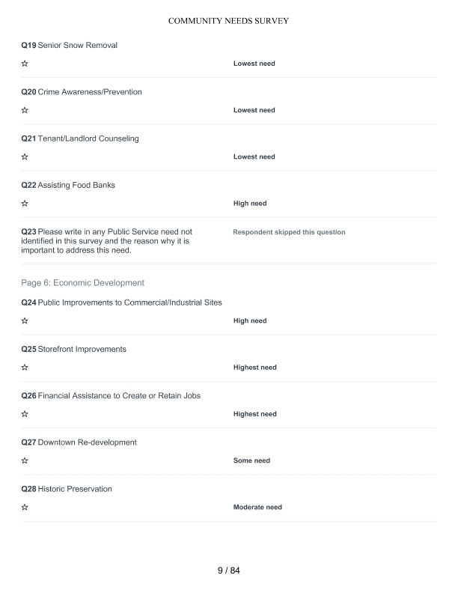
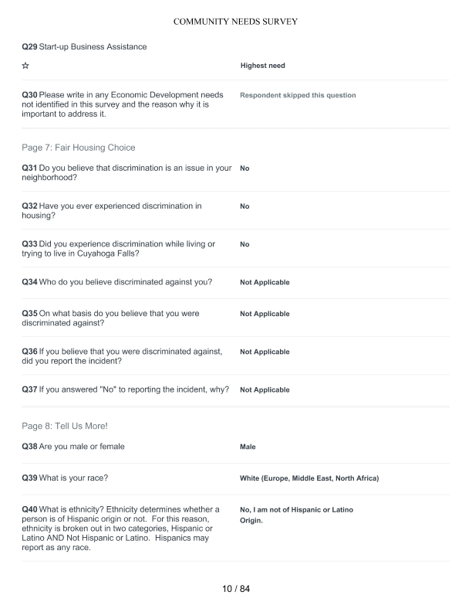
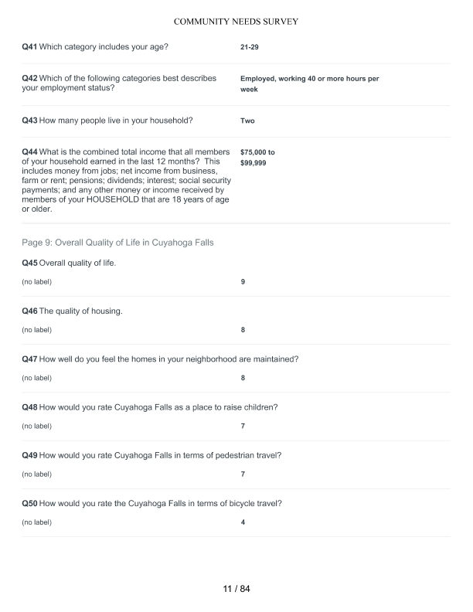
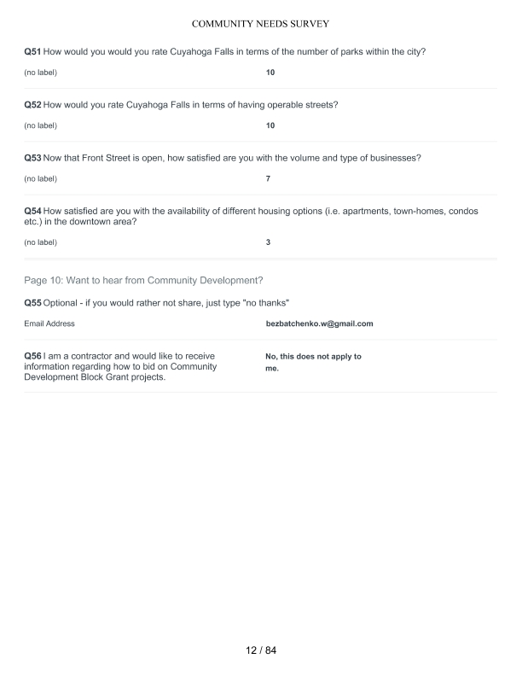
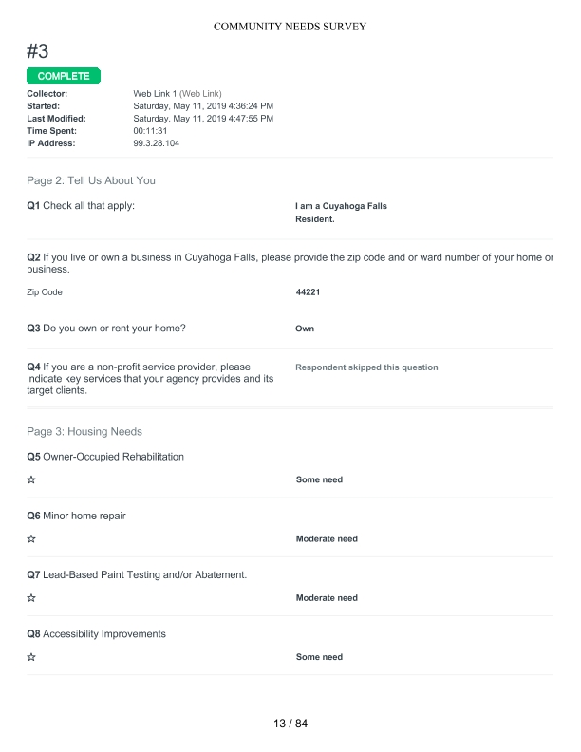
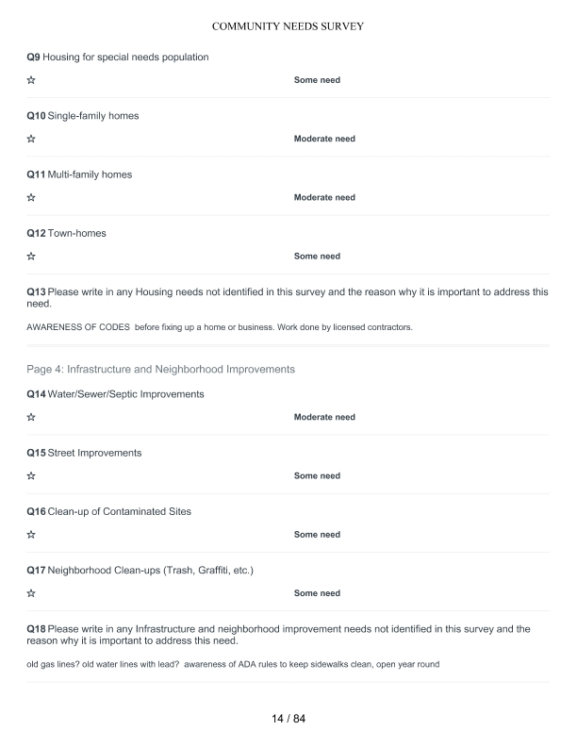
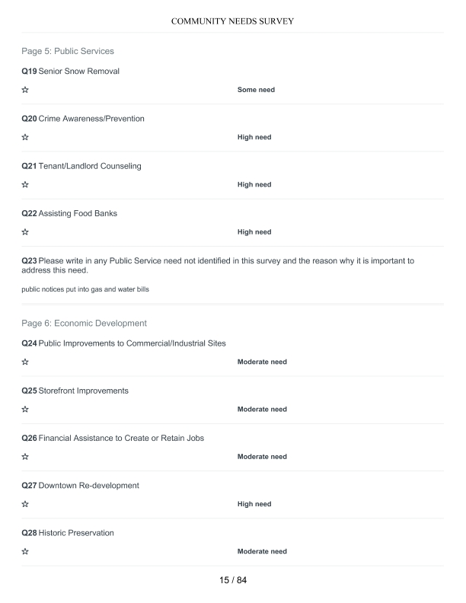
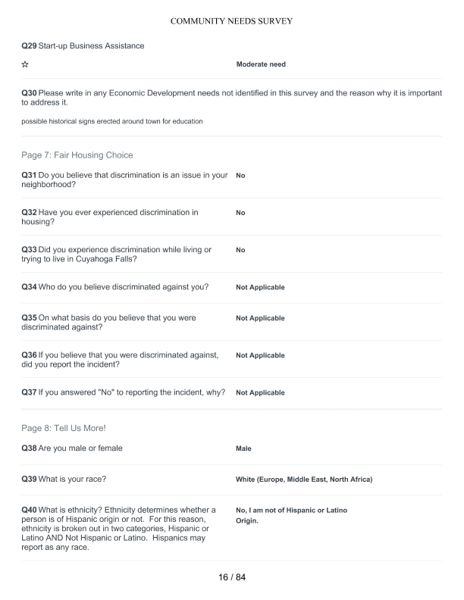
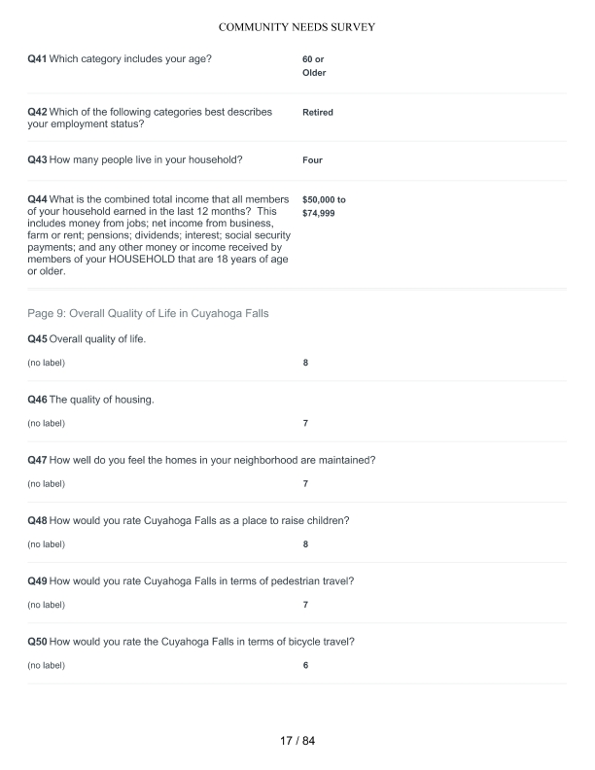
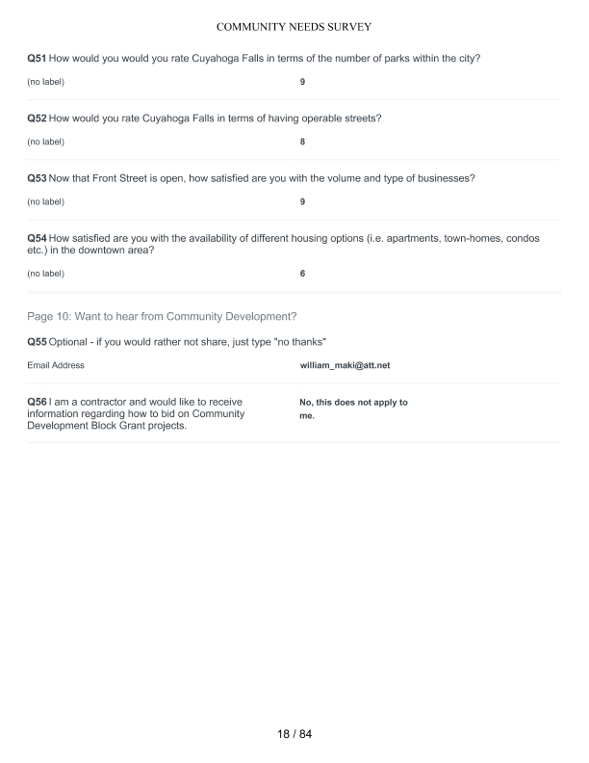
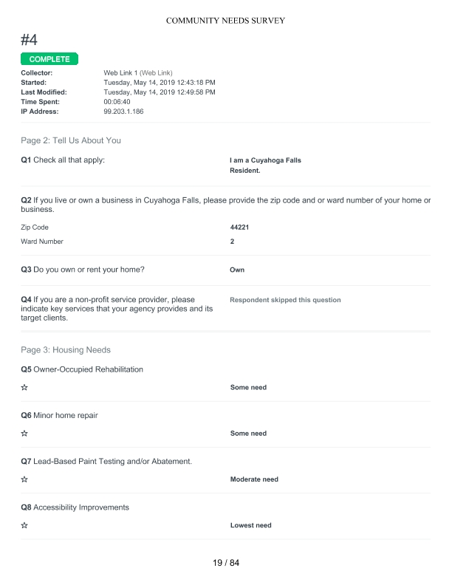
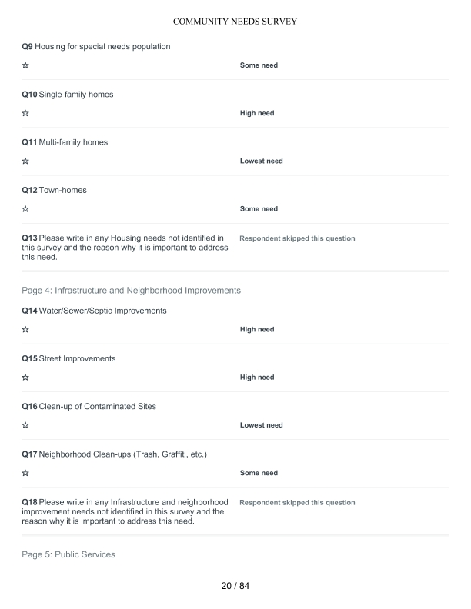
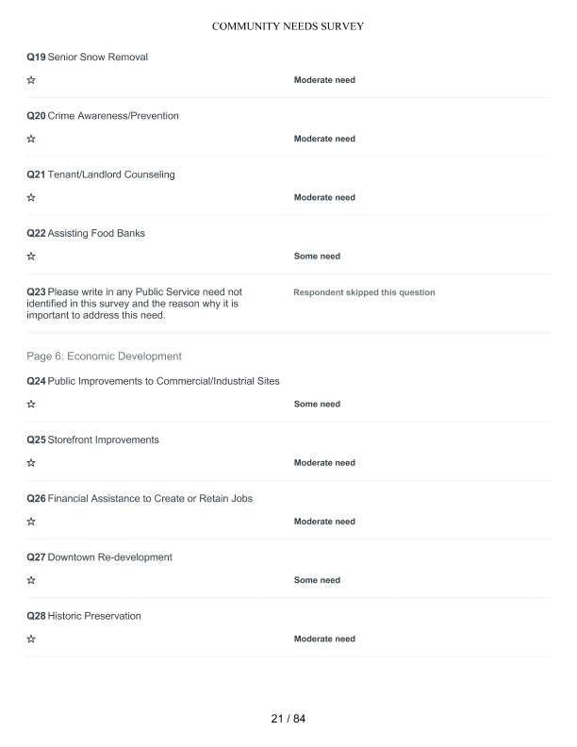
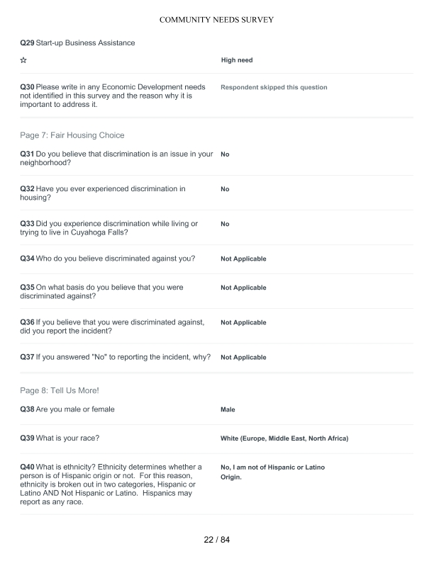
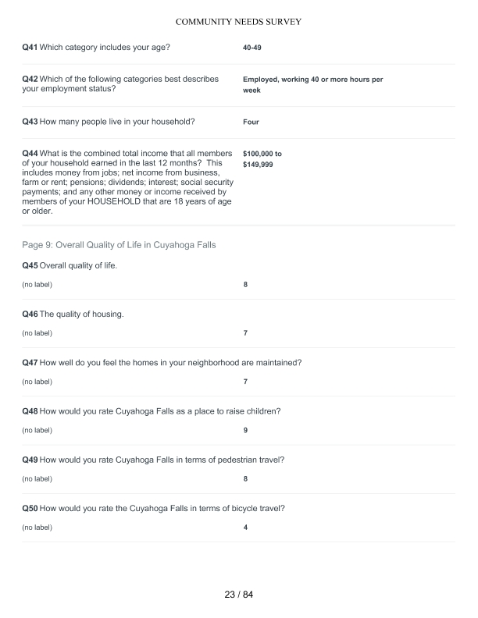
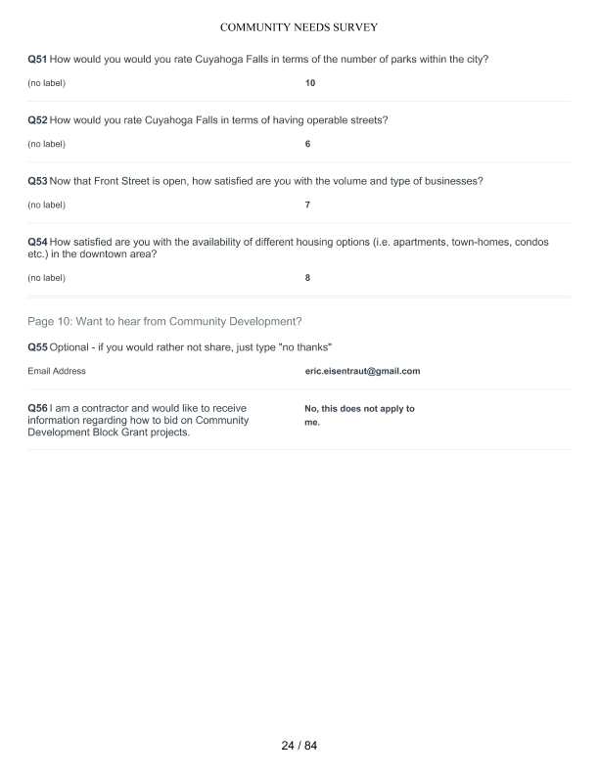
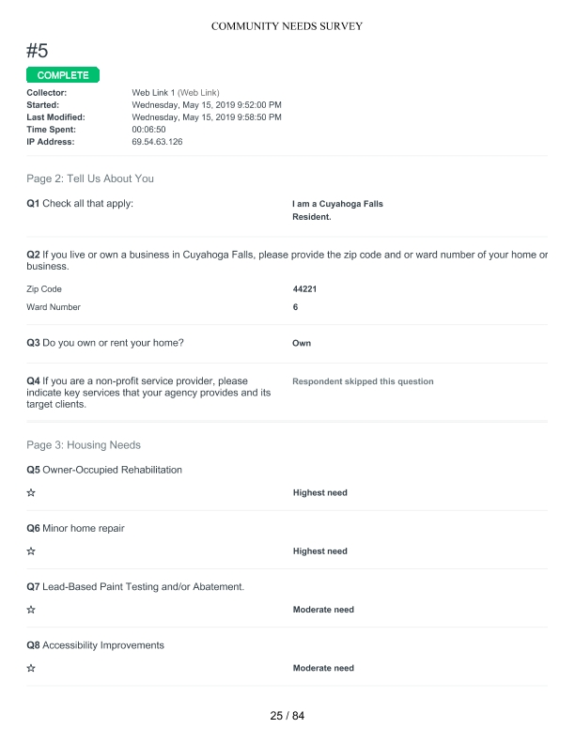
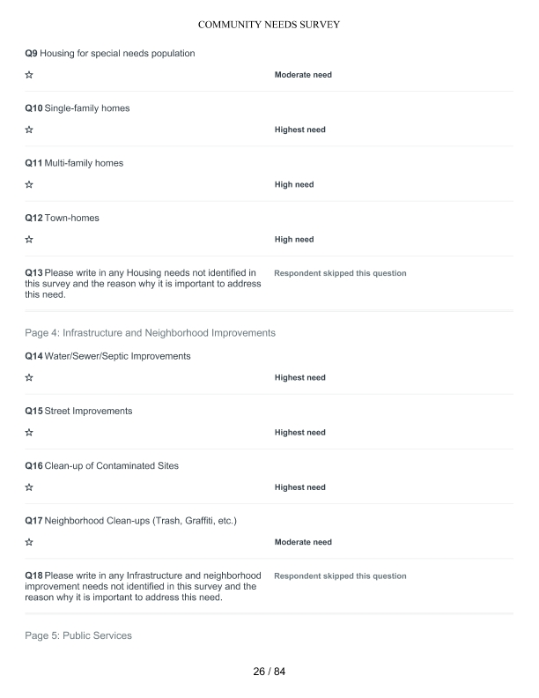
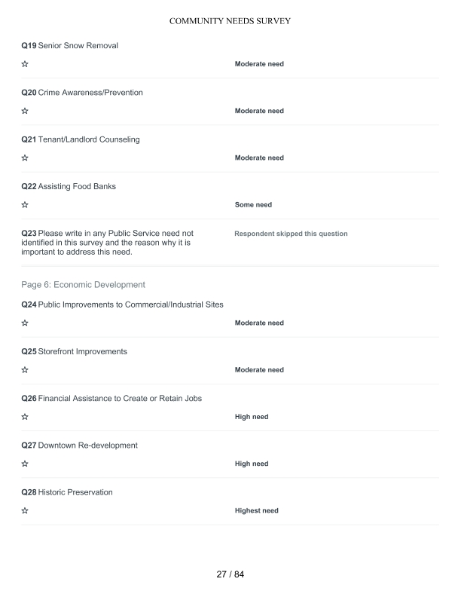
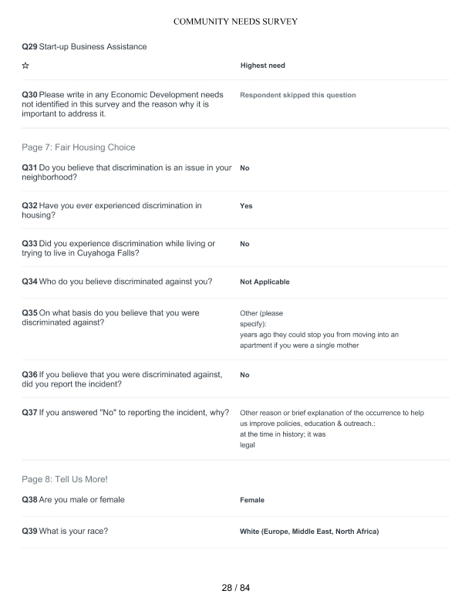
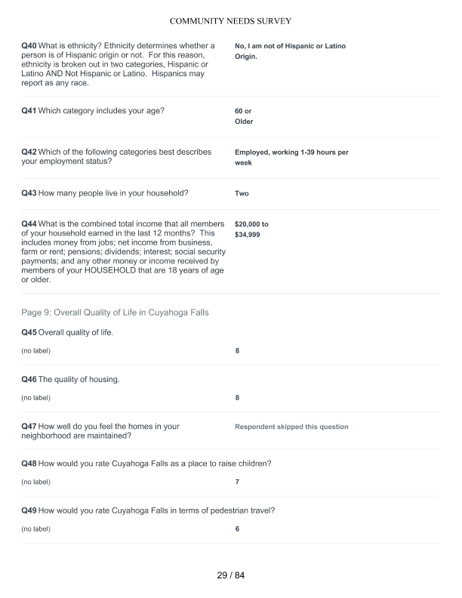
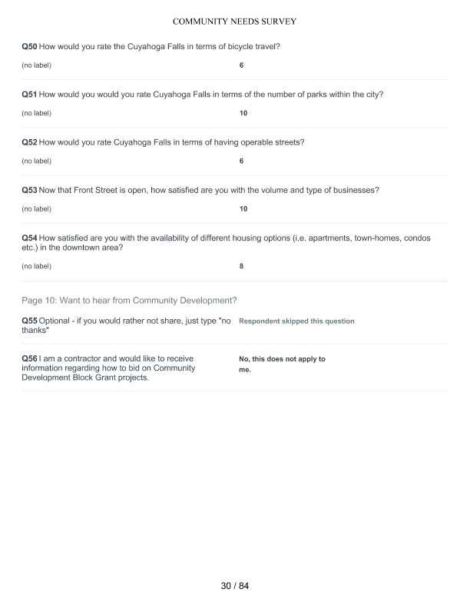
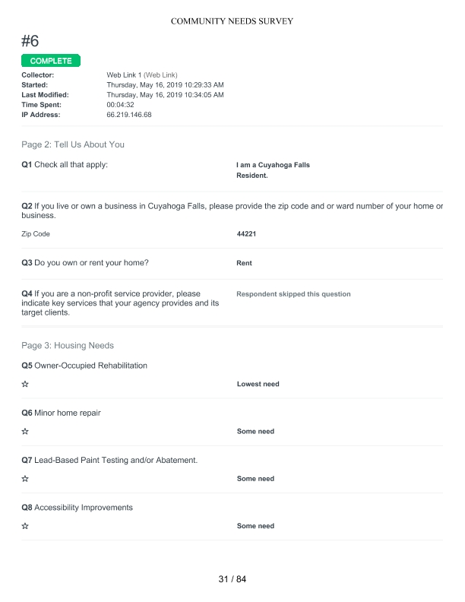
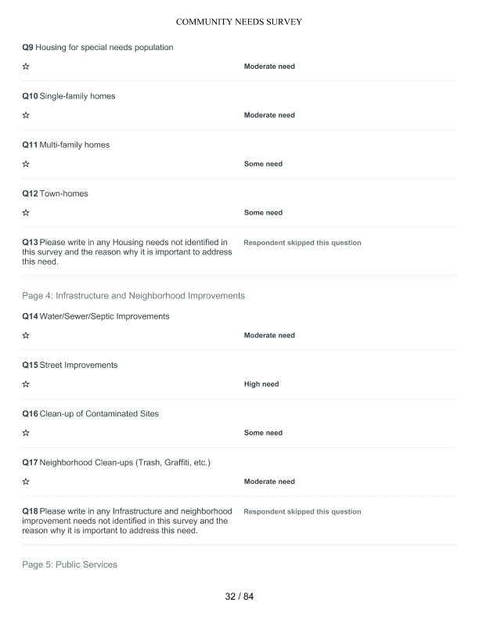
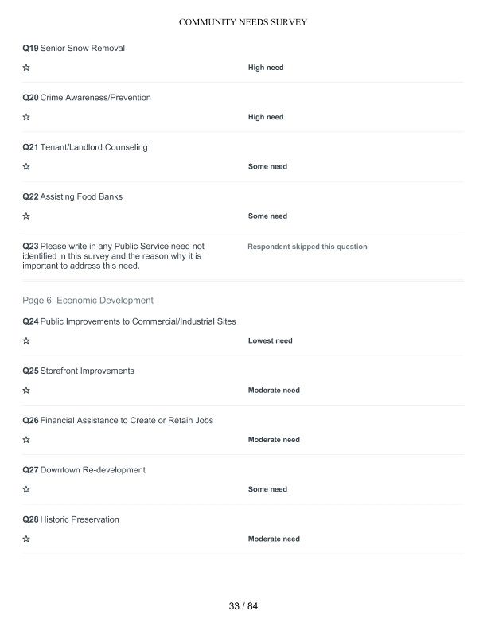
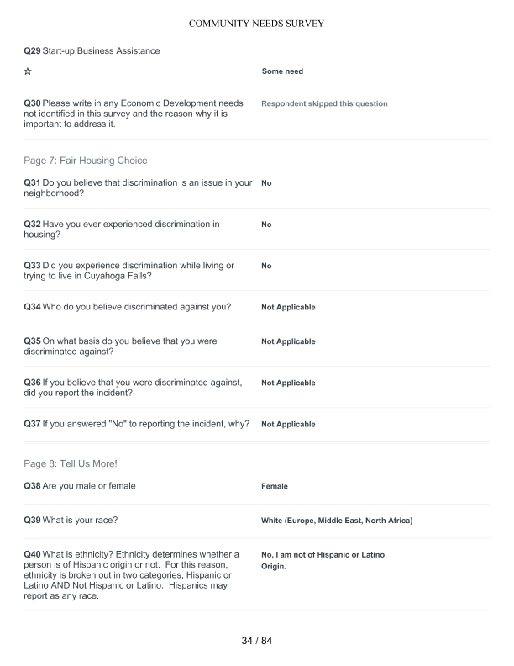
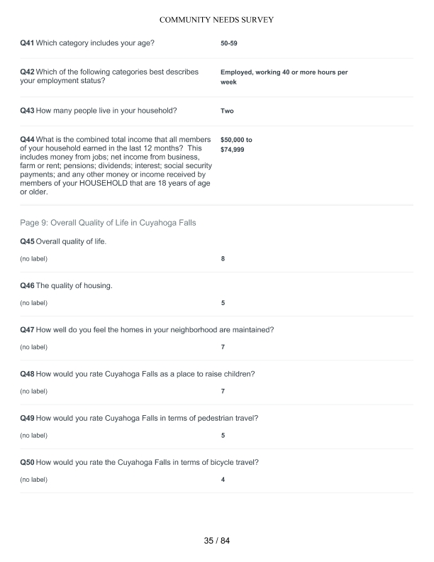
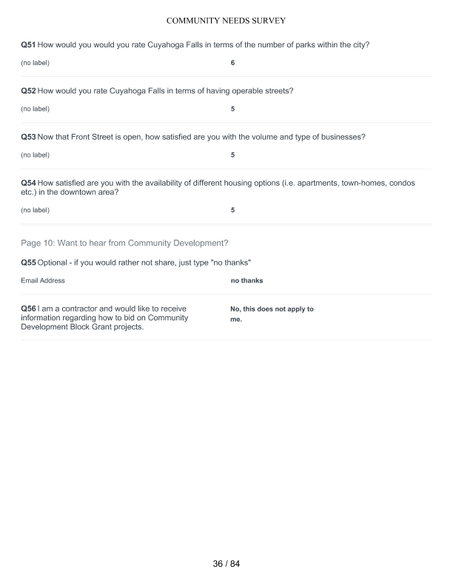
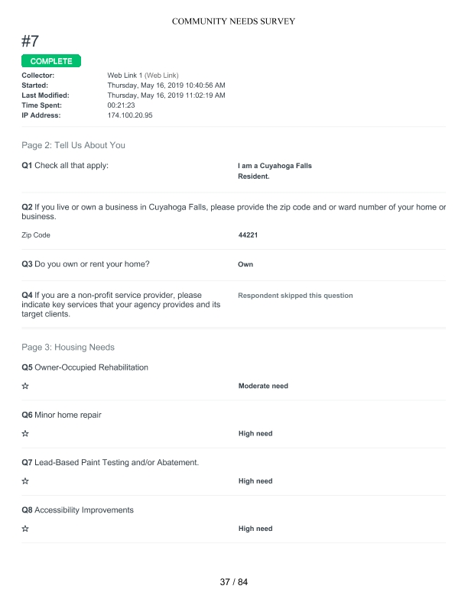
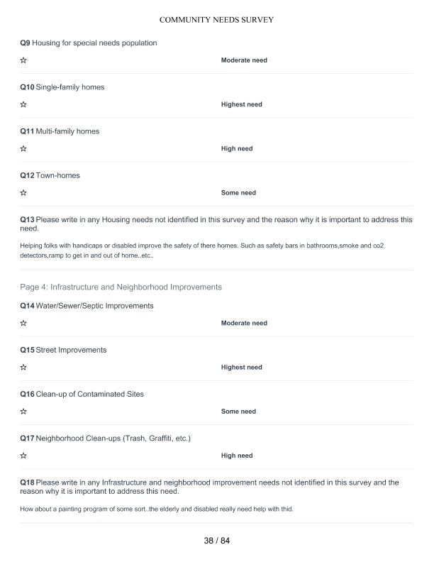
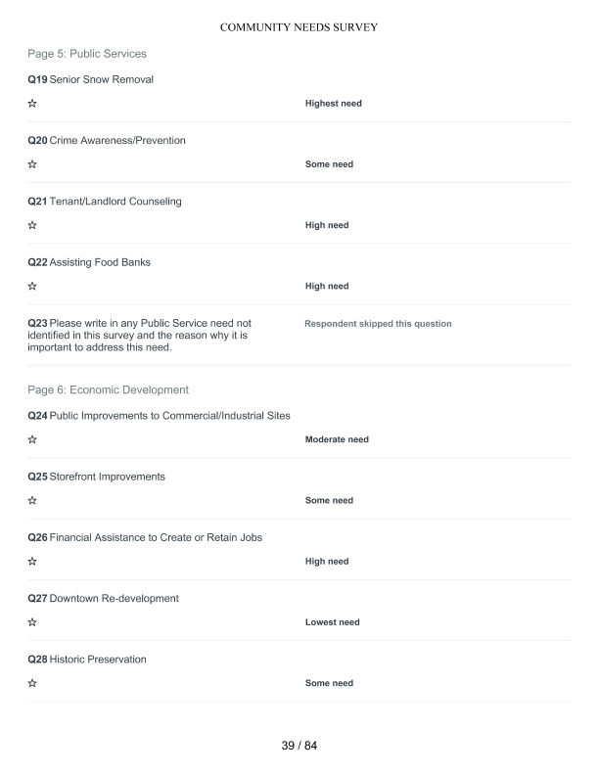
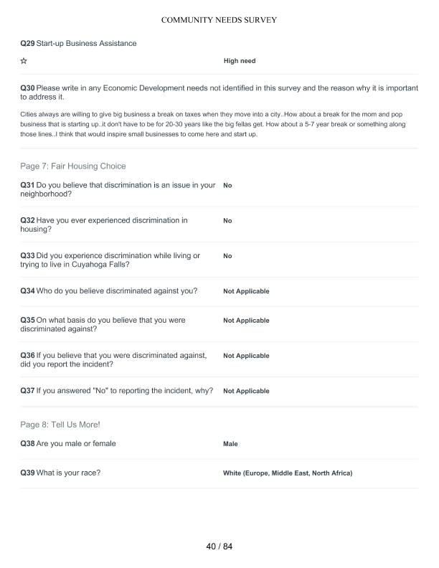
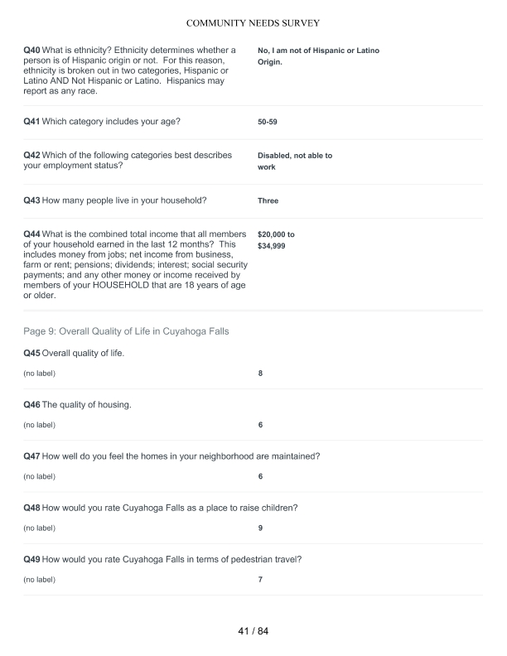
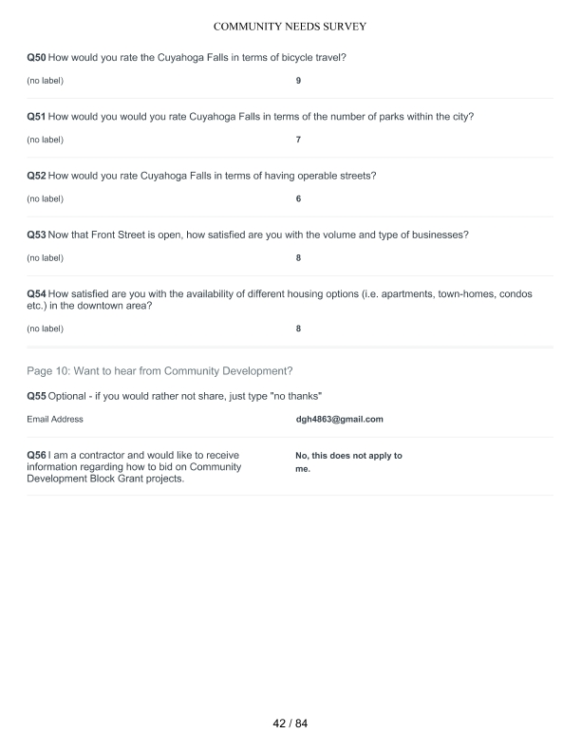
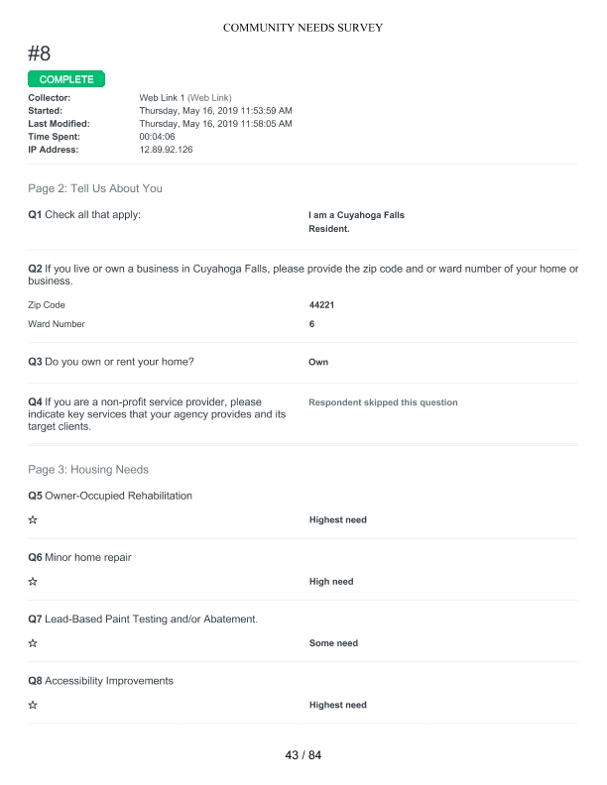
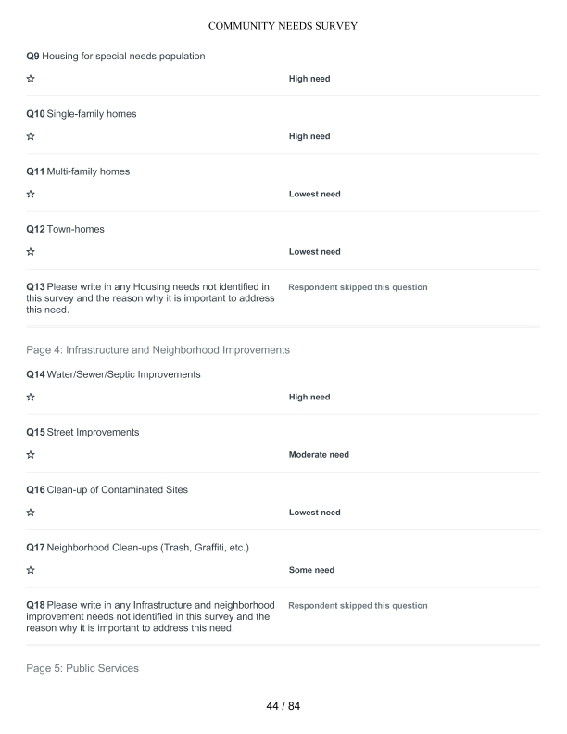
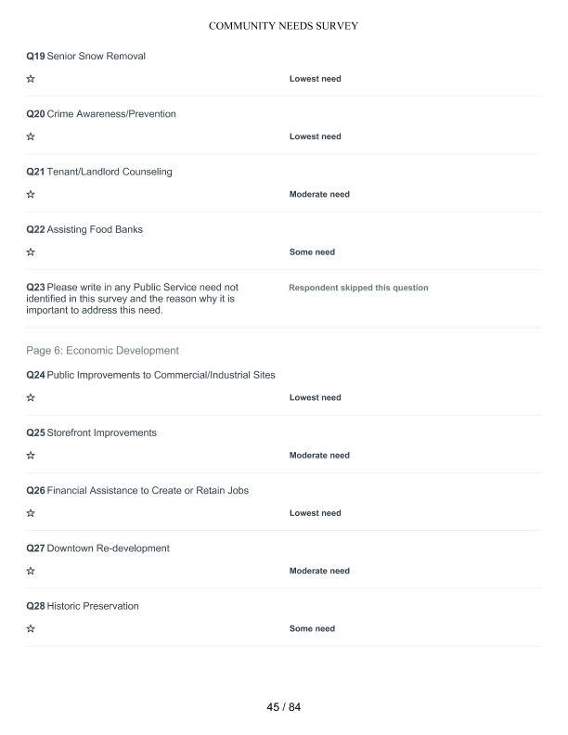
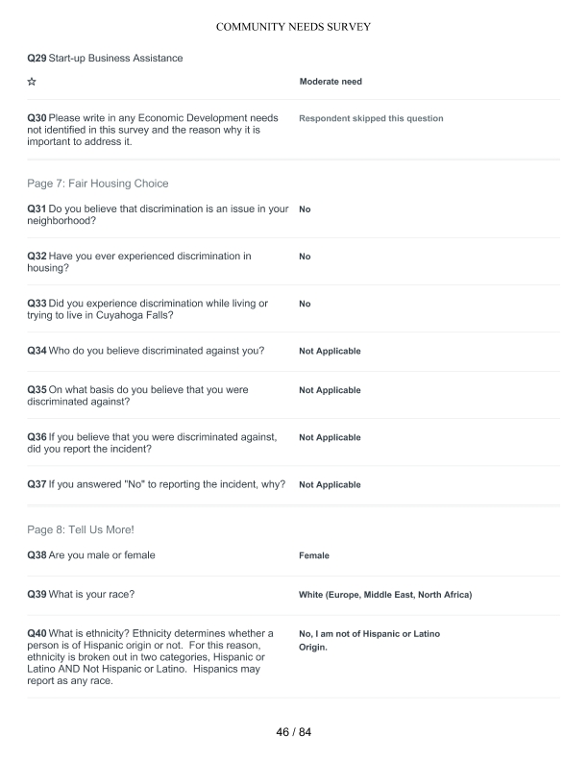
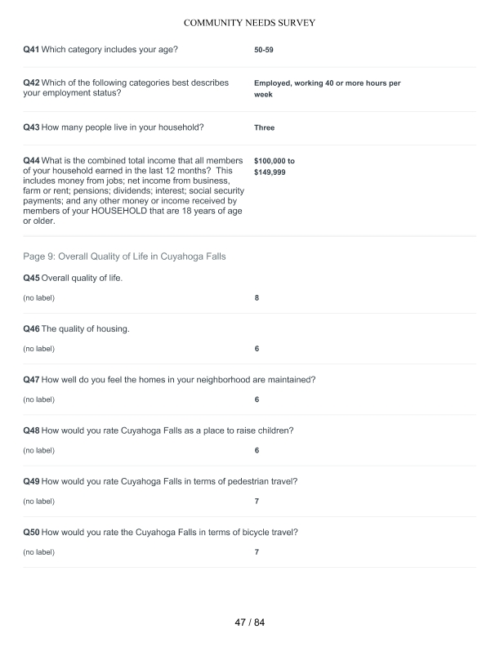
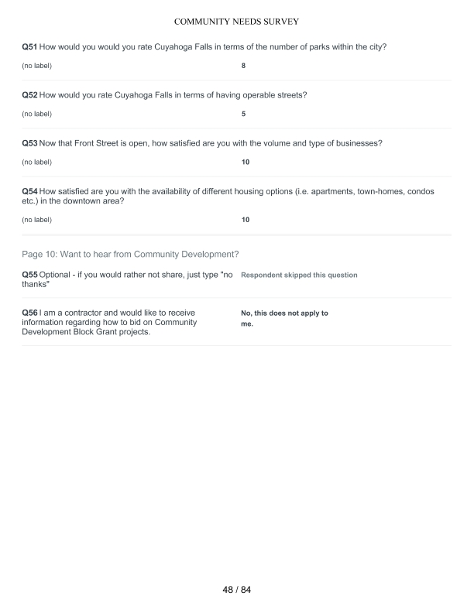
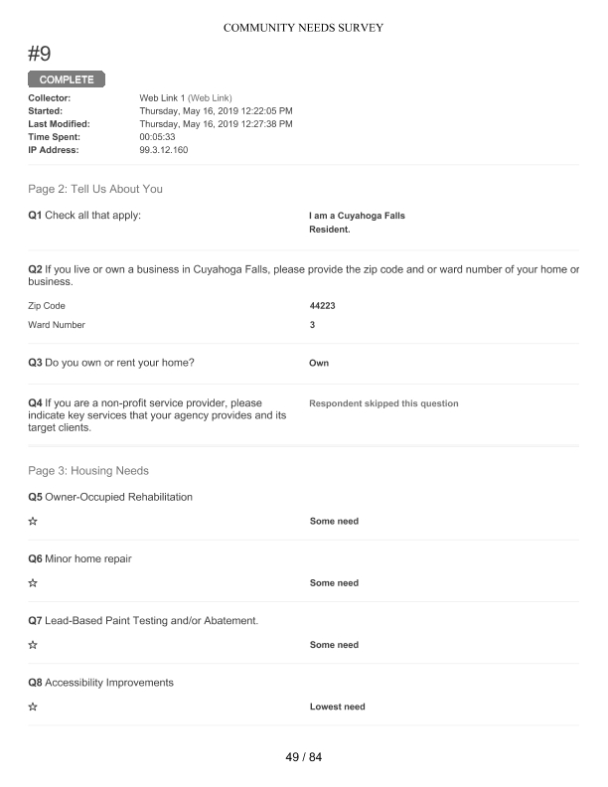
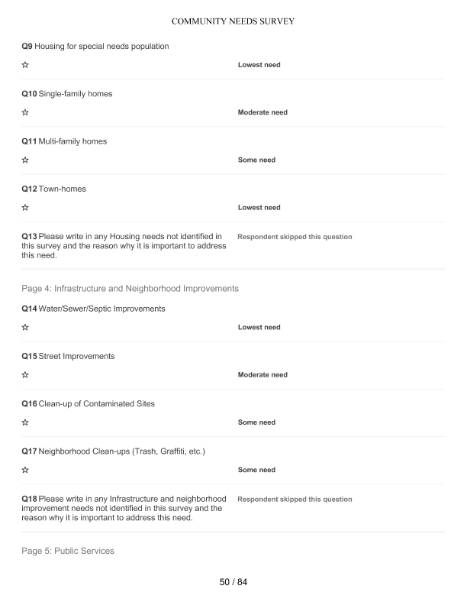
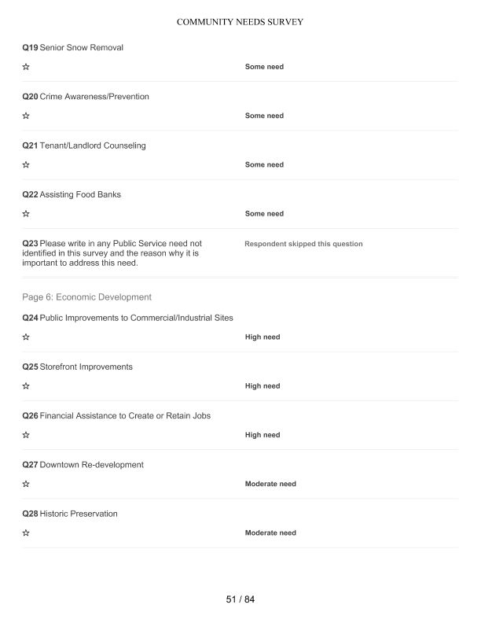
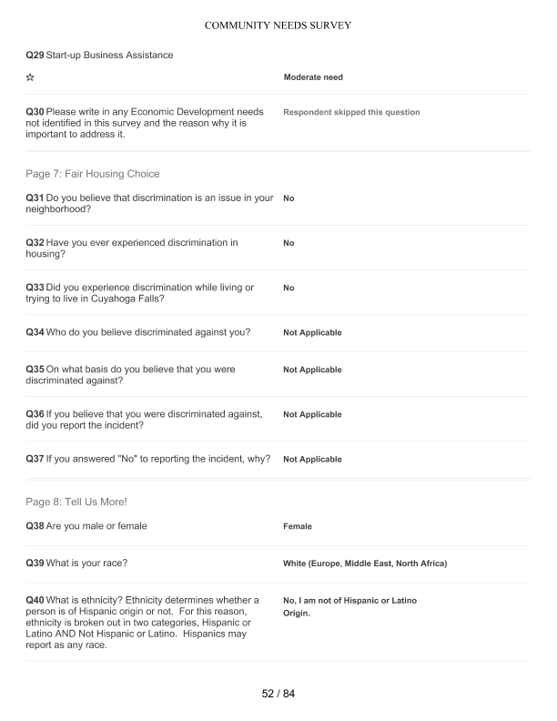
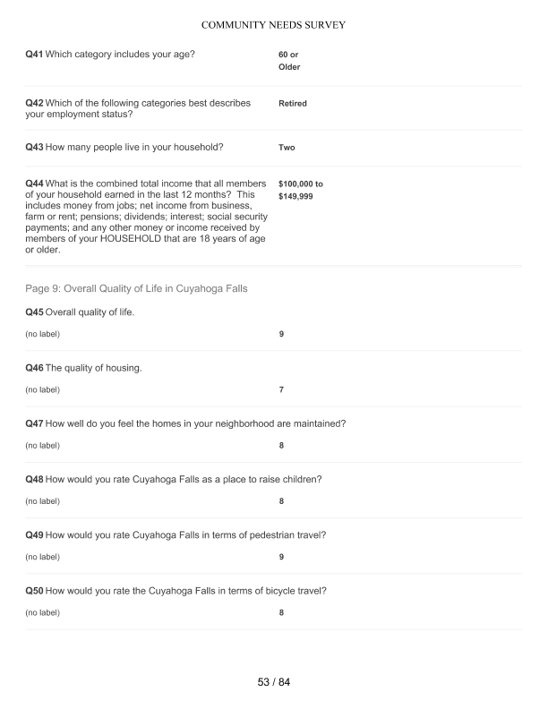
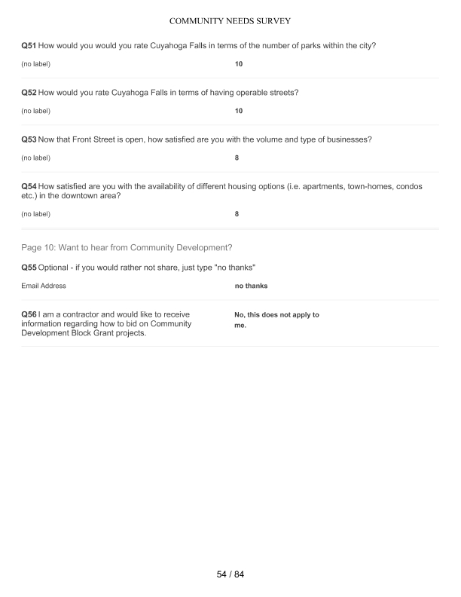
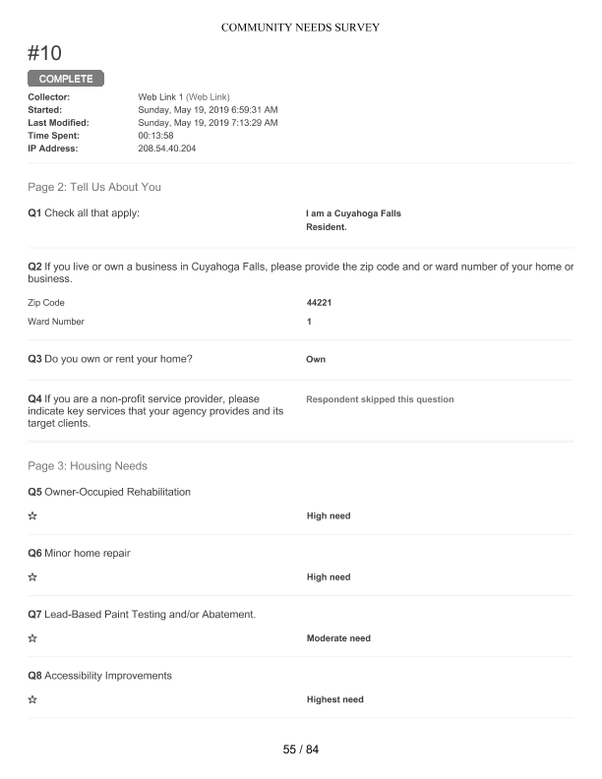
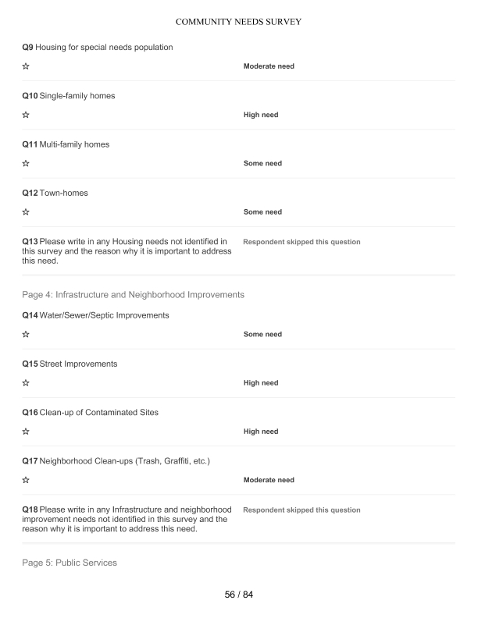
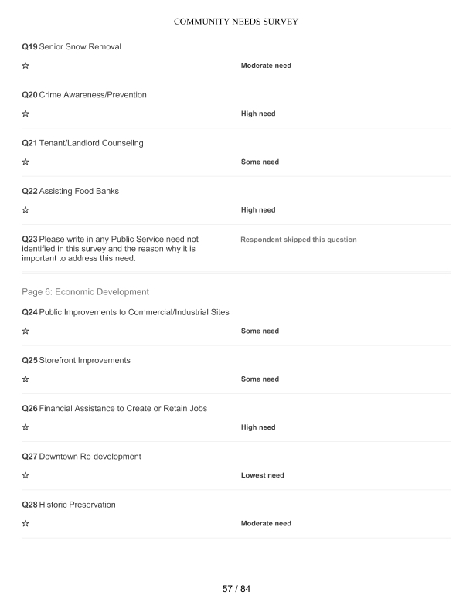
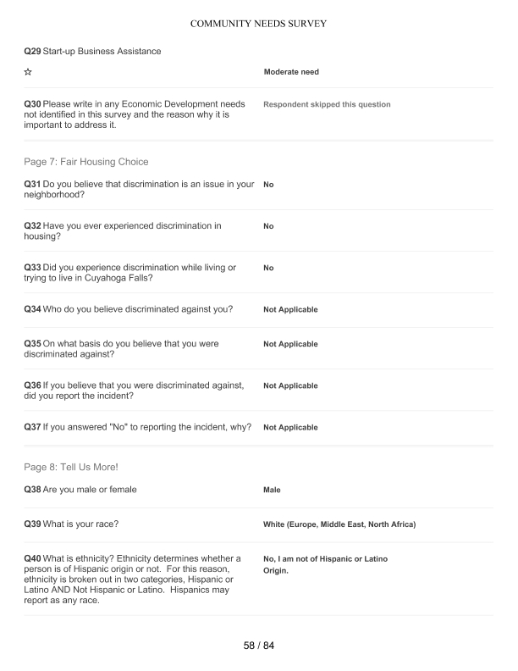
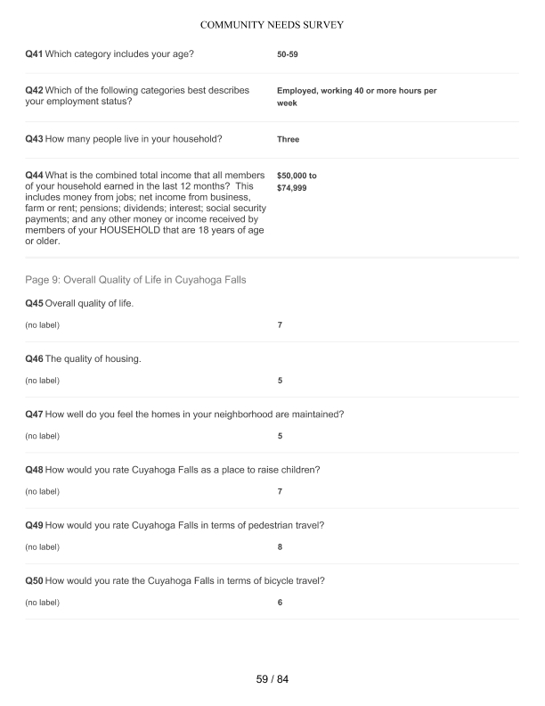
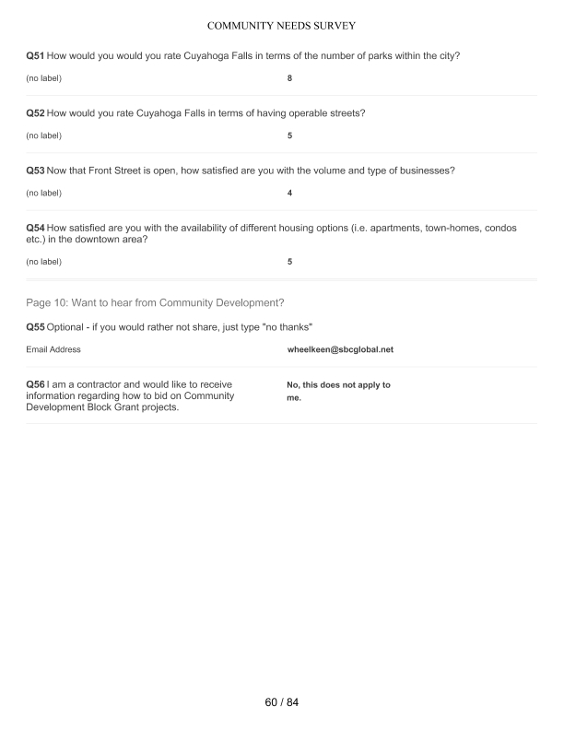
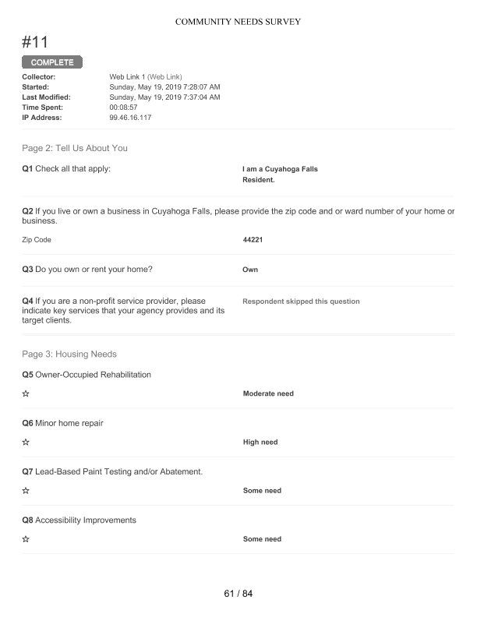
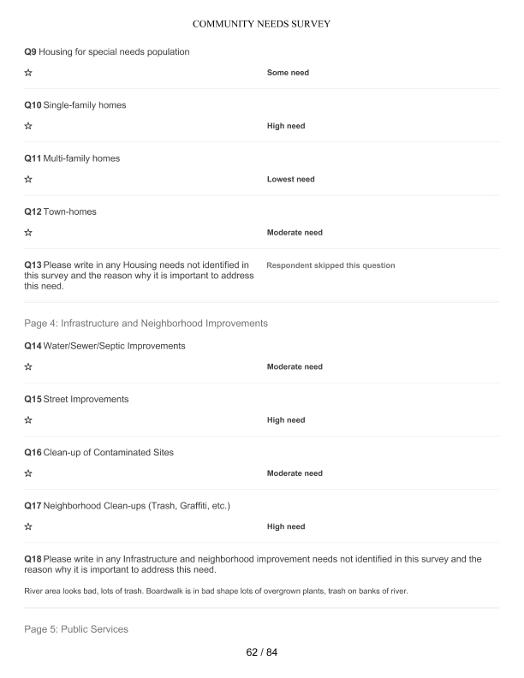
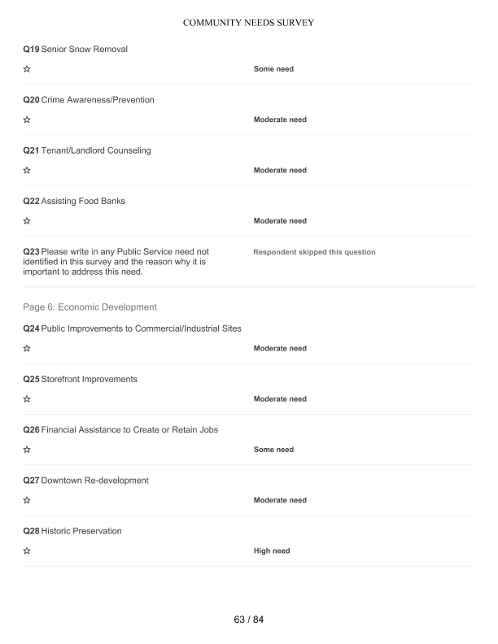
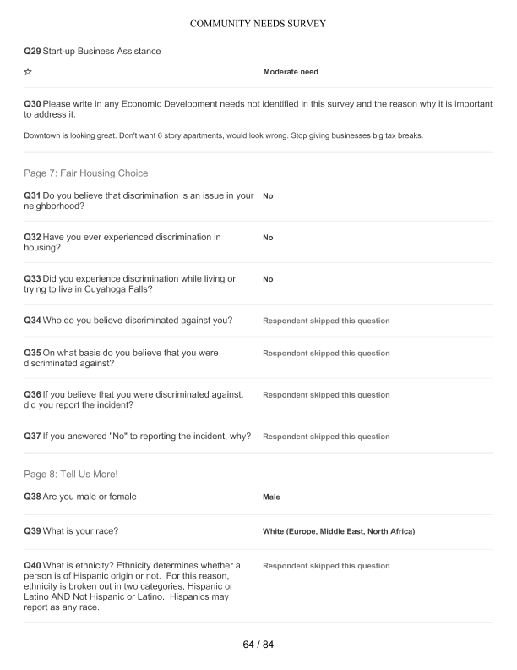
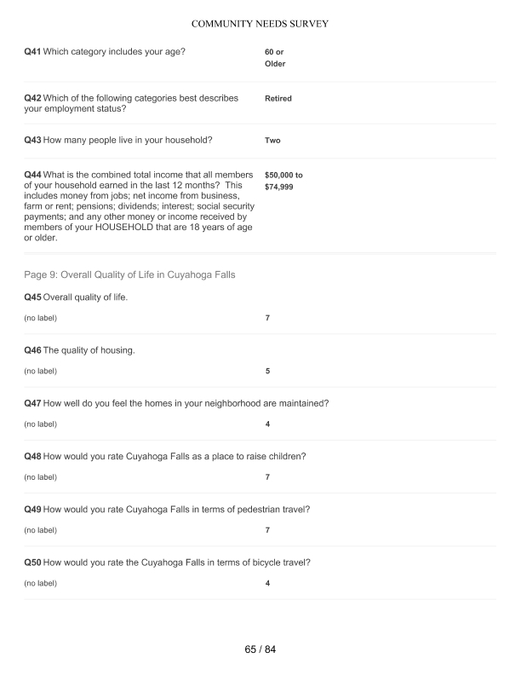
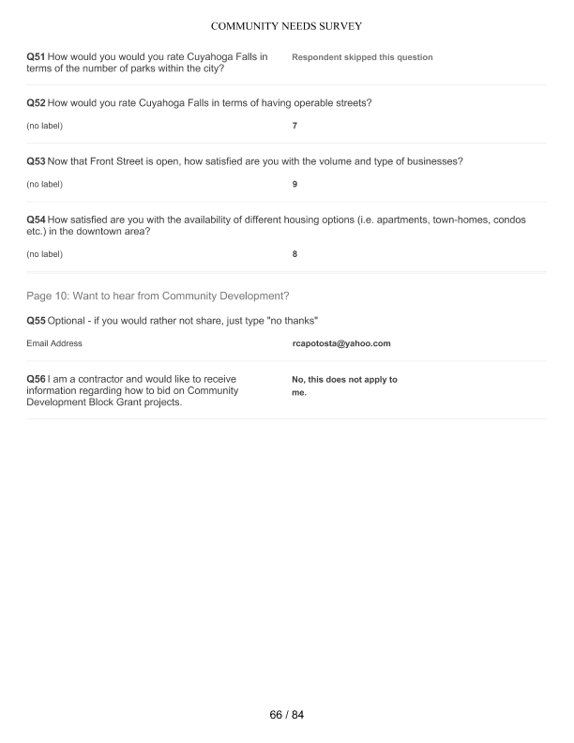
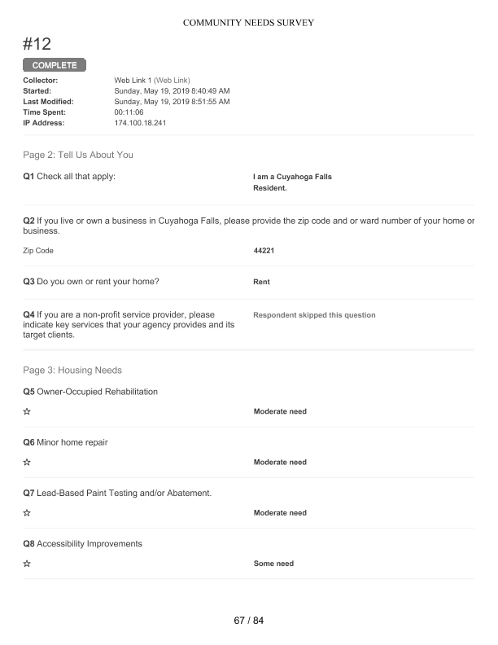
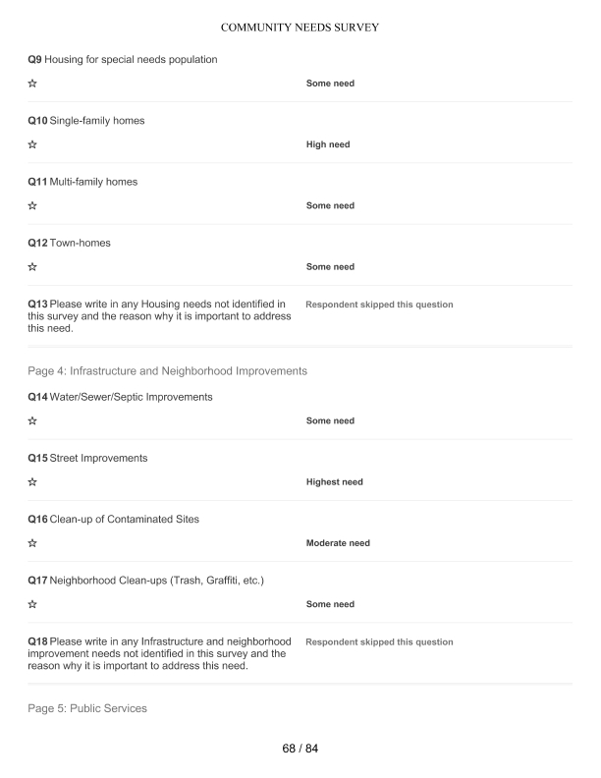
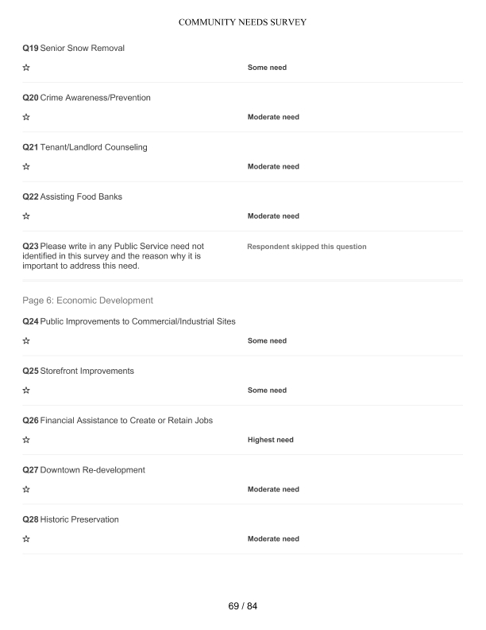
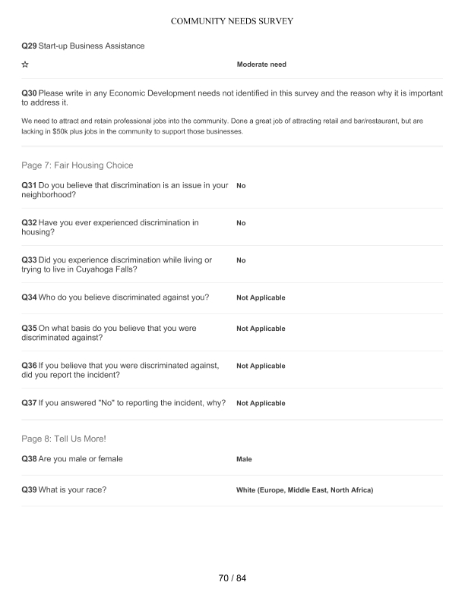
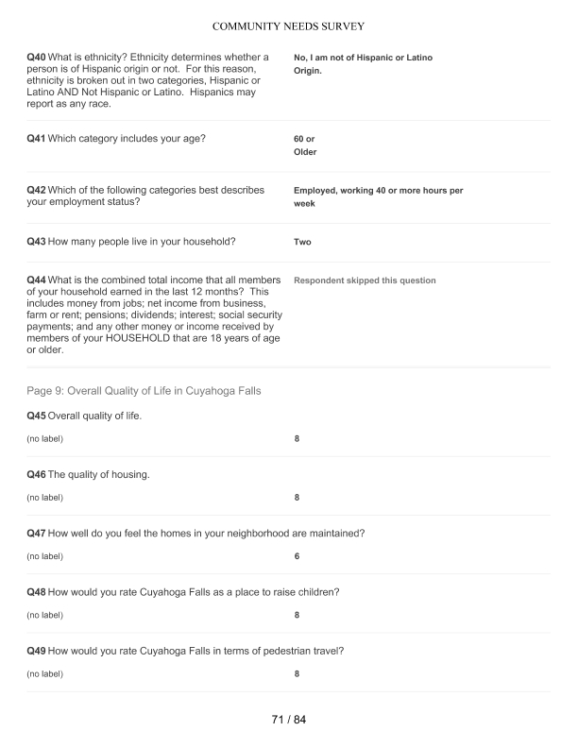
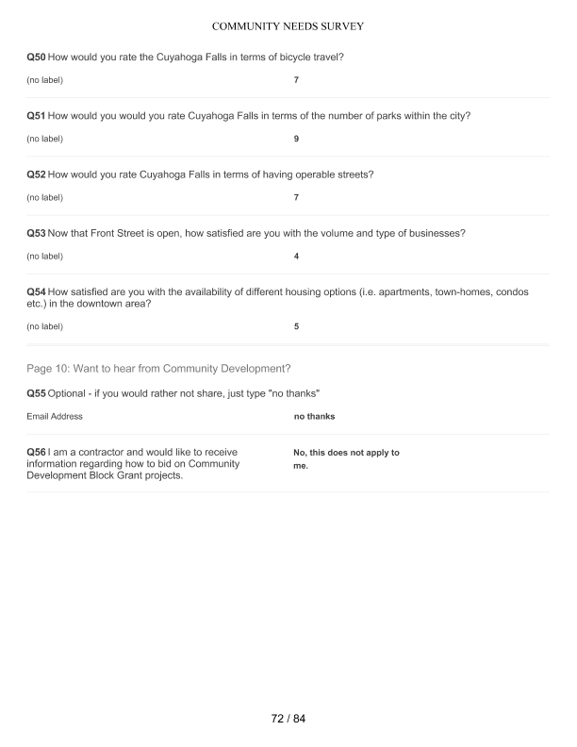
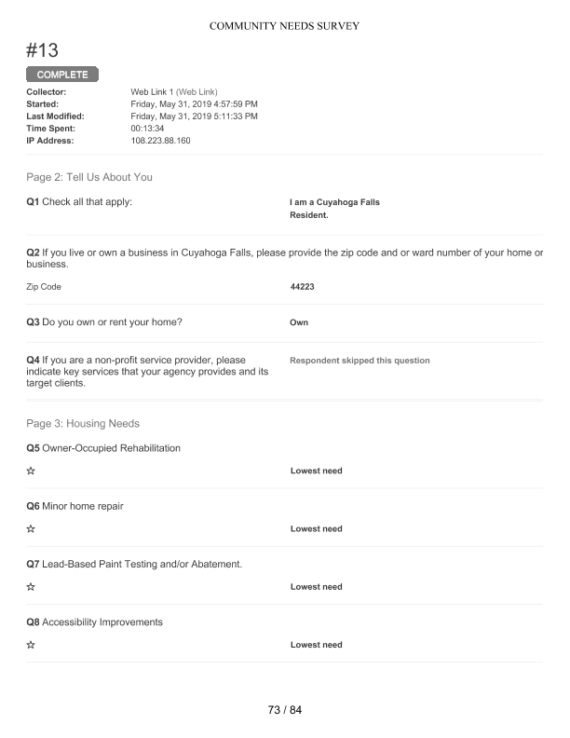
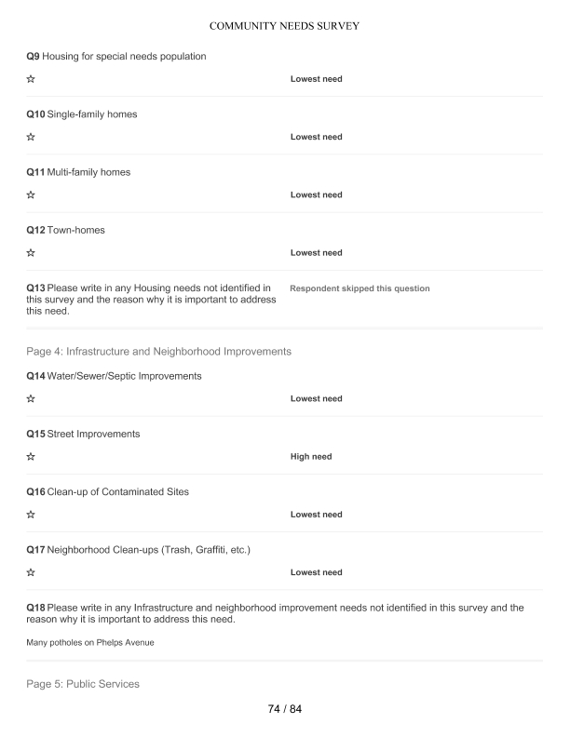
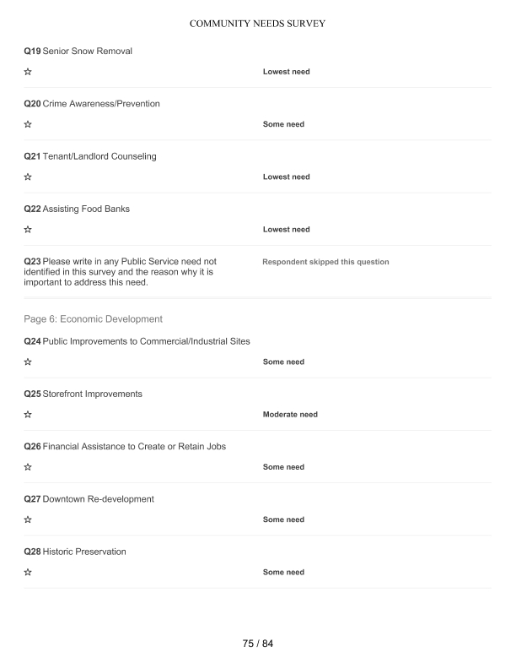
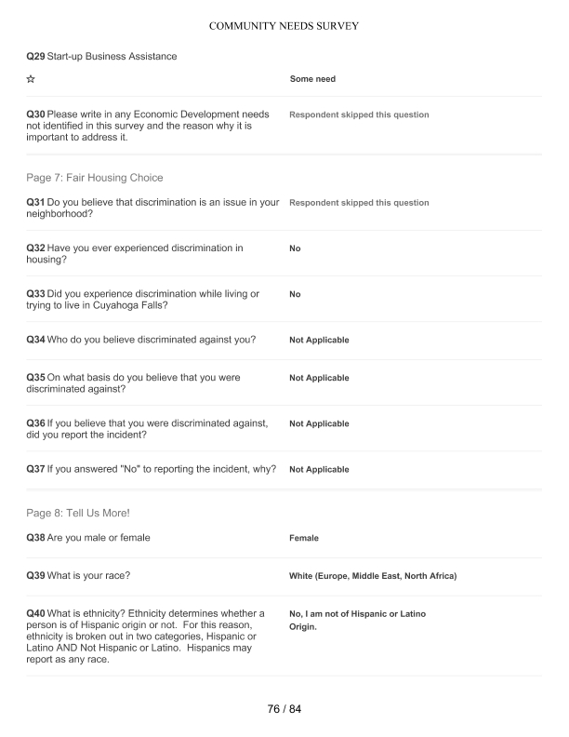
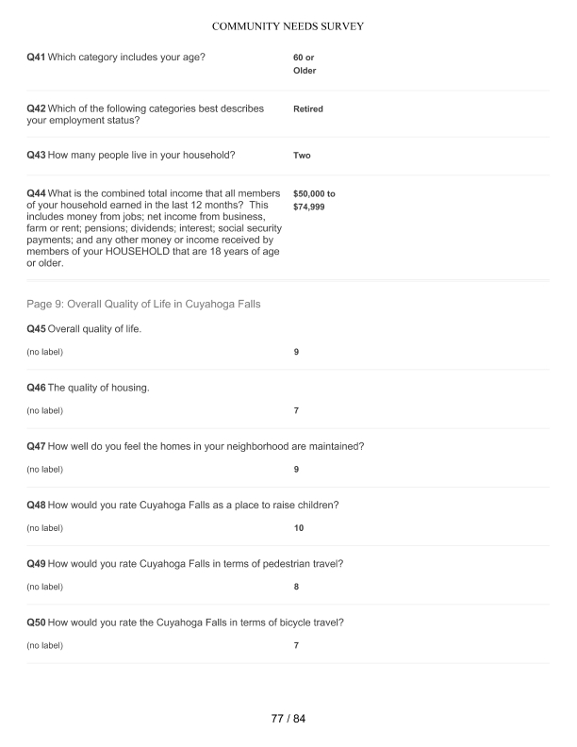
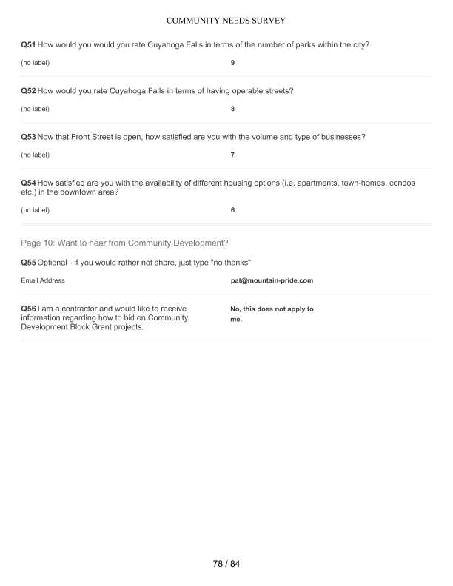
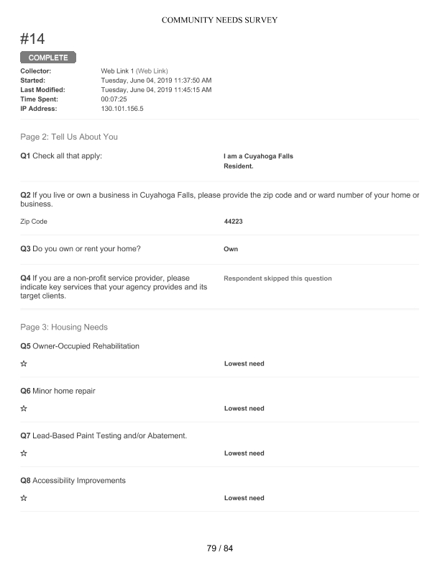
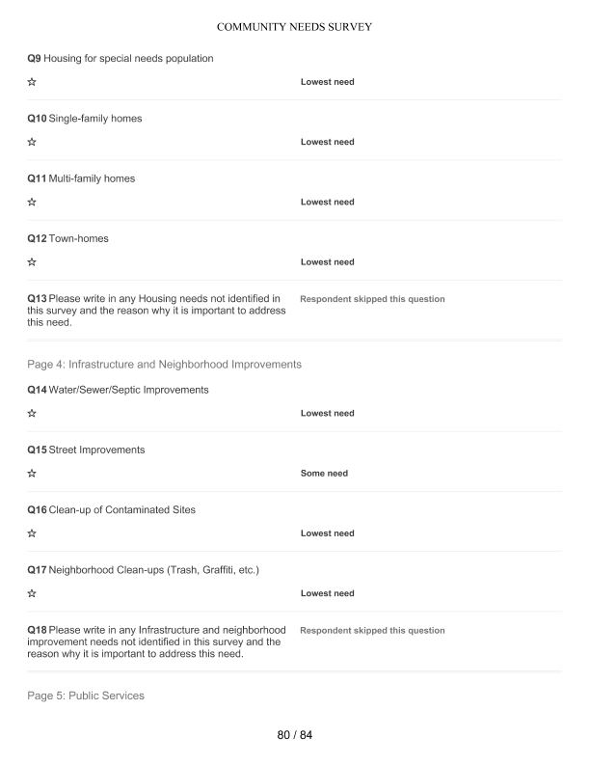
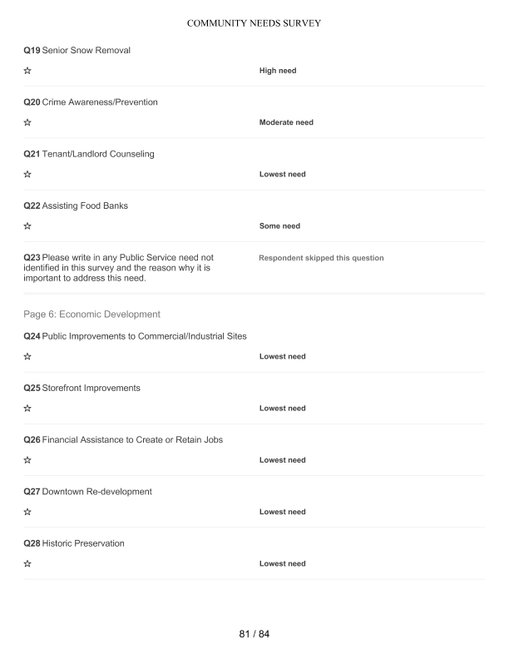
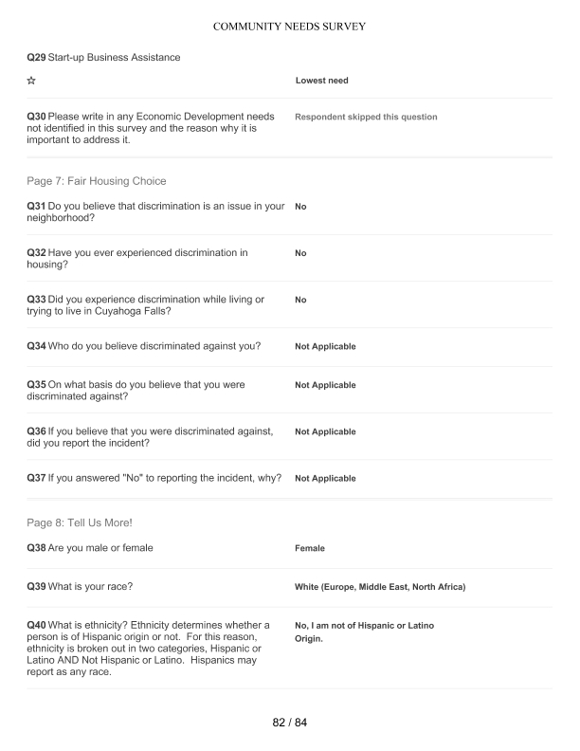
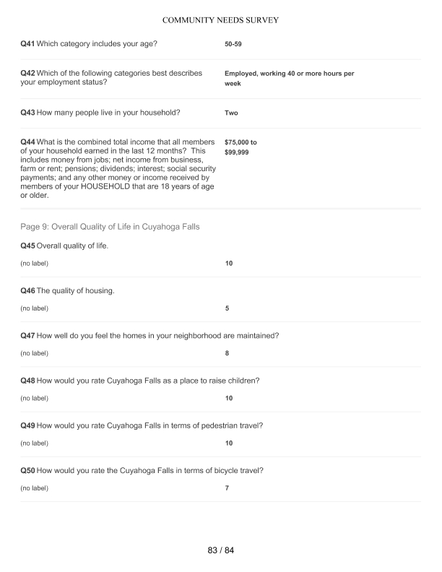
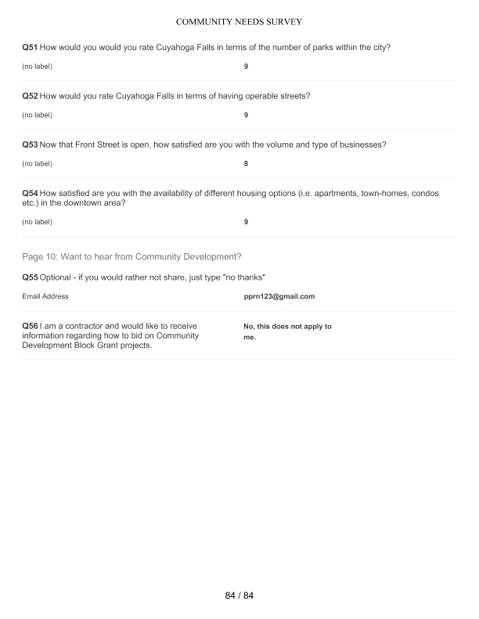

Grantee Unique Appendices
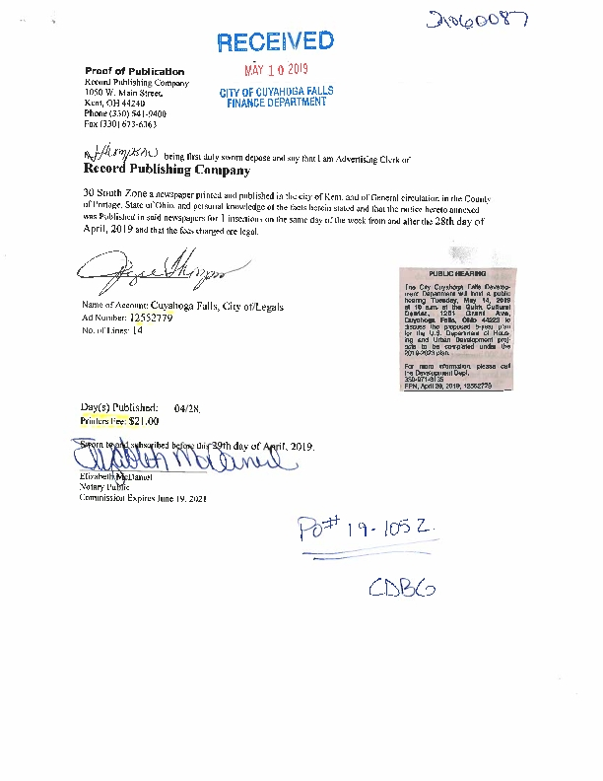
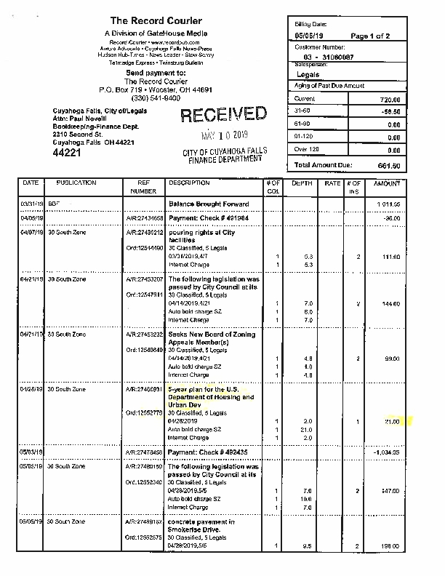
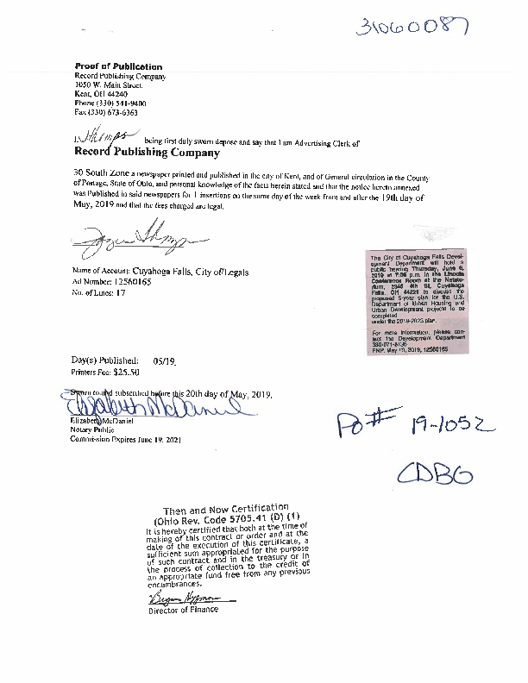
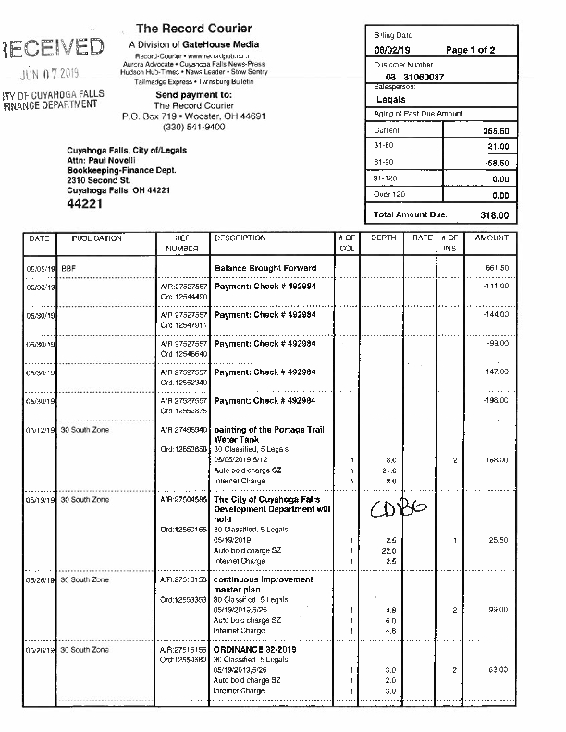
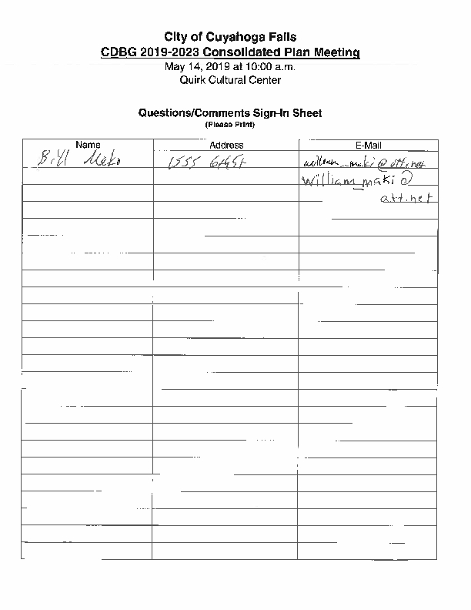
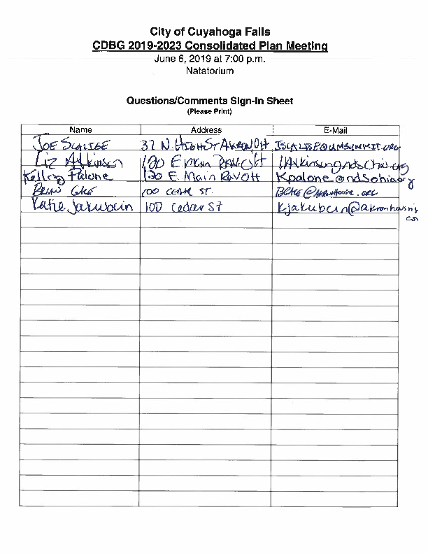
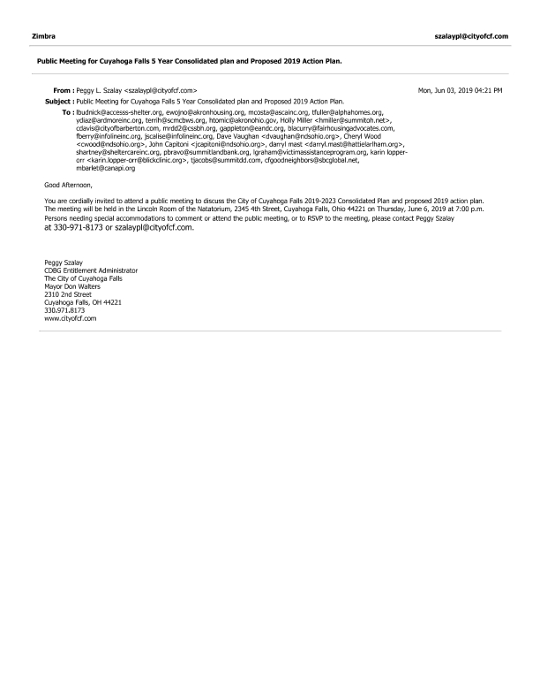
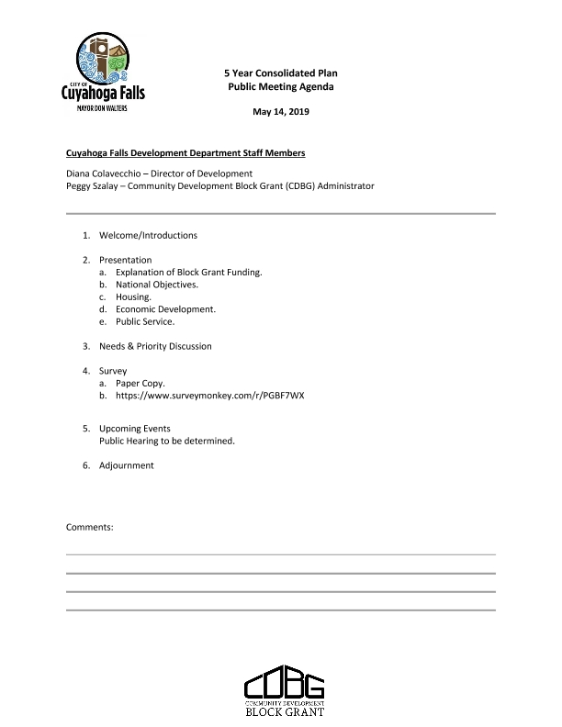
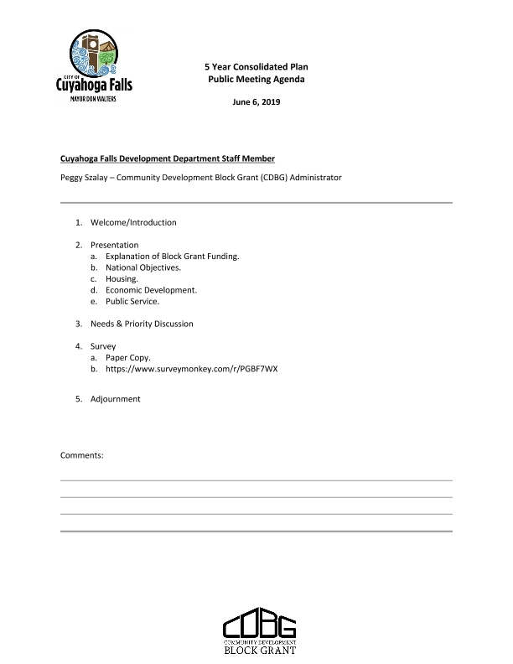
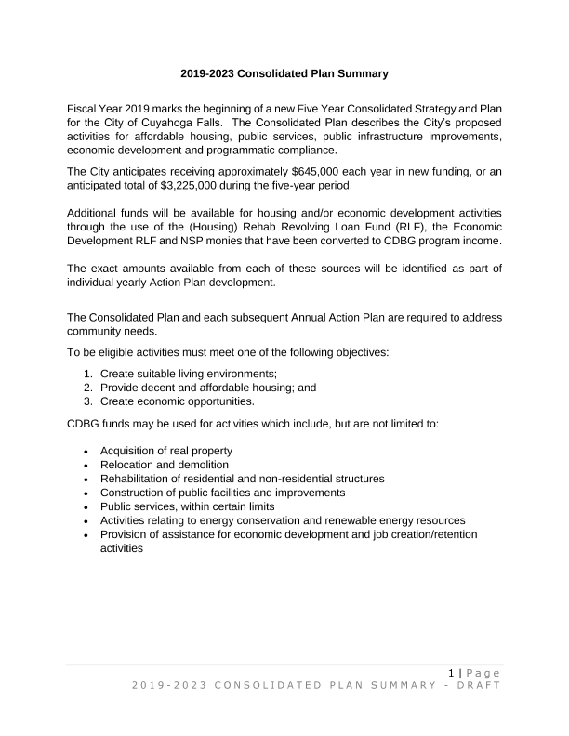
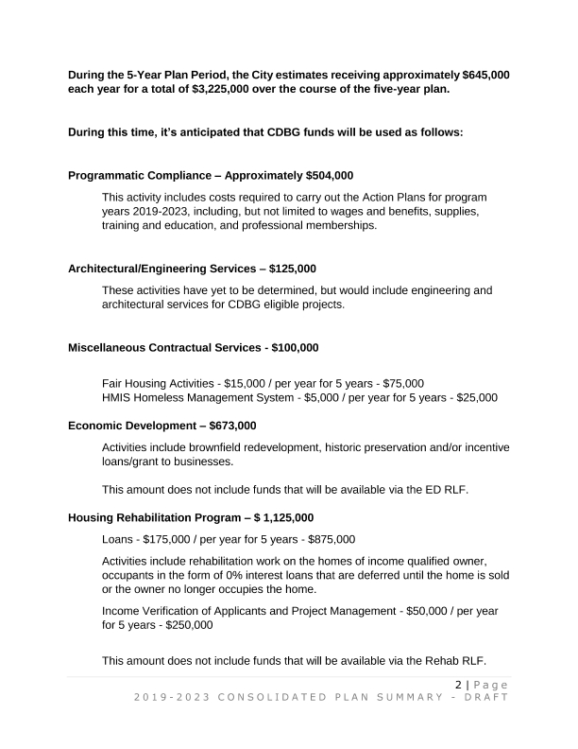
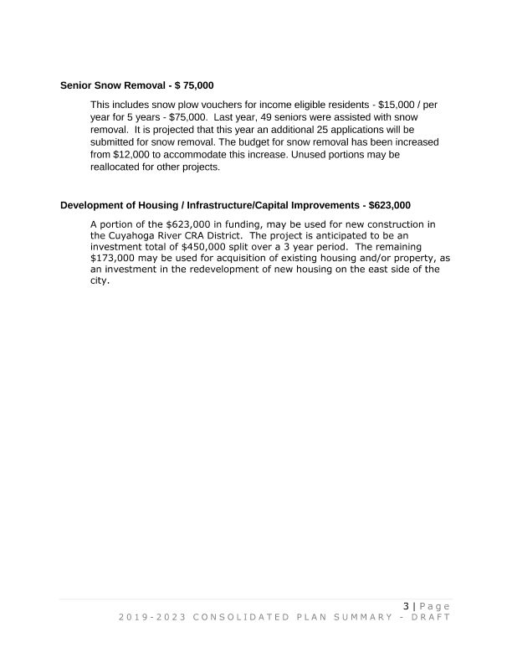
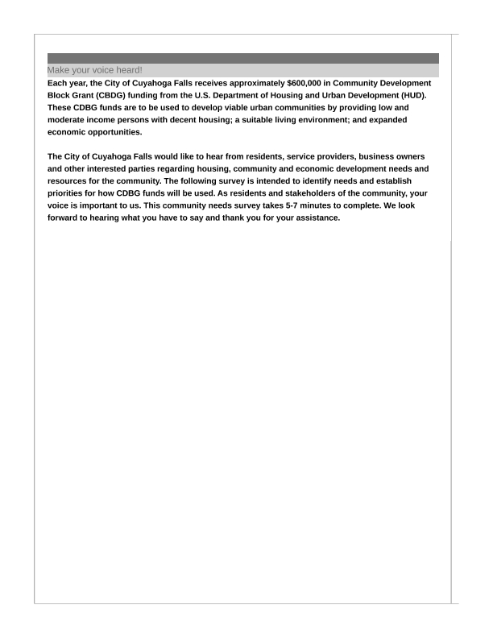
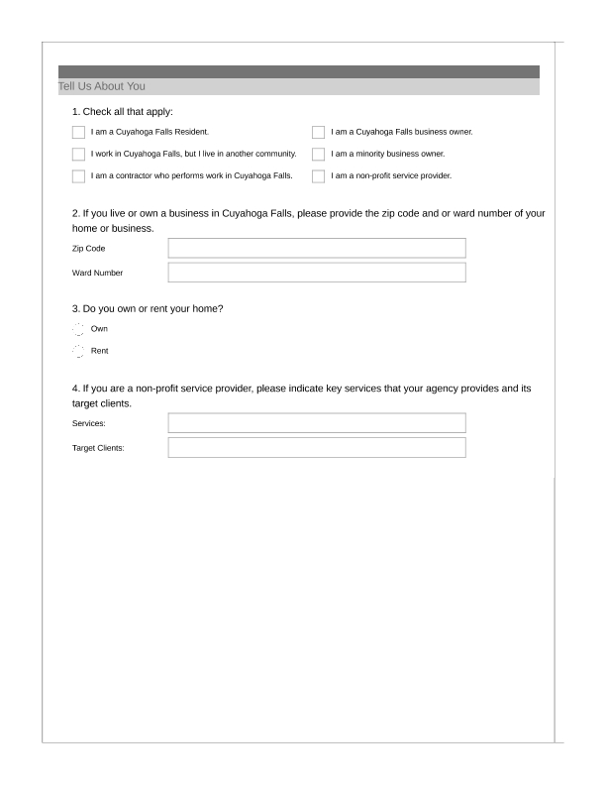
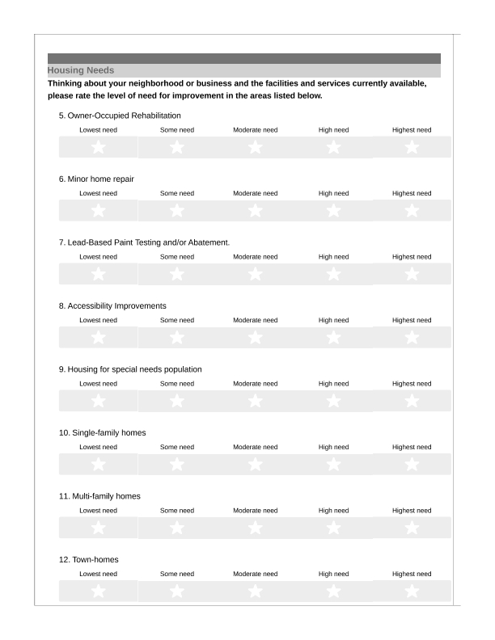
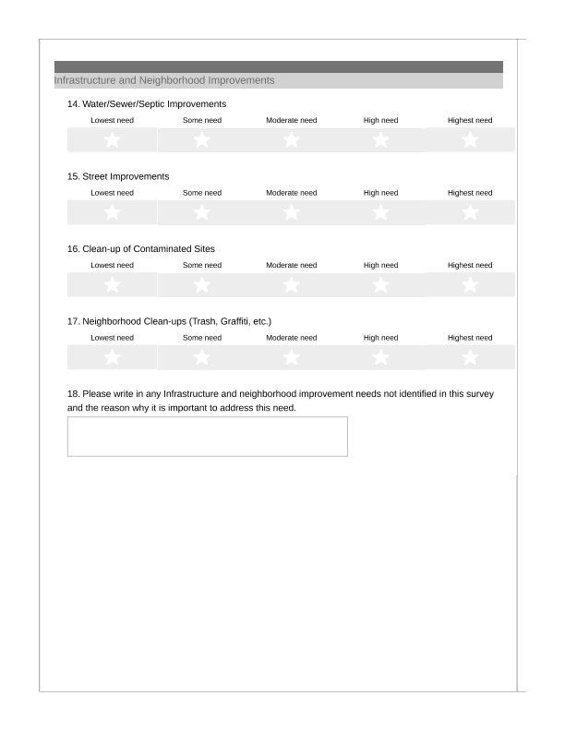
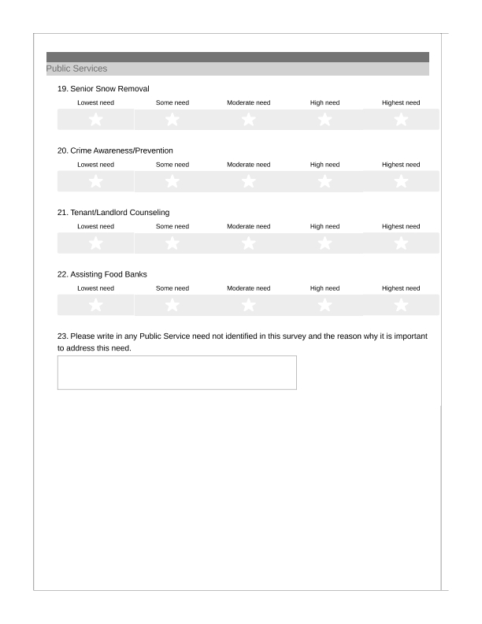
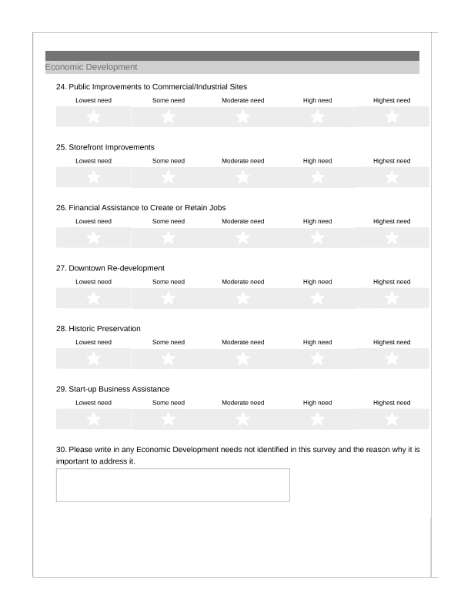
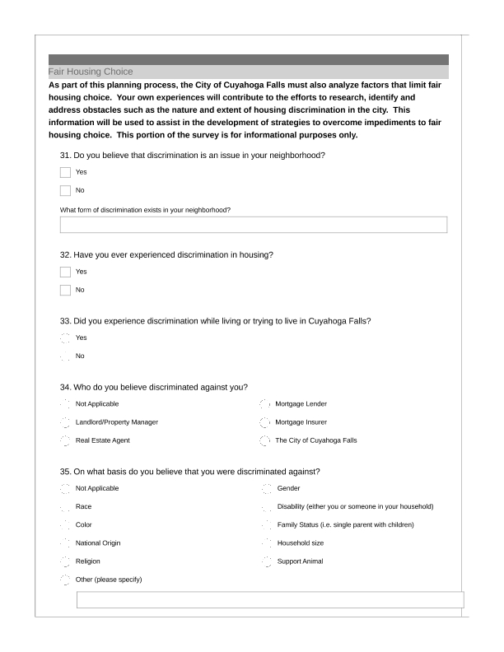
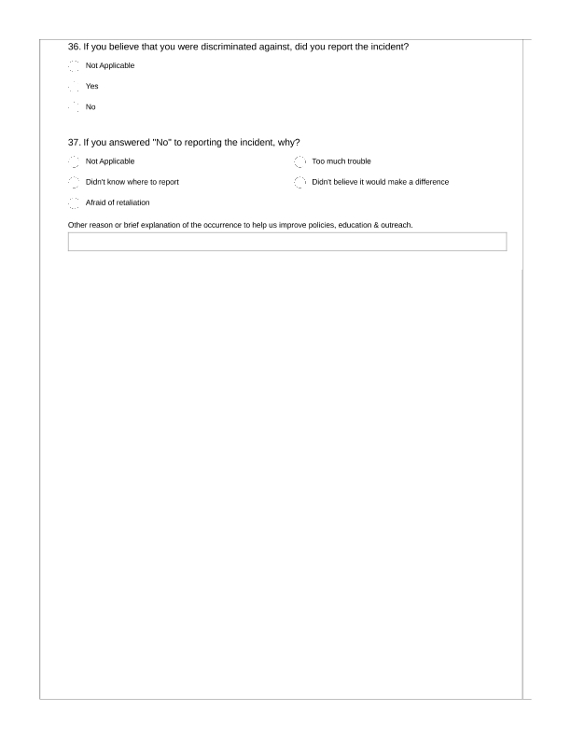
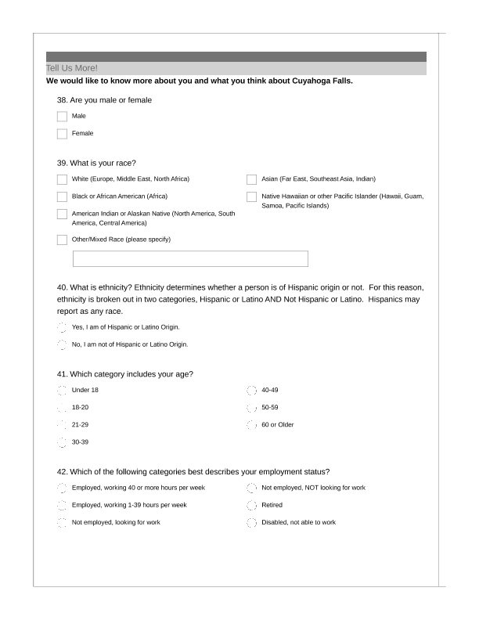
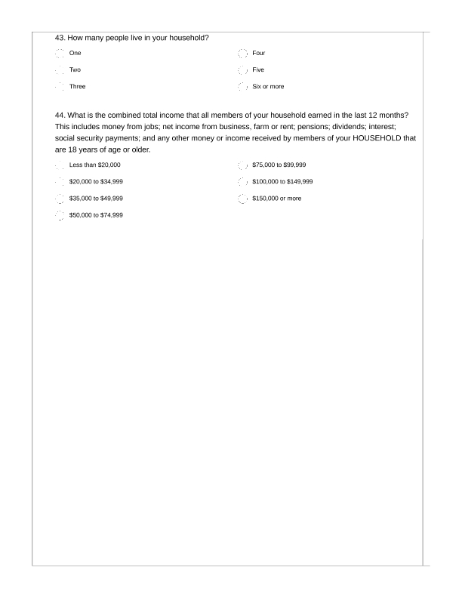
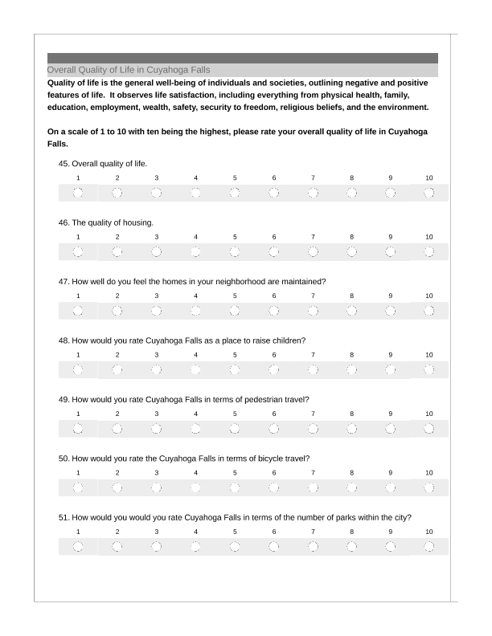
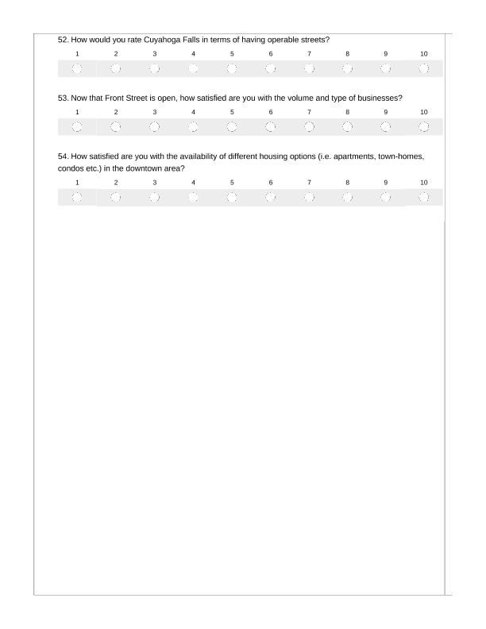
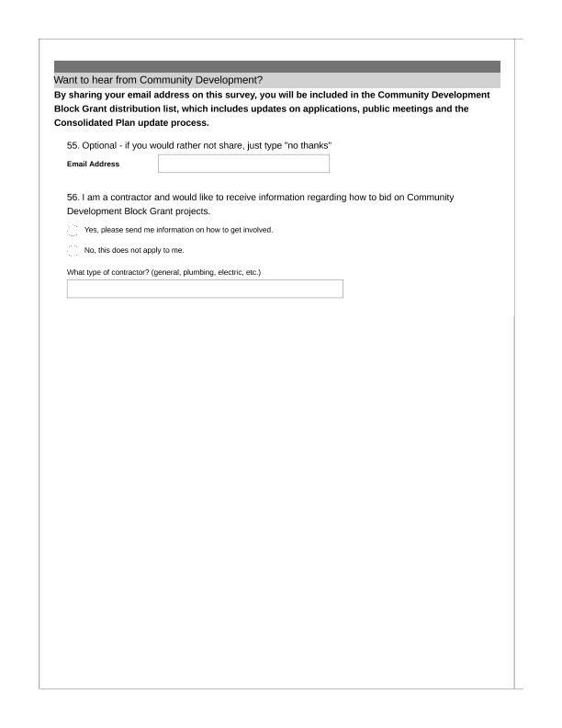
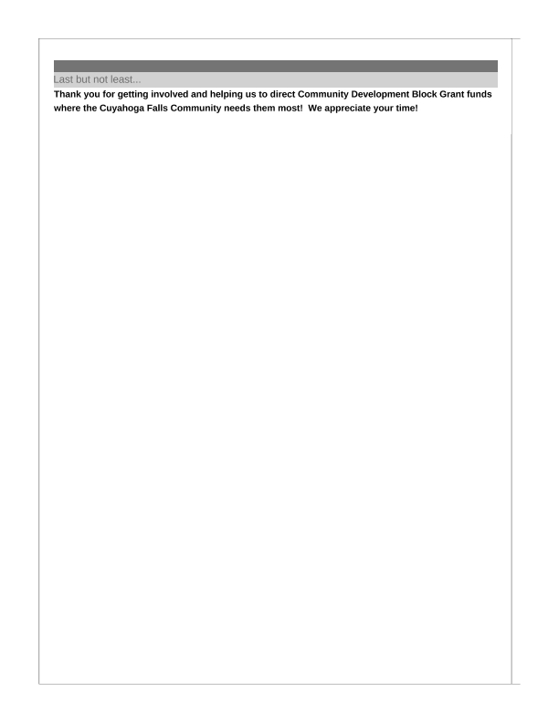
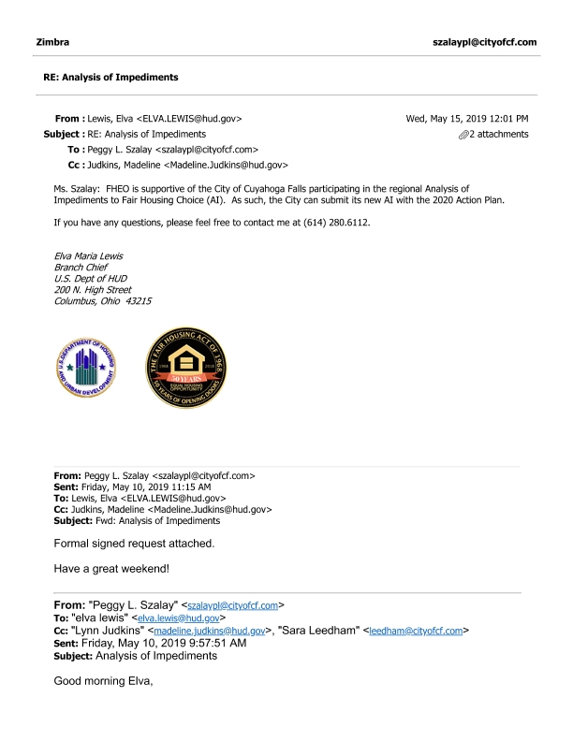
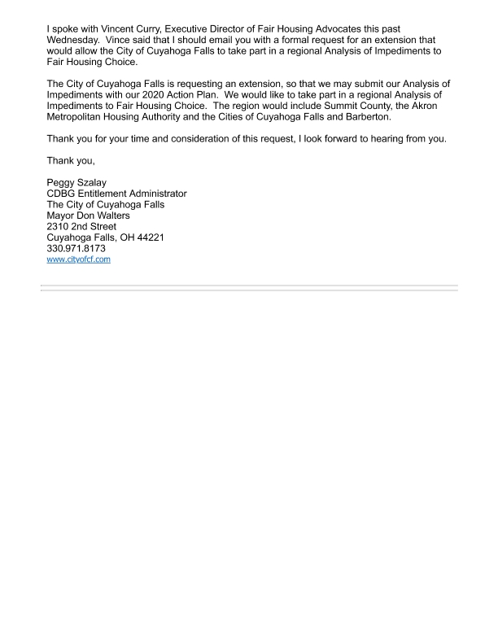

Grantee SF-424's and Certification(s)
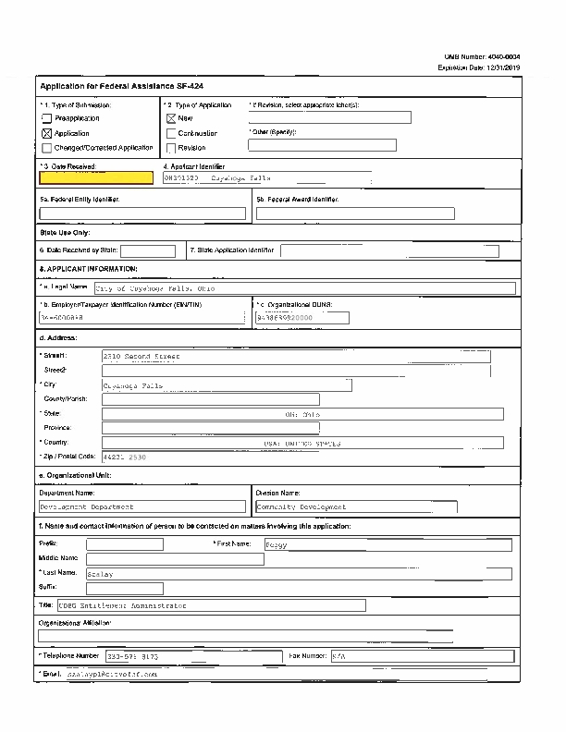
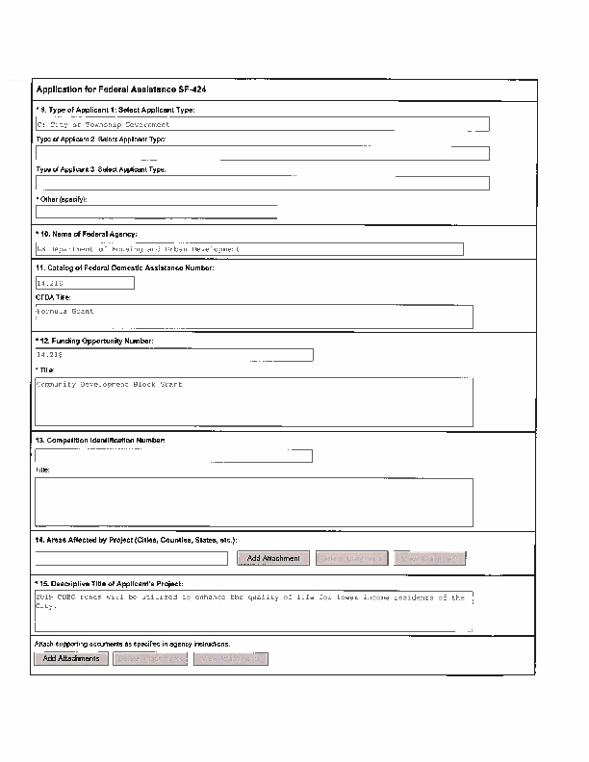
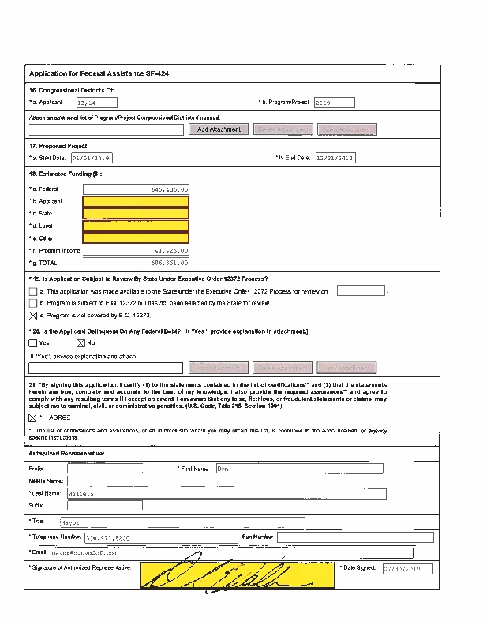
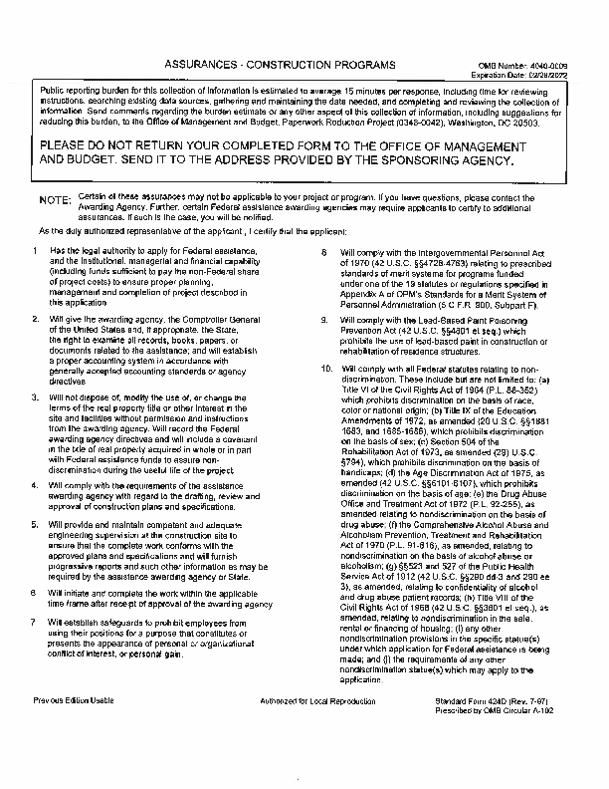
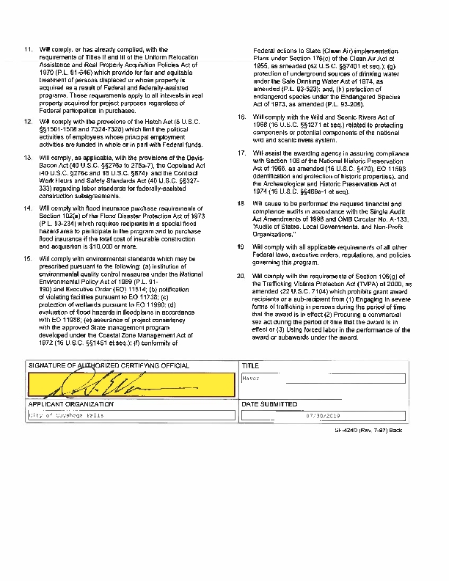
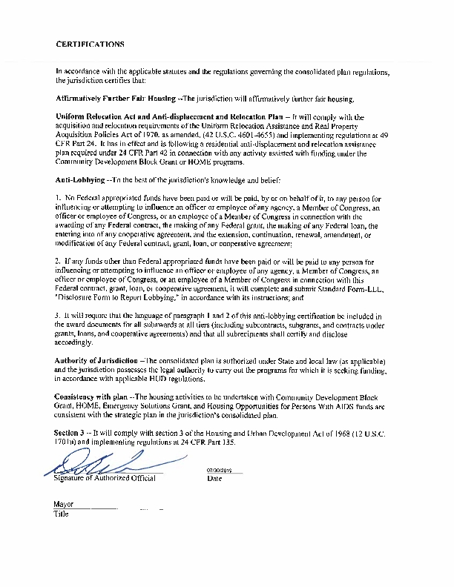
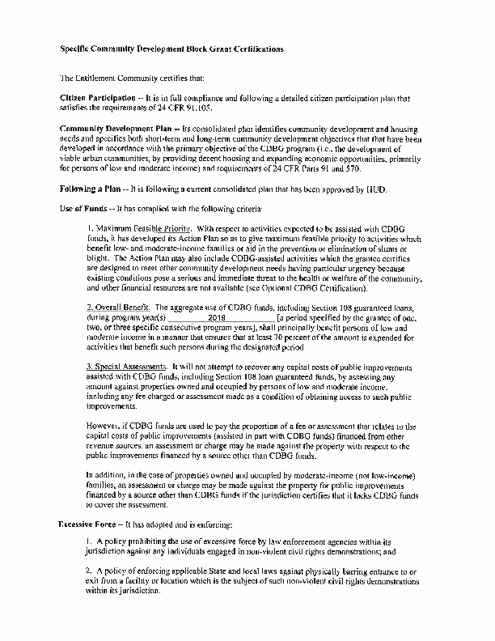
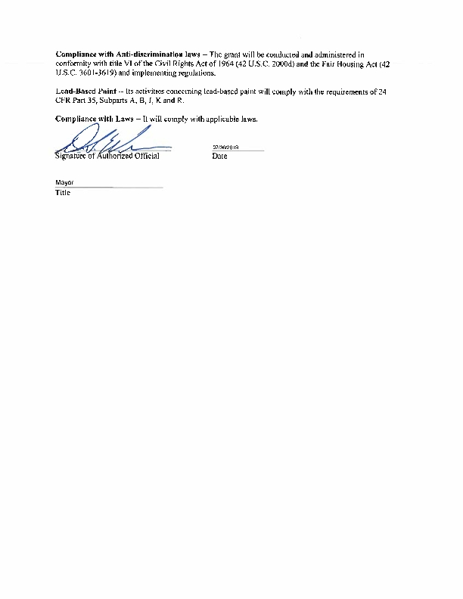
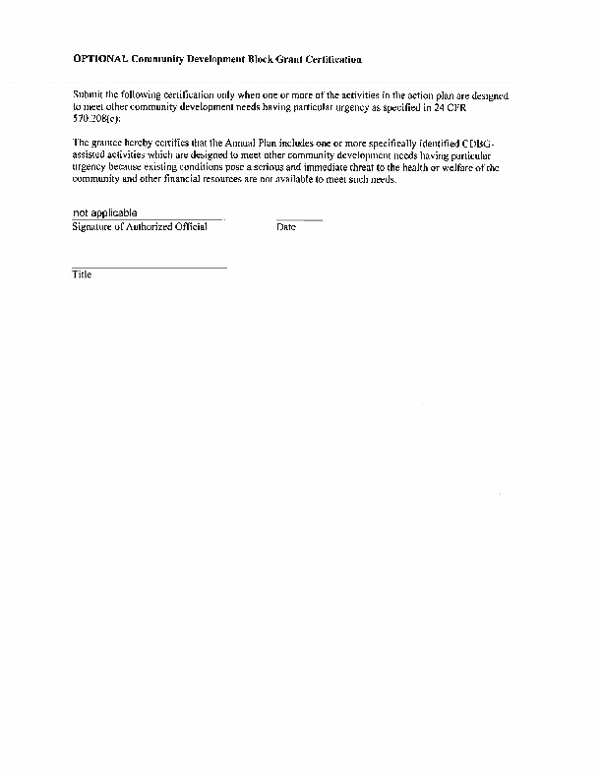
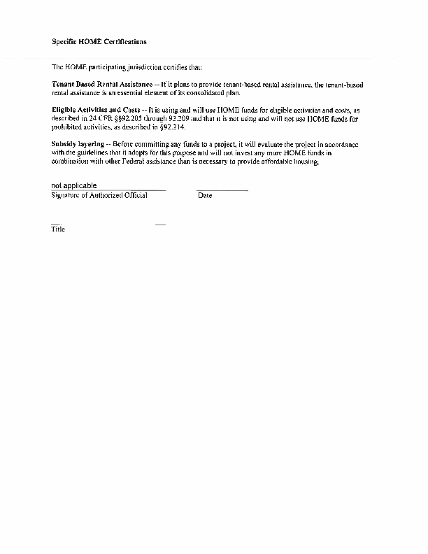
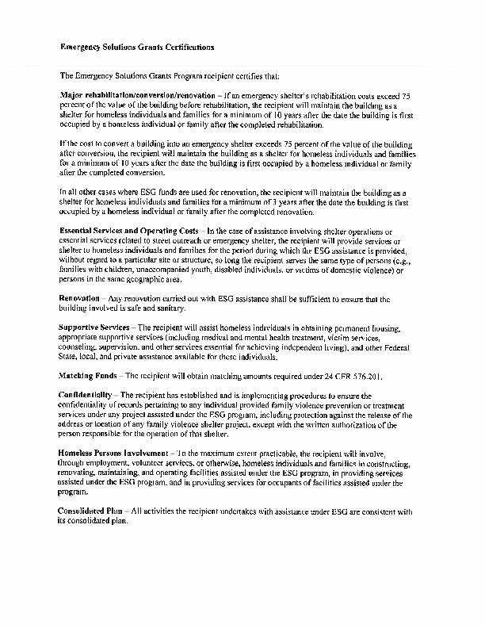
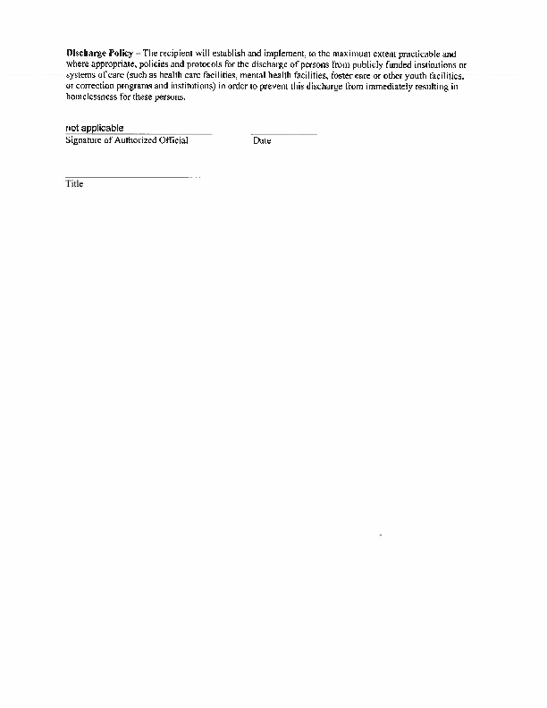
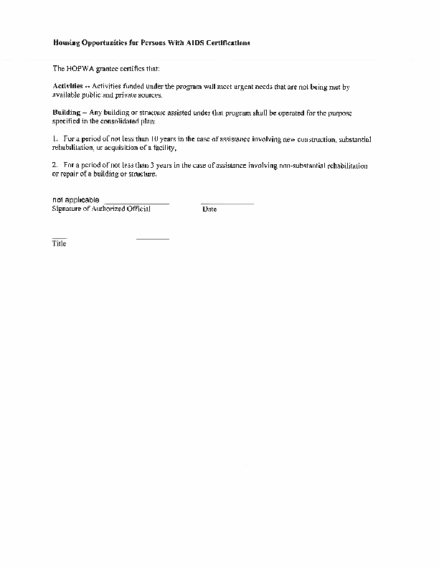
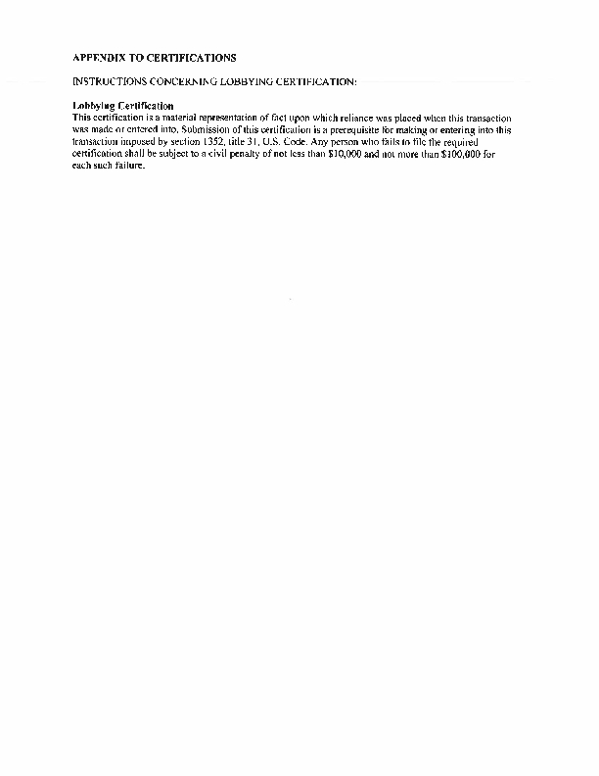

Appendixx - Alternate/Local Data Sources

1 | Data Source Name  Annual COC-HMIS PIT Count
List the name of the organization or individual who originated the data set.
The Akron/Barberton/Summit County Continuum of Care & HMIS.
Provide a brief summary of the data set.
At least every other year the local Continuum of Care-HMIS organization takes a physical count of the Counties homeless population. Based on the data collected from this physical count and inventory count is prepared and given to local governments and non-profit service organizations who use the data to make informed decisions.
What was the purpose for developing this data set?
To determine and count and other information concerning the local homeless population and their specific needs.
How comprehensive is the coverage of this administrative data? Is data collection concentrated in one geographic area or among a certain population?
The annual PIT count strives to make the best count possible including as much of the homeless population as possible on a given day in the year. It is a well organized program assisted my local volunteers who have some knowlegde or who work with this sub-population. It is also assisted by local law enforcement going into the woods and different buildings where the homeless are known to exist to make the count and information gathering as accurate as possible.
What time period (provide the year, and optionally month, or month and day) is covered by this data set?
The last annual count was made on January 22, 2013. Usually this count is made on an every other year basis.
What is the status of the data set (complete, in progress, or planned)?
Once the data and information is collected its drafted into a report and provided to local government officials and agencies who assist in caring for the homeless. The report is collected as a point in time date and is as complete as possible as of that date.

