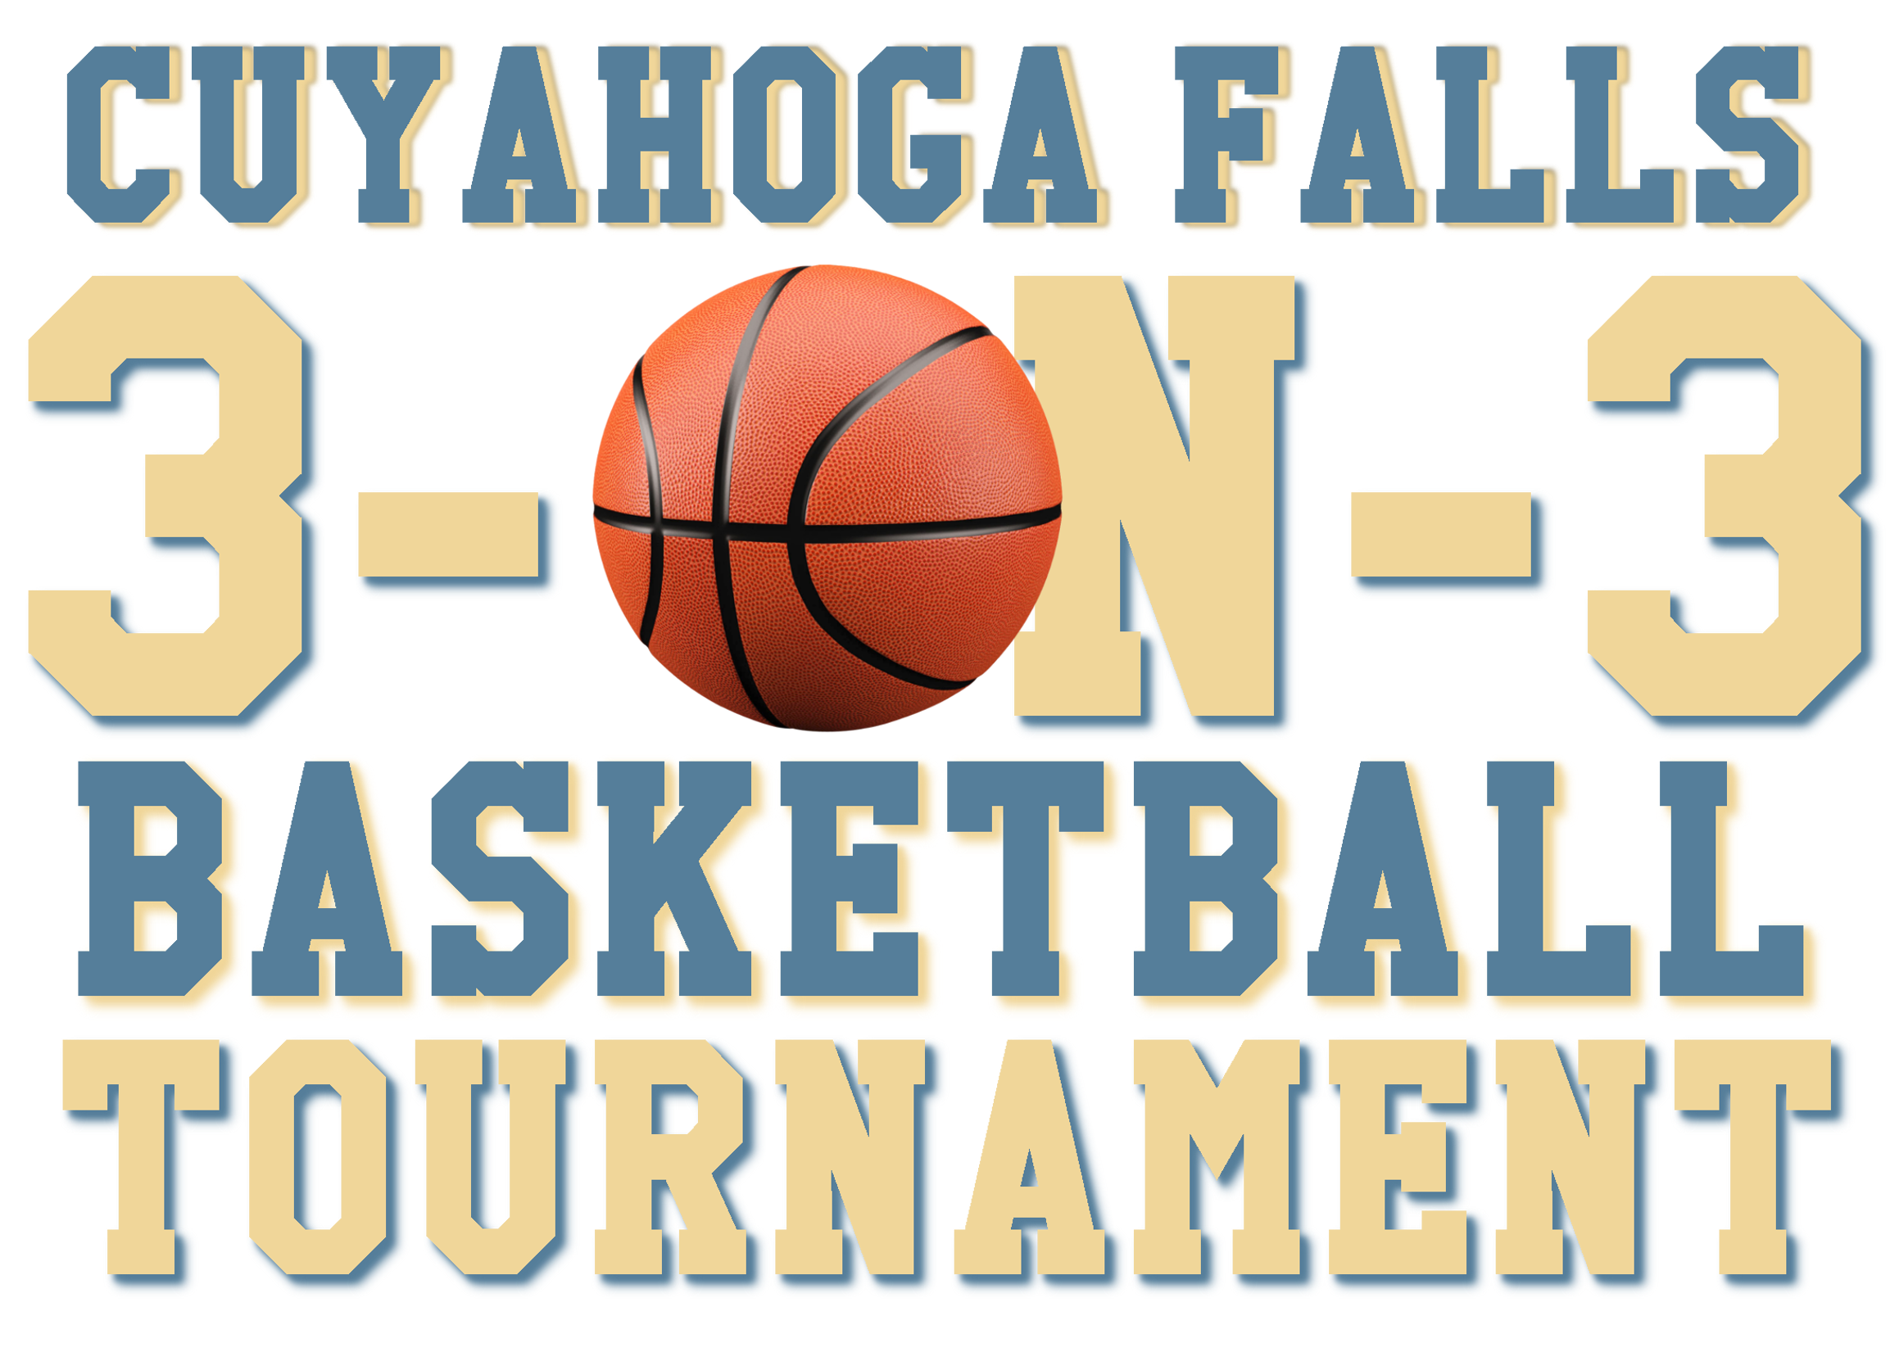
Cuyahoga Fall 3-on-3 Tournament 2018 Team Sign Up

Teams consist of three players plus one alternate—please include a team name (family friendly, please), age bracket, and full contact information for each team member. Sign up deadline is August 11th. For questions or concerns, please contact Neighborhood Ambassador Alex Hall at (330) 842-6619. Complete information and tournament rules are available at www.cityofcf.com/3on3. Please return form via email to Alex Hall at acohall26@gmail.com or by mail to the Department of Neighborhood Excellence, Communications and Community Outreach, City of Cuyahoga Falls, 2310 Second Street, Cuyahoga Falls, Ohio, 44221. You may also present your form in person at the Department of Neighborhood Excellence, Communications and Community Outreach inside the Cuyahoga Falls City Hall building.

Team Name: ___________________________________ Age Bracket _____Youth: 14-17* _____Adult: 18+

*Note: If a player is over the age of 17, but enrolled in high school, they are qualified to play on a youth team.

Team Captain: __________________________________ Age: _____________

Phone Number: ______________________ Email Address: _________________________________

Home Address: _____________________________________________________________________

Player Two: __________________________________ Age: _____________

Phone Number: ______________________ Email Address: _________________________________

Home Address: _____________________________________________________________________

Player Three: __________________________________ Age: _____________

Phone Number: ______________________ Email Address: _________________________________

Home Address: _____________________________________________________________________

Alternate Player: __________________________________ Age: _____________

Phone Number: ______________________ Email Address: _________________________________

Home Address: _____________________________________________________________________

