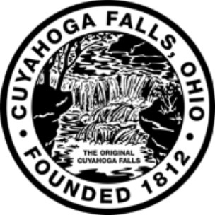

Senior Snow Plow Program

Mayor Don Walters is pleased to present a complimentary Senior Snow Plow Program for the 2017-2018 winter season. The program is open to year-long, owner occupied residents of the City who are 65 or older and/or disabled, income qualify and have no other persons living in the home who can remove the snow. Driveways must be concrete or asphalt. The program is limited to driveways only. Contractors will not provide salt.
Seniors should apply ahead of the snow season as applications must be received, reviewed and approved before being accepted into the program. Applications will be accepted until October 31, 2017 at 4:00pm; however, funds are limited and once the funds are expended the program will be discontinued for the season.

Service is not available to multi-unit residences.
Application –Please Print
Name of Homeowner_________________________ DOB _____/_______/_______
Address______________________________ Age_______
Home/Cell Phone ___________________
Name of all residents of this household Relationship to applicant DOB
________________________________ __________________ _____
________________________________ __________________ _____
________________________________ __________________ _____
Submit proof of age (driver’s license or birth certificate)
Income qualification – Single Household - $36,800 (annual gross)
Two Person Household - $42,050 (annual gross)
You must provide the following documentation:
- Proof of Homeowners Insurance. (The current declarations page. Not the entire policy.)
- Current pay stubs for all those working in the household over 18 years of age. (2 months worth)
- SSI, Disability, or Pension, most current statement or letter providing monthly or yearly amount received.
- Checking, Savings, Certificate of Deposit, Assets, and Investments etc. statements. (3 months worth)
- Self Employed – provide the most recent income tax returns (3 years)
- If applicable, provide a letter from your physician documenting your disability.

My driveway is concrete or asphalt (check box if yes)
______________________
Supplying false information will result in unaccepted participation
I have read and agree to adhere to all the qualifying requirements to participate in the program. (Check box as acknowledgement)
I, __________________________, hereby certify that all of the information supplied by me in this application is true. If the application is accepted by the City of Cuyahoga Falls, I agree that contractors hired by the City have my full permission to come upon my premises at the address indicated on the application for the purpose of snow removal. I further forever and completely release and discharge the City of Cuyahoga Falls, its employees and contractors from all liability, claims, damages, actions and causes of action whatsoever which I might otherwise have or enjoy as a result of the City providing snow plowing services at no cost to me for which I have hereby applied. I further understand and agree that the City may discontinue the snow removal program at any time and that there will be no liability or claims arising to the City as a result of discontinuance of this program. I have read and understand the requirements and rules of the City’s Senior Snow Plow Program and agree hereby to abide and be bound by the same.

__________________________________________________________________
Signature of Applicant(s) Date

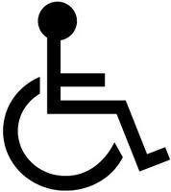
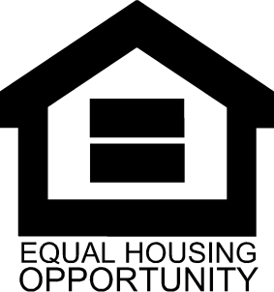

Please return your completed application, with all appropriate documentation, to Crawford-Smith@cityofcf.com or the Development Department, 2310 Second Street, Cuyahoga Falls, Ohio 44221. If you have questions, call 330.971.8140.

